Linköping University | Department of Physics, Chemistry and Biology

Type of thesis, 60 hp | Educational Program: Physics, Chemistry and Biology

Spring or Autumn term 20xx | LITH-IFM-A-EX— 16/3227--SE

Has breeding for appearance affected visual acuity in dogs?

Ida Milton

Examinator, Matthias Laska

Supervisor, Lina Roth





**Rapporttyp**

Report category

Examensarbete

D-uppsats

**Språk**/Language

**Engelska**/English

**Titel/**Title.

Has breeding for appearance affected visual acuity in dogs?

**Författare/**Author.

Ida Milton

**Sammanfattning/**Abstract.

Earlier studies have suggested that there are differences in visual ability between dog breeds of extreme skull shape. The skull shape of dogs have found to correlate with retinal ganglion cell topography. Dolichocephalic breeds have a horizontal visual streak, while brachycephalic breeds have retinal ganglion cells concentrated in an area centralis. However, it has not been investigated whether the differences in ganglion cell distribution correlate with the perceived visual acuity. The aim of this study was to determine visual acuity differences between two dog breeds based on skull shape, in both daylight (43 cd/m2) and dim light (0,0087 cd/m2) conditions. Whippets (N=4) and pugs (N=3) were tested in a two-choice visual discrimination test to achieve visual acuity thresholds. The stimuli were black and white sine-wave gratings of either horizontal or vertical orientation. In daylight, the best performing whippet reached a significant visual acuity threshold up to 16 cpd while the best pug discriminated stimuli of 24 cpd. This acuity threshold is better than what has previously been documented in dogs. In dim light conditions, all but one dog discerned two cpd. In daylight conditions there was an interesting trend, not significant, (r=0,089, P=0,87) between skull shape and visual acuity. To set conclusive results this trend needs to be investigated further with more test individuals. Hence, this study indicates that breeding dogs for appearance has not only resulted in extreme skull shapes but could also have affected the visual ability of the dogs.

**ISBN**

**LITH-IFM-A-EX—**99/1111**—SE**

**__________________________________________________**

**ISRN**

**__________________________________________________**

**URL för elektronisk version**

**Serietitel och serienummer ISSN**

Title of series, numbering

**Handledare/**SupervisorLina Roth

**Ort/**Location. Linköping

**Nyckelord/**Keyword.

Dog, Visual acuity, ganglion cells, skull shape

**Datum**/Date

2016-05-31

**Institutionen för fysik, kemi och biologi**

Department of Physics, Chemistry and Biology

Avdelningen för biologi

Institutionen för fysik och mätteknik

Contents

1 Abstract 5

2 Introduction 6

3 Method 8

3.1 Animals 8

3.2 Experimental set-up 9

3.3 Data Collection 11

3.3.1 Phase I – Pre-training by dog owners 11

3.3.2 Phase II – Training sessions 12

3.3.3 Phase III – Test sessions in daylight conditions. 12

3.3.4 Phase IV – Test sessions in dim conditions 13

3.3.5 Data analyses 13

4 Results 14

4.1 Learning curves 14

4.2 Side, stimulus orientation preference and pupil size difference 15

4.3 Visual acuity thresholds 15

4.3.1 Daylight Conditions 15

4.3.2 Dim light conditions 17

4.4 Correlation between Cephalic Index and Visual acuity thresholds 18

5 Discussion 19

5.1 Conclusions 22

5.2 Societal and Ethical Considerations 22

6 Acknowledgements 22

7 References 23

8 Appendix 26

# Abstract

Earlier studies have suggested that there are differences in visual ability between dog breeds of extreme skull shape. The skull shape of dogs have found to correlate with retinal ganglion cell topography. Dolichocephalic breeds have a horizontal visual streak, while brachycephalic breeds have retinal ganglion cells concentrated in an area centralis. However, it has not been investigated whether the differences in ganglion cell distribution correlate with the perceived visual acuity. The aim of this study was to determine visual acuity differences between two dog breeds based on skull shape, in both daylight (43 cd/m2) and dim light (0,0087 cd/m2) conditions. Whippets (N=4) and pugs (N=3) were tested in a two-choice visual discrimination test to achieve visual acuity thresholds. The stimuli were black and white sine-wave gratings of either horizontal or vertical orientation. In daylight, the best performing whippet reached a significant visual acuity threshold up to 16 cpd while the best pug discriminated stimuli of 24 cpd. This acuity threshold is better than what has previously been documented in dogs. In dim light conditions, all but one dog discerned two cpd. In daylight conditions there was an interesting trend, not significant, (r=0,089, P=0,87) between skull shape and visual acuity. To set conclusive results this trend needs to be investigated further with more test individuals. Hence, this study indicates that breeding dogs for appearance has not only resulted in extreme skull shapes but could also have affected the visual ability of the dogs.

# Introduction

Vision is one of the five common senses and is the process of detecting light and thereby perceive e.g. shapes, colors and motion. The first eyes evolved approximately 530 million years ago, in the early Cambrian period, and already then there was variety of different eyes (Land & Nilsson, 2002). The vertebrate eye is a camera-type eye, which consists of a cornea and a single lens focusing light upon a light-sensitive retina. In the very back of the retina there are two types of photoreceptor that absorb the light. The cones that are responsible for vision at high light intensities and the very sensitive rods for vision at low light intensities (Ygge, 2011). Depending on the activity pattern of the animal the distribution of photoreceptors, rods and cones, differs between species. Diurnal mammals have high proportion of cones e.g. the three shrew (*Tupaia belangeri*) whose retina consists of only 5% rods and 95% cones (Peichl, 2005). Nocturnal animals, on the other hand, have rod dominated retinae with only up to 3% cones. A strictly nocturnal animal is the African giant rat (*Cricetomys gambianus*) (Peichl, 2005). The photoreceptor signal is further processed by bipolar, horizontal and amacrine cells before it converges into the ganglion cells. The ganglion cells´s axons, creating the optic nerve, transports the visual signal out of the eye for further transport back to the visual cortex (Snell & Lemp, 1997). Hence, the distribution and the number of both types of photoreceptors and ganglion cells is of great importance for an animal’s visual abilities e.g. visual acuity.

Visual acuity is commonly defined as the ability of the eye to resolve the smallest distance between two objects or the ability to resolve spatial details (Land & Nilsson, 2002). The degree of visual acuity is dependent on different factors but mainly on how many photoreceptors are connected to a single ganglion cell (Land & Nilsson, 2002). The photoreceptor/ganglion cell ratio varies across the retina (Land & Nilsson, 2002). Increasing distance between ganglion cells in the retina indicates a higher signal summation from several photoreceptors and high convergence, therefore lowers the ability to achieve high visual acuity. In cats the highest ganglion cell density and thereby the highest visual acuity is obtained in the central region of the retina, called the area centralis (Wässle & Boycott, 1991). The retinal ganglion cells can also be distributed in a dense elongated arrangement, a horizontal visual streak (Peichl, 1992). Such an arrangement is found in e.g. wolves (Peichl, 1992).

The grey wolf is the ancestor of today´s dog (Serpell, 1995). This domestication from wild predator to domesticated pet is assumed to have started 15000 years ago (Leonard et. al, 2002) and due to more recent breeding and artificial selection has resulted in more than 400 dog breeds. Originally, breeds were selected on for qualities suiting for their field of use such as rat- or deer hunting or company (Svartberg, 2006). However, most apparent with dog breeds today is the huge morphological variation, which makes the dog the morphologically most diverse species on the planet. Indeed, Wayne (2001) found that the diversity among domestic dogs exceeds that of the whole family *Canidae*. As an example, an adult dog weighs between 1-90 kg while an adult wolf weighs around 45 kg (Mech, 2006). One morphological feature that has become drastically diverse is the skull shape. For example, the wolfs´s skull is around 30 cm long while the dog skull can vary between 9 cm for a pug to 25 cm for a borzoi (Carrasco, 2014).

Interestingly, Mcgreevy and colleagues (2003) showed that the skull shape of dogs correlate with ganglion cell topography. Dolichocephalic breeds (with long skulls) have a horizontal visual streak with high visual acuity, while brachycephalic breeds (with short skulls) have ganglion cells more concentrated in a round area centralis (Mcgreevy et al, 2003). The area centralis is shown to have approximately three times more ganglion cells (2640/mm2) than in the horizontal streak (880/ mm2), which gives the brachycephalic dogs an advantage in visual acuity over dolichocephalic breeds (Mcgreevy et al, 2003). However, to my knowledge, it has not been investigated whether the differences in ganglion cell distribution correlate with the visual acuity in dogs of different skull shapes. Additionally, very few studies have investigated the visual acuity of dogs in dim conditions.

The retina of the dog consists mainly of rod photoreceptors operating in dim light conditions. Even though there is a higher number of cones in the more central parts of the retina, the majority of photoreceptors here is rods (Mowat et.al. 2008). This distribution is similar to their ancient relative the wolf (Peichl, 1992). The distribution of photoreceptors among breeds and dogs of different skull shape are not yet known. If we assume that the photoreceptor distribution is the same in both brachycephalic and dolichocephalic dogs then, since brachycephalic dogs have higher number of ganglion cells in the area centralis, they schould also outperform the dolichocephalic breeds in visual acuity also in dim conditions.

The aim of this study was to determine possible visual acuity differences between two dog breeds based on skull shapes, in both daylight and dim conditions. The best way to assess what an animal is able to perceive is to use a behaviour test. Therefore, this study used two representative dog breeds in a two-choice discrimination test, which has been shown to be useful to determine sensory abilities in animals (Roth et.al. 2008). The test was performed in daylight to test the visual acuity generated by the cones and under dim conditions, to test rod receptors. I expected the dolichocephalic breed should display a lower visual acuity than the brachycephalic breed at both light intensities as their horizontal visual streak has less ganglion cells to sum up the visual signal and therefore lowers their visual acuity.

# Method

## Animals

This study included dogs of one brachycephalic breed and one dolichocephalic breed. The brachycephalic breed was represented by the pug (N=3) and the whippet (N=4) represented the dolichocephalic breed (Table 1). All dogs were recruited through social media or personal contacts and were all privately owned. The participating dogs’ characteristic data were noted and included name, sex, age, neuter status, weight, withers and the cephalic index (CI; Table 1). The cephalic index is a parsimonious measurement of the dogs’ skull, where a high CI indicate a short and relatively wide skull. The CI is calculated by, skull width divided by skull length and multiplied with 100. The skull measurements were assessed by taking a photo of the dog’s skull from above while indicating the back of the skull with thumb or index finger (Fig. 1). The skull width was measured from zygomatic arch to zygomatic arch, which was displayed with a measuring tape in the photo. The length was measured from the tip of the nose to the occipital lobe (Fig. 1) (Mcgreevy et. al, 2003). The program IMAGE J (1.5b) was used to take these measurements from the photo.

In order to achieve a general medical status of the dogs´ eye and visual capabilities, all participating dogs went through a veterinarian eye control (ophthalmoscopy) performed by a legitimized veterinarian, at Anicura Linköping, Sweden (31/10-2015 & 29/1-2016). Written consent, allowing me access to these results with addition to participation throughout the study was signed by the owners.

Table 1. Characteristic data for every dog participating in the study

|  |  |  |  |  |  |  |  |
| --- | --- | --- | --- | --- | --- | --- | --- |
| Name | Breed | Sex | Age | Weight (kg) | Neuter status | Withers (cm) | Cephalic index (CI) |
| Poppe | Pug | Male | 3 years | 8 | No | 26 | 91.1 |
| Bosse | Pug | Male | 3 years | 9.8 | No | 32 | 97.4 |
| Doris | Pug | Female | 10months | 8.5 | No | 30 | 100.0 |
| Sniff | Whippet | Male | 11 years | 16.6 | Yes | 56 | 47.9 |
| Acke | Whippet | Male | 6 years | 15 | No | 54 | 52.8 |
| Gaia | Whippet | Female | 4 years | 13.1 | No | 47.5 | 53.6 |
| Dafne | Whippet | Female | 5 years | 10.5 | No | 44 | 58.0 |

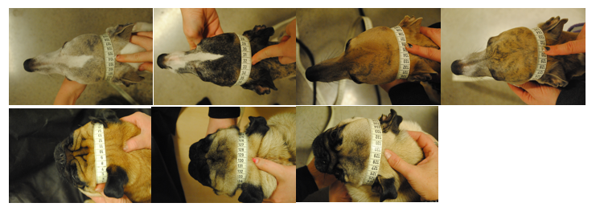

Figure 1. Photos were taken from above of all participating dogs to measure cephalic index (CI). The skull width was measured from zygomatic arch to zygomatic arch (measuring tape). The length was measured from the tip of the nose to the owner´s fingertip. On the top, from the left, are the whippets Sniff, Acke, Gaia and Dafne. On the lower line are the pugs Poppe, Bosse and Doris.

## Experimental set-up

The test sessions took place at Linköping University´s animal testing facilities. The dogs were tested with a two-choice discrimination test (Fig. 2). The test set-up consisted of a wooden board with connecting metal fence and a hall matt in front. The wooden board had two guillotine hatches, which were opened by the test leader when pulling a connecting rope. These guillotine hatches were used to control the dog´s access to a reward/no reward. Above each hatch was a stimulus holder, one located at low level and one at high level. To create a forced choice for the dog a plain wooden board separated the two hatches, creating a path to each hatch. The distance from where the dog was forced to choose was 1.5 m and marked with a line of scotch tape. Two LED spotlights (Star trading led spotlight, 4000 K) were directed at the stimulus holders. LEDs of 4000K were chosen to achieve the best resemblance of daylight. For the daylight condition, the intensity was set to 43 cd/m2, while for the in dim light condition the intensity was 0.0087 cd/m2. The dim light was achieved by adding 6 neutral density filters (0.6 Lee filters) in front of the spotlights and covering any additional light source near the testing arena.

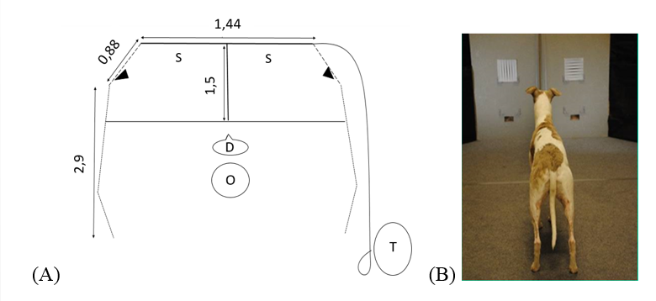

Figure 2. A) Schematic illustration of the experimental set-up, S=Stimuli, D=dog, O=Owner and T=Test leader (all measurements are in metres). B) A dog about to choose between a horizontal and a vertical stimulus.

The stimuli were printed paper (20x20 cm) with evenly spaced black and white sine-wave gratings with a Gaussian mask generated in Matlab (R2014a). The frame was removed and size adjusted in Illustrator. The stimuli were printed by LIU tryck (Canon image PRESS C7010VP) on Multidesign Original White paper (300 g, papyrus). Visual acuity was measured by cycles per degree (cpd), which is the number of cycles that fits in 1° (Fig. 3). The distance between lines was systematically varied to assess a dog´s visual acuity. Stimulus of every second cpd (2-30 cpd) were used in tests and how fine gratings that was used depended on the performance of the dog.

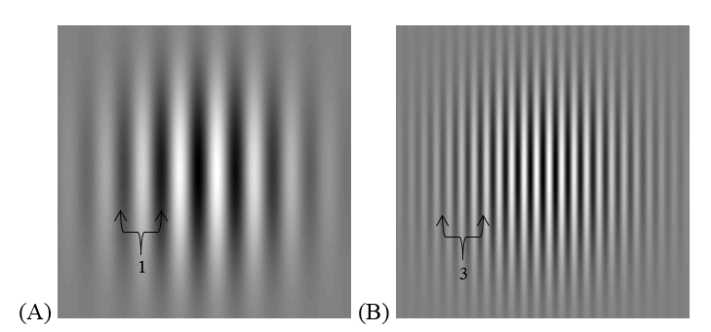

*Figure 3. Two stimul*us *sheets to illustrate the cpd measurement. Cpd is equal to how many cycles (one black and one white line) that fits into 1 $°$ at a certain distance. (A) one cycle for 1 $°$ (B) three cycles for 1 $°$.*

## Data Collection

### Phase I – Pre-training by dog owners

The dogs were pre-trained in their home by their owner for around three months prior to training sessions with the test leader. The owner was given instructions on how to train the dog at home (see appendix). The aim of the pre-training was for the dog to have enough time and repetitions to associate the horizontally oriented stimulus with a reward. The owners were instructed to present only the correct stimulus choice for the first 100 repetitions. When the dog looked at the stimulus it was given praise and treats. The owners gradually increased the distance to the stimulus to 0.5-1 m. When the dog understood the procedure, the owners set up both horizontal and vertical lines with a few decimeters distance between them. If the dog, then chose the correct stimulus a reward was given. Alternatively, if the dog chose the wrong option the owners ignored it and tried again. To avoid stress and frustration, the owners were instructed to go back to simpler training if the dog chose the wrong choice multiple times when presented with the two stimuli.

When the owner thought that the dog had understood the procedure they were instructed to do approximately 20 repetitions a few times a week. The stimuli used during this stage were one and three cpd, calculated by a distance of 1.5 m. Additional instructions were that the owner should train the dog in different environments, such as different rooms of the home, and take care to not influence the dog by pointing or to reveal the correct choice for the dog.

### Phase II – Training sessions

When starting the training sessions in the experimental set-up the dogs were given a “non-error” choice i.e. only the correct stimulus was presented either to the right or left side, so that no error could be made. If the dog chose the side with no stimulus it was ignored by the owner and then went on with the next trial. When the dogs had habituated to the set-up they were given choices with both horizontally and vertically oriented stimuli patterns. Training sessions were performed according to predetermined schemes of 20 trials with pseudorandom preset correct choice on either left or right side, alternating between one and three cpd. All dogs were trained to associate horizontally oriented lines with a reward (frolic). The owner told the dog to make a choice by the command “choose”. When doing this the owner was instructed, beforehand, not to acknowledge the stimuli and look down, to not influence the dog. The dog was noted to have made a choice when it crossed the line (1.5 m in front of the stimuli) with at least one paw. When the dog chose the correct stimulus it was rewarded with a treat (Frolic) released from the hatch. The hatch was opened by the test leader by pulling a connecting rope. When the dog chose the wrong stimulus the owner ignored the choice and continued with the next trial. After approximately half the trials the dog was given a short break. The number and the length of the break depended on the dog’s motivation, which was discussed with the owner.

The dogs were approved for data collection when they scored ≥75% correct choices in two consecutive test sessions. Hence, 15 correct choices out of the 20 trials was needed which is significantly different from random according to the two- tailed binominal test (P<0.05).

### Phase III – Test sessions in daylight conditions.

When a dog was approved for data collection, stimuli with 2-30 cpd were presented in predetermined schemes of 24 trials. The test procedure was similar to the training sessions. The exception was that in addition to the “no-error” trials, two trials of one cpd (where correct choice was presented once to the left and once to right) were both needed to be correct to proceed with the collection scheme. Horizontal stimuli were presented an equal number times to the left and the right in a pseudorandom order (maximum of two choices on the same side in a row). These schemes were extended with trials for certain dogs that needed to be tested on stimuli with additional higher cpd. The original number of trials in daylight conditions was 24 per session, but with extended trials it could be 50 trials depending on the dog’s motivation. Stimuli of 2-16 cpd were used but stimuli with higher cpd was added to the schemes of dogs that performed high percentage of correct choices. Three whippets (Acke, Gaia and Sniff) were tested with foundation stimuli of 2-16. One whippet (Dafne) and two pugs (Doris and Bosse) were tested with additional cpd of 18-24. One pug (Poppe) was tested with additional cpd of 24-30.

### Phase IV – Test sessions in dim conditions

The tests in dim light conditions were performed after having finished the daylight testing sessions. Before the start of the test sessions in dim light the dog were allowed to be habituated to the dark surroundings. The eyes and the rod photoreceptors were assumed fully dark adapted after 30 min according to earlier studies (Hecht et.al. 1937). To begin data collection in dim light conditions the dogs had to first fulfil the learning criterion. The learning criterion for dim conditions was to have six correct trials (with stimuli of one cpd) in a row, which is significantly different from random according to binominal tests. The difference between daylight and the dim condition test procedure was that different cpds were assessed and had different number of trials. The cpds used in dim conditions were 0.5-10 with a scheme of 16 trials per session. As in daylight testing the number of trials could be extended for certain dogs that showed high motivation, with the maximum of 40 trials. This was, as for the number and length of breaks, discussed with the owner.

#### Pupil measurements

To measure the pupil adaptation to the dim light, the pupils of each dog were filmed first in daylight and then in dim light after adaptation. To be able to film in dim conditions a IR-video camera was used (Sony Handycam HDR-XR500).

### Data analyses

To assess if the dogs had any preference for a specific side in the experimental setup or for a specific pattern orientation of the stimulus the binomial test was used (Rohlf & Sokal, 1995). The dog´s visual acuity threshold was also assessed by using the binomial test (Rohlf & Sokal, 1995). If the number of correct trials (for a specific cpd) was significantly different from random it indicated that the dog could discriminate that specific cpd. Additionally, to establish relation between the skull length and visual acuity, spearman´s rank correlation was used. Included in the correlation analysis were the dogs that had a significant visual acuity threshold. The variables used in the correlation and regression was cephalic index (cm) for each dog and their highest significant cpd. To assess if there was a difference in pupil adaptation (daylight/dimlight) between pugs and whippets a Mann-Whitney U-test was done. The data assessed in the t-test was the mean of the pupil diameter (mm) and the mean pupil area fold difference between daylight and dim light for each breed. All statistical tests were performed in IBM SPSS statistics (Version 23) with a significance level of P<0.05.

# Results

## Learning curves

Learning the process and reaching the learning criterion took different numbers of sessions for each dog (Fig. 4). The best dog needed 4 sessions to reach the criterion, while the slowest took 13 sessions (Fig. 4).

*Figure 4*. *Learning curves of all whippets (A) and pugs (B) during training sessions.*

## Side, stimulus orientation preference and pupil size difference

The pug called Doris was the only dog that showed a side preference during total (day- and dim light) data collection (P<0.05). She chose the right side of the test apparatus significantly more times than the left side. Even though all the dogs were trained on horizontal stimuli, Bosse and Doris did not show any significant preference for the horizontal stimuli. Acke, Sniff, Gaia, Dafne and Poppe chose the horizontal orientation significantly more times than the vertical orientation across all cpds. There was no significant difference (P>0.05) in pupil diameter between the whippets (2.7 mm +/- 1.2 SE) and the pugs (2.5 mm +/- 1.1 SE) according to the Mann-Whitney U-test. Additionally, there was neither any significant difference (P>0.05) in mean pupil area fold difference between the whippets (1.5 +/- 0.2 SE) and the pugs (1.6 +/- 0.2 SE).

## Visual acuity thresholds

### Daylight Conditions

In daylight conditions all the dogs (whippets N=4 and pugs N=3) reached the learning criterion and were therefore approved for data collection. The best performing whippet reached a significant cpd up to 16 while the best pug reached 24 cpd (Fig. 6 and Fig. 7). However, the inter-individual variation was large within both breeds. Among the whippets (Fig. 6), Dafne had the highest visual acuity threshold of 16 cpd. Gaia had a visual acuity threshold of 14 cpd, Sniff 12 cpd and the lowest visual acuity threshold among the whippets had Acke with four cpd. Among the pugs (Fig. 7), Poppe had the highest visual acuity threshold of 24 cpd. Doris had an acuity threshold of six, while Bosse chose randomly for all tested cpds.

(A)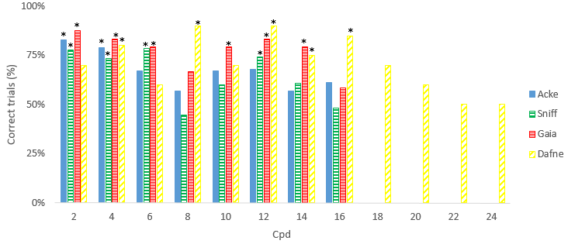

(B)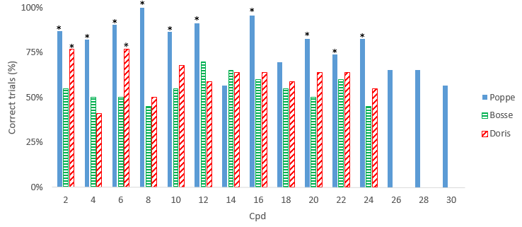

*Figure 5. Visual acuity thresholds of all whippets (A) and pugs (B) tested in daylight conditions. * P<0.05.*

### Dim light conditions

In dim light conditions all whippets (N=4) and 2 pugs (Poppe and Doris) reached the learning criterion and were approved for data collection. Among the whippets (Fig. 6), Sniff, Gaia and Dafne had the highest acuity threshold of two cpd. Acke, on the other hand, reached an acuity threshold of 0.5 cpd. For the pugs, Poppe was the only one reaching a significant acuity threshold of two cpd. Doris did not reach significance for any tested cpds and Bosse (as mentioned) was excluded from data collection since he did not reach the learning criterion.

(A)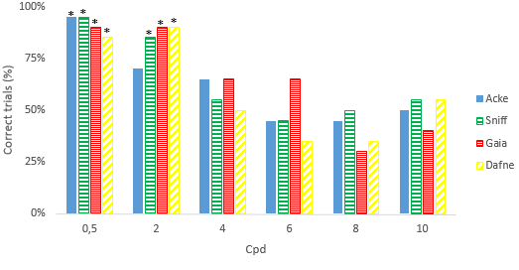

(B)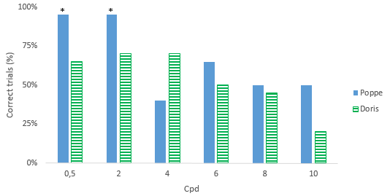

Figure 5. Visual acuity thresholds of all whippets (A) and pugs (B) in dim light conditions. * P<0.05.

## Correlation between Cephalic Index and Visual acuity thresholds

In daylight conditions (Fig. 8) there was a tendency for a positive correlation between the cephalic index and visual acuity, but it was not significant (r=0.089, P=0.87). However, only one dog (Poppe) that has a higher acuity threshold than 16cpd. In dim conditions (Fig. 9) there was a positive correlation (r=0.25, P=0.68) between cephalic index and visual acuity. However, this correlation does not give reliable results since in dim light all but one dog (Acke) had the same acuity threshold at two cpd.

(A)

(B)

Figure 6. Correlations between cephalic index of each dog and their highest significant cpdin daylight conditions (A) and in dim light conditions (B). Each data point represents an individual dog. Diamonds represents pugs and circles represents whippets.

# Discussion

This study indicates that there could be a difference in visual acuity in dogs of extreme skull shapes. To my knowledge this is the first study that behaviourally tests this. Additionally, research on how the dogs´ visual acuity is affected by different light conditions is scarce but this study reveals a visual acuity of two cpd in dim conditions.

The highest determined visual acuity in daylight in this study was 24 cpd. Compared to other studies this threshold is considerably higher than what has previously been established. Odom and colleagues (1983) found in their study a mixed breed dog with its highest acuity of 12.6 cpd. Another study, done by Murphy and colleagues (1996), found in 3 beagles a maximal acuity of 7-9.5 cpd. In daylight it is a clear variety between the dogs achieved acuity thresholds, ranging from 2 to 24 cpd for the pugs (Fig. 5B) and 4 to 16 cpd for the whippets (Fig. 5A). As mentioned above, different acuity threshold for different individuals has been found (Murphy et. al. 1996, Odom et.al. 1983).

The results of Mcgreevy and colleagues, in 2003, support my hypotheses and the trend in my results. I expected a positive correlation between the dogs’ cephalic index and their visual acuity in both day- and dim light (Fig. 6). However, instead of a clear correlation my results can only indicate a trend. The results of Mcgreevy et al. (2003) state the higher the cephalic index the denser ganglion cell distribution in the area centralis. According to my results, the pug (Poppe) can also better perceive small details, which is seen by their visual acuity thresholds in daylight (Fig. 5B). Interestingly, the same ganglion cell distribution pattern has also been found in horses. Evans and Mcgreevy (2007) investigated the retinal ganglion cell distribution in horse breeds of different skull shape. They found that, horses that had longer heads also had higher density of ganglion cells in their visual streak than short nosed horses (Evans & Mcgreevy, 2007). Evans and Mcgreevy (2007) compared their own results on ganglion cell density in the visual streak in horses with different skull shapes with Mcgreevy and colleagues (2003) results in dogs. They found that horses had a 2,4-fold difference while dogs had a 5,5-fold difference (Mcgreevy et.al. 2003) within their respective breed group of individuals. Combined with the low number of dogs and the dogs´ motivation the variety between individuals in this study is therefore not surprising. This similar pattern in both dogs and horses, show that breeding for specific features could also affect the senses of our pets.

In dim conditions there are less photons, which makes the pupil to dilate to be able to capture more light (Land & Nilsson, 2002). When executing the test in dim light this study assessed the activity of the rods. In dim conditions, the whippet´s acuity threshold ranged from 0.5 to 2 cpd (Fig. 6A), which was equal to the thresholds of the pugs (Fig. 6B). This similar pattern could be a result of similar dim light adaptations in retina and pupil dynamics. Between breeds there was no significant difference in either pupil diameter or area fold. This is similar to Roth & Lind (2013) where domestic chickens and red jungle fowl had similar pupil dynamics when adapted to dim conditions. However, they found general differences in eye size between the two groups. Additionally, it could be that the breeding has not affected their visual ability to the same degree as in daylight. The rod/ganglion cell ratio should therefore also be similar between the breeds.

The lower variability in threshold values, both between breeds and individual, in dim conditions could be due to the simple fact that vision in dim conditions is much harder physically. In a study on barn owls (*Tyto alba*) Orlowski et.al. (2012) found that visual acuity of barn owls is slightly above one cpd in similar dim light conditions (0.0048 cd/m2 ) (Orlowski et.al. 2012). Comparing dogs and owls, the dogs vision is supposed to be sufficient under a wide range of light conditions while the barn owl is a nocturnal bird of prey. If the barn owl has difficulties seeing details in dim light, depending on their hearing instead, it is not surprising that the dogs in this study had generally lower visual acuity thresholds (Fig. 5, 6) in dim conditions. The dogs could for example been dependent on their scent instead. Since rods is the dominant photoreceptor in the dog retina (Mowat et.al.2008) and the dog being a predator, the ability to detect motion in dim conditions might be more beneficial than detecting details. Additionally, according to Warrant (2004) for an animal to see well in dim light conditions, their eyes adjust to maximize their sensitivity to light as a trade-off to elements of their visual acuity.

This study shows a solely interesting trend between cephalic index and visual acuity thresholds(Fig. 7). This could be due to the few participating dogs and breeds in the study. To establish more conclusive results I would have needed more dogs of each breed and preferably also tested more breeds with extreme skull shapes. All the whippets fulfilled the learning criterion and learned generally faster than the pugs (Fig. 4A & B). However, Poppe was the only pug that showed significant visual acuity thresholds both in daylight and dim light (Fig. 5B, 6B) and learned the fastest (Fig. 4B). The pug Doris fulfilled the criteria but showed only two significant cpd in daylight and none in dim light (Fig. 5B, 6B). Doris did not show any vision difficulties when examined by the veterinarian. However, Doris was the youngest dog participating in this study (6-10 months during the study). Even though studies state that visual acuity decreases with increasing age because of eye deterioration (de Rivera et.al. 2005) a young dog could easily be distracted. Indeed, Wallis and colleagues (2014) show that less selective attention in adolescent dogs could be explained by their greater levels of distractibility. It is also found that the trainability of a dog increases and peaks at four years of age (Asp et.al. 2015). In addition, Doris showed a significant preference of choosing the right side in the experimental set-up, which skew her results and make it not reliable.

The third pug, Bosse, did not have any significant cpd in daylight and also did not reach the participation criteriion for dim light (Fig. 5B,6B). According to the vet, executing the eye control, Bosse had extensive pigmentation in both eyes, representing only 20% visual capability. According to a medical study by Krecny and collegues (2015) eye diseases and eye abnormalities are quite common in pugs and brachycephalic breeds. They found corneal pigmentation in 40% of the eyes examined in the study (Krecny et. al. 2015). Bosse´s corneal pigmentation is a valid reason why he did not achieve any significant acuity threshold. Additionally, both Bosse and Doris was the only ones significantly not preferring the horizontal stimuli, even though the dogs were trained to do so. This shows that neither Bosse or Doris results are reliable and are not favorable for this study. Analyzing data with only one representative pug (Poppe) skews the results and prevents me from drawing any conclusions with regard to possible differences in visual acuity between pugs and whippets.

Even though this study has few dogs, there are still indications that breeding for appearance has effected the visual ability of our dogs. This study indicates a trend between brachycephalic skull shape and better visual acuity. Over the past few years, the topic of breeding for appearance has been debated, relating brachycephalic breeds with negative aspects such as eye and breathing diseases (Krecny et. al. 2015). However, this study shows instead a positive aspect with increased visual acuity in these dogs. Although Svartberg (2006) states that today’s dog breeding is in majority based on the dog´s physical appearance, this study suggests that the historical and field of use is still represented in dog breeding. The whippet is originally a hunting dog with its origin in the breed group sighthounds (Skk, 2007). They hunt by stalking their prey and are therefore sensitive to motion (Skk, 2007). The pug, on the other hand, is originally a companion dog, with the main purpose of being friendly and having an intriguing appearance (Skk, 2010). Being a companion dog, it is important to interpret the physical language of your owner. Then the ability for the pug to see fine details give them an advantage. With their respective field of use the visual acuity results are logical. If the whippet needs to spot a prey, their ability of detecting motion is much more important than detecting fine details.

## Conclusions

This study showed a visual acuity threshold considerably higher than what has previously been established in daylight. With additional research, this study could indicate that brachycephalic breeds have higher visual acuity than dolichocephalic breeds. Hence, skull shape does not only correlate with retinal ganglion cell distribution (Mcgreevy et.al. 2003) but could also be a trend with the dog´s visual acuity. To establish more conclusive results and if this pattern is also present in dim conditions, more research is needed especially with more dogs and several representative breeds.

## Societal and Ethical Considerations

The author declares that this study has no conflict of interest. All the participants in this study were freely involved in it and signed a consent form of participation. This study can bring further information and insight about the societal welfare debate for breeding dog´s for appearance. This study followed the Swedish and European Union Animal Welfare laws and was carried out with the highest ethical standards.

# Acknowledgements

I would like thank my supervisor dr. Lina Roth for giving me the opportunity to work on this project and guiding me through it. I would also like to thank the participating dogs and their owners for their persistence and positive spirit. I am also grateful to Dr. Olle Lind for helping with the experimental set-up and light settings. As working on the sister project I say thank you to Elin Andersson for practical help and fun conversations. Lastly, I am also grateful to prof. Per Jensen and the Avian group for being a part of your interesting seminars, meetings and giving helpful advice.

# References

Asp, H. E., Fikse, W. F., Nilsson, K., & Strandberg, E. (2015). *Breed differences in everyday behaviour of dogs*. Applied Animal Behaviour Science, 169, 69-77.

Carrasco, J. J., Georgevsky, D., Valenzuela, M., & McGreevy, P. D. (2014). *A pilot study of sexual dimorphism in the head morphology of domestic dogs*. Journal of Veterinary Behavior. Clinical Applications and Research, 9(1), 43-46.

de Rivera, C., Boutet, I., Zicker, S. C., & Milgram, N. W. (2005). *A novel method for assessing contrast sensitivity in the beagle dog is sensitive to age and an antioxidant enriched food*. Progress in Neuro-Psychopharmacology and Biological Psychiatry, 29(3), 379-387.

Evans, K. E., & McGreevy, P. D. (2007). *The distribution of ganglion cells in the equine retina and its relationship to skull morphology*. Anatomia, histologia, embryologia, 36(2), 151-156.

Hecht, S., Haig, C., & Chase, A. M. (1937). *The influence of light adaptation on subsequent dark adaptation of the eye*. The Journal of general physiology, 20(6), 831-850.

Krecny, M., Tichy, A., Rushton, J., & Nell, B. (2015). *A retrospective survey of ocular abnormalities in pugs. 130 cases*. Journal of Small Animal Practice, 56(2), 96-102.

Land, M. F., Nilsson, D. E. (2002). *Animal eyes*. Oxford .Oxford University press.

Leonard, J. A., Wayne, R. K., Wheeler, J., Valadez, R., Guillén, S., & Vila, C. (2002). *Ancient DNA evidence for Old World origin of New World dogs*. Science, 298(5598), 1613-1616.

McGreevy, P., Grassi, T. D., & Harman, A. M. (2003). *A strong correlation exists between the distribution of retinal ganglion cells and nose length in the dog*. Brain, behavior and evolution, 63(1), 13-22.

Mech, L. D. (2006). *Age-related body mass and reproductive measurements of gray wolves in Minnesota*. Journal of Mammalogy, 87(1), 80-84.

Mowat, F. M., Petersen-Jones, S. M., Williamson, H., Williams, D. L., Luthert, P. J., Ali, R. R., & Bainbridge, J. W. (2008). *Topographical characterization of cone photoreceptors and the area centralis of the canine retina*. Molecular vision, 14, 2518.

Murphy, C. J., Mutti, D. O., Zadnik, K., & Ver Hoeve, J. (1997). *Effect of optical defocus on visual acuity in dogs*. American journal of veterinary research, 58(4), 414-418.

Odom, J. V., Bromberg, N. M., & Dawson, W. W. (1983). *Canine visual acuity: retinal and cortical field potentials evoked by pattern stimulation.* American Journal of Physiology-Regulatory, Integrative and Comparative Physiology, 245(5), R637-R641.

Orlowski, J., Harmening, W., & Wagner, H. (2012). *Night vision in barn owls. Visual acuity and contrast sensitivity under dark adaptation*. Journal of vision, 12(13), 4-4.

Peichl, L. (1992). *Topography of ganglion cells in the dog and wolf retina*. Journal of Comparative Neurology, 324(4), 603-620.

Peichl, L. (2005). *Diversity of mammalian photoreceptor properties. adaptations to habitat and lifestyle?.* The Anatomical Record Part A. Discoveries in Molecular, Cellular, and Evolutionary Biology, 287(1), 1001-1012.

Rohlf, F. J., & Sokal, R. R. (1995). *Statistical tables*. W.H. Freedman & co, New york.

Roth, L. S., Balkenius, A., & Kelber, A. (2008). *The absolute threshold of colour vision in the horse*. PLoS One, 3(11), e3711.

Roth, L. S., & Lind, O. (2013). *The Impact of Domestication on the Chicken Optical Apparatus.* PloS one, 8(6), e65509.

Serpell, J., 1995. *The Domestic Dog. Its Evolution, Behaviour, and Interactions with People*. Cambridge University Press, Cambridge, UK, pp. 257e262.

Snell, R. S., & Lemp, M. A. (1997). *Clinical anatomy of the eye*. Wiley-Blackwell.

Svartberg, K. (2006). *Breed-typical behaviour in dogs—Historical remnants or recent constructs?*. Applied Animal Behaviour Science, 96(3), 293-313.

Skk. (2007). Rasstandard Whippet. <http://www.skk.se/sv/hundraser/whippet/>

Skk. (2010). Rasstandard Mops. <http://www.skk.se/sv/hundraser/mops/>

Wässle, H., & Boycott, B. B. (1991). *Functional architecture of the mammalian retina.* Physiological reviews, 71, 447-480.

Wallis, L. J., Range, F., Müller, C. A., Serisier, S., Huber, L., & Zsó, V. (2014). *Lifespan development of attentiveness in domestic dogs. drawing parallels with humans*. Frontiers in psychology, 5.

Walls, G. L. (1944). *The vertebrate eye and its adaptive radiation*. The Journal of Nervous and Mental Disease, 100(3), 332.

Warrant, E. (2004). *Vision in the dimmest habitats on earth*. Journal of Comparative Physiology A, 190(10), 765-789.

Wayne RK (2001) *Consequences of domestication. morphological diversity of the dog.* In. Ruvinsky A, Sampson J, eds. The genetics of the dog. Oxon, UK. CABI Publishing. pp 43–60.

Ygge, J. (2011). *Ögat och synen*. Karolinska Institutet University Press.

# Appendix

**Training instructions for the study of vision in dogs at Linköping University**

To begin with we would like to thank you for participating in this research study! The dogs will have to be trained at home in a calm and quiet environment before coming to the experimental site. You will train your dog/dogs to discriminate between vertical and horizontal gratings that varies in thickness. The goal with this pre-training is to make the data collection more effective and off course to make it easier for the dogs. The basis of the training is associative training with positive reinforcement, where the correct choice will be associated with a treat. The instructions below are suggestions on how you can train your dog/dogs, but if you use e.g. a clicker it works just as well.

* Try not to point or in another way give any clues to the dog on which side is the correct one.
* Use a new command for releasing the dog when the dog is about to make its choice. A suggestion of a command is “choose”.
* Do around 20 repetitions two times a week and try to train the dog in different rooms and environments.
* Only present the stimuli with the correct grating orientation for the first 100 stimuli presentations, vary in thickness of the gratings. Give the dog approval immediately when it looks at the stimulus. Try to give the treat to the dog as close as possible to the correct choice, even if the dog turns to you before given the treat. Later you can increase the distance and let the dog walk toward the stimulus (0.5-1 m of distance).
* After about 5 occasions with 20 repetitions each time (i.e. 100 repetitions) present both grating orientations, using only the stimuli with thick gratings to start with. Present the stimuli approximately 20 cm apart and reward the dog each time it makes a correct choice.
* If a dog choose the wrong grating orientation ignore and let the dog try again. If the dog choose wrong again do some repetition using only the correct stimulus to avoid frustration.
* Write down, in a simple way, the choices the dog makes, to keep track on the learning. RLLRLR for 6 choices (R=right, L=left).
* Make sure to have approximately equal choices to left and right and do not have e.g. three correct left choices in a row.
* When the dog chose the wrong stimulus mark with a X. E.g. if the dog makes the wrong choice in the 2nd and 6th choice the repetitions above will be: RXLRLX (even if X consists of several repetitions).
* Be patient, the dog will probably get 40-60% correct choices at several occasions, but if the dog have not achieved >70% after around 10 occasions using both stimuli contact us and we will try to help and give some tips. One tip is to put the stimuli a little higher.

Good luck and do not hesitate to contact us if you have any questions!

Ida Milton Elin Andersson

Phone: 070-6065153                                       Phone: 070-4923310

Mail:idami948@student.liu.se                        Mail: [elian534@student.liu.se](mailto:elian534@student.liu.se)