Department of Physics, Chemistry and Biology

Master Thesis
Taste preference thresholds of black-and-white ruffed lemurs (Varecia variegata) for nine substances tasting sweet to humans
Sandra Nicklasson
LiTH-IFM- Ex--15/3007--SE

Supervisor: Matthias Laska, Linköping University
Examiner: Mats Amundin, Linköping University

Department of Physics, Chemistry and Biology
Linköpings universitet
SE-581 83 Linköping, Sweden

Rapporttyp
Report category

Examensarbete
D-uppsats
Språk/Language
Engelska/English
Titel/Title:
Taste preference thresholds of black-and-white ruffed lemurs (Varecia variegata) for nine substances tasting sweet to humans

Författare/Author:
Sandra Nicklasson
Sammanfattning/Abstract:

Comparative studies of taste perception are an important tool to study the mechanisms underlying the evolution of the sense of taste, as the taste perception of a species is thought to be linked to its feeding ecology. The different species within the primate order display a high diversity in dietary specializations, with the black-and-white ruffed lemur (Varecia variegata variegata) being one of the most frugivorous primates. The aim of the study was to determine taste preference thresholds of black-and-white ruffed lemurs to stevioside, rebaudioside A, glycine, L-alanine, L-proline, saccharin, sorbitol, polycose and galactose. All of these substances have been described as sweet-tasting to humans. A two-bottle preference test of short duration was used, with tap water as the alternative simulus. Taste preference thresholds were found to be 0.1-0.2 mM for stevioside, 0.05-0.15 mM for rebaudioside A, 15-20 mM for glycine, 2 mM for L-alanine, 10-20 mM for L-proline, 30-110 for sorbitol, 30-40 mM for polycose, 70-90 mM for galactose and saccharin was instead rejected at 1 mM by one individual. L-alanine, stevioside and saccharin were either rejected at some concentrations or were neither preferred nor rejected at any concentration. These three substances have a bitter side taste to humans, and it is possible that the lemurs in this study are particularly sensitive to bitter taste. In general, the black-and-white ruffed lemurs were found to prefer the taste of the majority of the tested substances over water.
ISBN
LITH-IFM-A-EX—15/3007—SE
__________________________________________________
ISRN
__________________________________________________

Serietitel och serienummer ISSN
Title of series, numbering

Handledare/Supervisor Matthias Laska

Ort/Location: Linköping
Nyckelord/Keyword:
Amino acids, black-and-white ruffed lemurs, galactose, primates, starch, sweeteners, taste
Datum/Date

2015-05-18
URL för elektronisk version

Institutionen för fysik, kemi och biologi
Department of Physics, Chemistry and Biology

Avdelningen för biologi
Instutitionen för fysik och mätteknik
Content

1. Abstract 1
2. Introduction 1
3. Material & methods 4
3.1 Animals and housing 4
3.2 Chemicals 5
3.3 Experimental setup 5
3.4 Data analysis 7
4. Results 7
4.1 Stevioside 7
4.2 Rebaudioside A 8
4.3 Glycine 9
4.4 L-alanine 9
4.5 L-proline 10
4.6 Polycose 11
4.7 D-sorbitol 11
4.8 Saccharin 12
4.9 Galactose 12
5. Discussion 13
5.1 The taste preference threshold of galactose, polycose and three
amino acids 13
5.2 The taste preference threshold for sorbitol, stevioside,
rebaudioside A and taste rejection threshold for saccharin 17
5.3 General individual differences 19
5.4 Rejected and non-preferred substances 20
5.5 Conclusion 21
5.6 Societal and ethical considerations 21
6. Acknowledgements 22
7. References 22

1. Abstract

Comparative studies of taste perception are an important tool to study the mechanisms underlying the evolution of the sense of taste, as the taste perception of a species is thought to be linked to its feeding ecology. The different species within the primate order display a high diversity in dietary specializations, with the black-and-white ruffed lemur (Varecia variegata variegata) being one of the most frugivorous primates. The aim of the study was to determine taste preference thresholds of black-and-white ruffed lemurs for nine substances tasting sweet to humans; stevioside, rebaudioside A, glycine, L-alanine, L-proline, saccharin, sorbitol, polycose and galactose. A two-bottle preference test of short duration was used, with tap water as the alternative simulus. Taste preference thresholds were found to be 0.1-0.2 mM for stevioside, 0.05-0.15 mM for rebaudioside A, 15-20 mM for glycine, 2 mM for L-alanine, 10-20 mM for L-proline, 30-110 for sorbitol, 30-40 mM for polycose, 70-90 mM for galactose. One individual rejected saccharin at 1 mM, and no taste preference could be observed for this substance for any individual. L-alanine, stevioside and saccharin were either rejected at some concentrations or were neither preferred nor rejected at any concentration. These three substances have a bitter side taste to humans, and it is possible that the lemurs in this study are particularly sensitive to bitter taste. In general, the black-and-white ruffed lemurs preferred the taste of the majority of the tested substances over water.

Keywords: amino acids, black-and-white ruffed lemurs, galactose, primates, starch, sweeteners, taste

2. Introduction
A valuable tool to better understand how the sense of taste has evolved are comparative studies, especially with species from the primate order. Not only do we humans belong to this order of mammals, there is also a great diversity in the feeding ecology between different species of primates (e.g. omnivores, gummivores, folivores). The dietary specialization of a species appears to be linked with the species’ taste perception (Breslin 2013). The primate order can be divided into two suborders; strepsirrhini and haplorrhini (Goodman et al. 1998). Lemurs, which belong to the strepsirrhini, are endemic to Madagascar and split from the other primate species between 61 and 87 Mya (Martin 1999). The black-and-white ruffed lemur (Varecia variegata variegata) is considered to be a highly frugivorous species, with up to 92 % of their diet in the wild consisting of fruits (Britt 2000). Only to a lesser degree, with some seasonal variation, do they include leaves, nectar and seeds in their diet. Additionally, another indicator of this species being highly frugivorous is its relatively rapid gut passage time compared to other species of primates (Cabre-Vert & Feistner 1995, Lambert 1998).

Several studies have already tested whether or not different mammalian species, including primates, can perceive, and have a preference for, a variety of different substances (e.g. hamster; Danilova et al. 1998, domestic pig; Hellekant & Danilova 1999). Humans have described several of these substances as sweet tasting. Taste perception in animals has been assessed both behaviourally, using the two-bottle preference test (TBP), and physiologically by assessing, for example, taste receptors and/or nerve activity (for a review, see e.g. Jakinovich & Sugarman 1988). The taste preference threshold is assessed by studying the behaviour of the animal, whereas the detection threshold is usually found by physiological experiments. The taste preference and sensitivity of the black-and-white ruffed lemur for different substances is not well documented. So far it has only been studied for simple sugars, e.g. glucose and fructose (Wielbass et al. 2015) and a few amino acids and sweeteners (Nofre et al. 1996). However, the taste preference for the monosaccharide galactose has not yet been tested with the black-and-white ruffed lemur.

Stevia (Stevia rebaudiana) is a plant native to South America (Katayama et al. 1976). Its dried leaves taste sweet to humans, and are used as a sweetener. A group of compounds, called stevioglycosides, has been identified as the source for this sweet taste, of which the two most intensely sweet-tasting ones are stevioside and rebaudioside A (for a review, see Geuns 2003). Humans perceive them as 300-400 times sweeter than sucrose, and they can be detected at concentrations of around 8-11 μM (Hellfritsch et al. 2012). Both stevioside and rebaudioside A elicit a sweet taste in humans, but at the same time a bitter side taste (Schiffman et al. 1995), which tends to increase with an increasing concentration. Stevioside has been reported to have a more bitter side taste than rebaudioside A. Only a few studies have investigated if non-human primates are able to detect stevioglycosides (e.g. Hellekant et al. 1993, Hellekant et al. 1997b), and to the best of my knowledge, there are currently no published studies on the taste responsiveness of non-human primates to stevioglycosides at a behavioural level.

Not much is known about the taste responsiveness of non-human primates to all of the 20 amino acids. However, in humans it is well investigated which taste quality each of the amino acids elicits. Some of them have been reported to have a sweet taste (Schiffman et al. 1981). These are the following: L-alanine, L-glutamine, glycine, L-lysine, L-methionine, L-proline, L-serine, L-threonine and L-valine. Of these above-mentioned amino acids, the human taste detection threshold varied from 30.9 mM (glycine) to 0.7 mM (L-lysine). Two of the non-human primate species that have been tested for their taste responsiveness to amino acids are the common marmoset (Callithrix jacchus) (Haefeli et al. 1998) and the spider monkey (Ateles geoffroyi) (Larsson et al. 2014), both being New World monkeys. The former had no preference for any L-amino acids, but preferred glycine, whereas the latter displayed a preference for 8 of the 20 amino acids. 10 species that belong to the Lemuridae family, including the black-and-white ruffed lemur prefer glycine at a concentration of approximately 890 mM to tap water (Nofre et al. 1996).

The artificial sweetener saccharin has been used since the late 19th century (Bakal & O’Brien Nabors 2012), and is reported to be between 200 and 800 times sweeter than sucrose (DuBois 1991, found in Bakal & O’Brien Nabors 2012). The Old World monkey Macaca mulatta, preferred saccharin, at 1.6 mM, over water, in the TBP test (Hellekant et al. 1997a). It has also been shown that saccharine stimulates the same nerve fibers as sucrose does, but at the same time, nerve fibers that respond to a bitter taste were also stimulated, with a greater response at higher concentrations. At 1.6 mM, sodium saccharin also elicits a nerve response in Microcebus murinus, the gray mouse lemur (Hellekant et al. 1993). However, M. murinus did not prefer saccharin at a concentration of 2 mM when tested with the TBP test (Schilling et al. 2004).

Sorbitol, a sugar alcohol, is a sweetener that has been available for commercial use since the late 1930’s (Bakal & O’Brien Nabors 2012). Sorbitol is present in a wide range of different plants and their fruits (for a review, see e.g. Lee 2015). Despite the fact that sorbitol can be found in many different plants, not much is known about the gustatory responses that it evokes in animals. The few studies that have examined this have not tested the taste preference behaviourally, but only neurophysiologically (for a review, see Jakinovich & Sugarman 1988). Plata-Salamán et al. (1993) investigated the neural response of several sweeteners in Macaca fascicularis. Amongst these, sorbitol was tested at a concentration of 1 mM, and it elicited a nerve response similar to that of simple sugars (e.g. glucose and fructose). To humans it is approximately 60% as sweet as sucrose. However, as it is not easily digested, it mostly passes by to the lower gastrointestinal tract (Bakal & O’Brien Nabors 2012).

In the mid-1980’s, it was discovered that some species of rodents can distinguish between starch and simple sugars (e.g. rats: Sclafani & Clyne 1987, rats, gerbils, hamsters and mice: Feigin et al. 1987). The same studies also showed that at certain concentrations, the rats, and other species of rodents, would even prefer polysaccharides over, for example, sucrose at equimolar concentrations. In fact, the taste receptors of mono- and polysaccharides in rodents may even be entirely different from each other (e.g. Giza et al. 1991). Later on, a study by Laska et al. 2001 showed that four species of non-human primates prefer the taste of a polysaccharide, namely polycose, over water. Humans, on the other hand, were thought not to be able to distinguish starch separately from other sources of carbohydrates, and that its taste was rather similar to that of maltose (Feigin et al. 1987, Hettinger et al. 1996). However, this interpretation of the results has recently been questioned (Lapis et al. 2014), and it has been hypothesised that humans also have a separate polysaccharide receptor in addition to the canonical sweet receptors. To this date, it has been shown that, at least some species belonging to the haplorrhini order are attracted to the taste of polycose. However, there are no studies as to whether strepsirrhini species are attracted to polycose or not.
The aim of this project was to determine the taste preference thresholds of black-and-white ruffed lemurs for different substances tasting sweet to humans, and to compare the results with the thresholds of other species.

3. Material & methods

3.1 Animals and housing
Three adult male black-and-white ruffed lemurs (Varecia variegata), housed together at Kolmården Wildlife Park, were tested for their taste preferences for different substances. Hereafter, they will be referred to as subject (S) 1, 2 and 3. Two of them were 12 years old (S1 and S3) and one was 20 years old (S2). During daytime, the lemurs had access to a 100 m² large outdoor enclosure. However, during night time and during the test sessions they were kept in their indoor enclosure, with a size of 117 m³. However, during late summer and autumn, the lemurs were kept indoors the entire time due to the low temperatures outside. The testing was performed in a smaller holding cage in direct connection to their indoor enclosure. The holding cage could be divided into smaller compartments, thus making it possible to test all three lemurs at the same time, with a physical barrier between them. One of the lemurs (S3) died during the study of liver failure, however, it was shown that this study was not the cause of death. Because of this, only three taste substances were tested with all three lemurs, the two stevioglycosides and glycine. Thus, the rest of the taste substances were only tested with two individuals (S1 and S2).

3.2 Chemicals
The following substances were tested during the study: sucrose (CAS# 57-50-1), stevioside (CAS# 57817-89-7), rebaudioside A (CAS# 58543-16-1), glycine (CAS# 56-40-6), L-alanine (CAS# 56-41-7), L-proline (CAS# 147-85-3), galactose (CAS# 59-23-4), D-sorbitol (CAS# 50-70-4), polycose and saccharin (CAS# 81-07-2). Stevioside was obtained from Shanghai Xunxin Chemical Co., rebaudioside A from Xinghua Green Biological Preparation Co., sucrose, glycine, L-alanine, L-proline, galactose, D-sorbitol and saccharin from Sigma-Aldrich and polycose from Ross Products.

3.3 Experimental setup
A two-bottle preference test of short duration (1 minute) was used (Richter & Campbell 1940). For every trial, in all experiments, the animals were presented simultaneously with two graduated bottles of 120 mL with metal drinking sprouts. One of the two bottles contained tap water and the other bottle contained a solution of a taste substance of a given concentration. The animals had learnt the procedure of the test in a previous study (Wielbass 2014). Every solution was prepared with water from the same tap as the water that was used as the alternative stimulus. After the one-minute trial, the consumption of liquid from each bottle was recorded. Two test sessions were performed each day, one in the morning at 7 am and one in the afternoon at 4 pm. Every session included two to three trials with taste solutions of different concentrations. The number of trials that were performed depended on the willingness of the lemurs to cooperate. This resulted in a total of four to six trials per individual and day. The order in which the concentrations were presented was pseudorandomized, both within and between sessions and days. This was done so that the animals would keep an interest in continuing to cooperate. After six trials per concentration, the relative consumption of the taste solution compared to the tap water was calculated. If an individual had consumed 80 % or more of a given concentration, compared to tap water, and had consumed more of the former in at least five out of the six trials, it was considered to be a preference. However, if the result of an individual did not match both criteria, four additional trials were performed. The lowest concentration of a given taste substance for which an individual displayed a preference was defined as the taste preference threshold. At the beginning of the present study the animals were tested for one week with a 100 mM sucrose solution in one bottle and tap water in the other. The sucrose concentration of 100 mM was chosen because Wielbass et al. (2015) had found it to be above their taste preference threshold, and highly preferred by all of the individuals. This was done in order to confirm that the animals still remembered what to do and that they were still willing to participate. The tested concentrations of the other substances included in this study were based on preferred concentrations of other primate species, including humans. The study took place between May and December 2014.

In the two first experiments the lemurs were given a choice between a bottle of tap water and a bottle containing a defined concentration of one of the two stevioglycosides; stevioside and rebaudioside A. The concentrations that were tested with both substances were 1, 0.5, 0.2, 0.1 and 0.05 mM. Additionally, intermediate and lower concentrations were tested when needed in order to establish a more precise taste preference threshold. All three lemurs were tested for their taste preference thresholds with these two substances.

In the next three experiments the lemurs were given a choice between a bottle containing tap water and a bottle containing a defined concentration of one of the three amino acids; glycine, L-alanine or L-proline. All amino acids were tested at 100, 50 and 20 mM. However, in order to obtain a more precise value for the threshold, intermediate, higher, or lower concentrations were tested when needed. The taste preference threshold for glycine was tested with three animals, whereas, the other amino acids were only tested with two individuals.

As in the above mentioned experiments, the lemurs were given a choice between a bottle containing tap water and, in this case, a bottle containing a polycose, D-sorbitol, or saccharin solution of a defined concentration. The polycose solutions were always prepared 24 hours before testing to allow mutarotation to occur, this was not needed for the D-sorbitol nor the saccharin solutions. S3 died at the beginning of the polycose experiment, because of this the performed trials of polycose with him were not included in the results. Only S1 and S2 were tested for polycose and D-sorbitol. The tested concentrations for polycose were 100, 50, 40, 30 and 20 mM. Eight different concentrations of D-sorbitol were tested, ranging from 200 to 20 mM.

The taste preference threshold for saccharin was tested at six concentrations ranging from 50 to 0.05 mM, and both S1 and S2 were tested in this experiment.

The last substance to be tested was the monosaccharide galactose. In this experiment, S1 and S2 were presented simultaneously with a bottle containing tap water and another bottle containing a solution of galactose at a concentration between 50 and 100 mM.

3.4 Data analysis
For all experiments, a two-tailed binomial test was performed. For an individual to have a preference for a taste substance at a given concentration, two criteria had to be met. First of all, a majority of the total amount of liquid consumed must have been from the bottle containing the taste substance in at least 8 out of 10 (or 5 out of 6) trials (p<0.05). Secondly, with all of the trials summed up, 66.7 % (i.e. two-thirds) of the total liquid consumed had to come from the bottle containing the given concentration.

4. Results

4.1 Stevioside
The taste preference threshold for stevioside was 0.2 mM for S2 and S3, and 0.1 mM for S1 (p<0.05) (Figure 1). S2 did not show a preference at the highest initially tested concentration of 0.5 mM, whilst the other two lemurs had a preference at this concentration. Therefore, S1 and S3 were tested at an even higher concentration of 1 mM. Unfortunately, only S1 was able to complete this test series, with a clear preference (p<0.05, binomial test). S3 died before completing the test series for 1 mM. However, with four trials, he seemed to be on his way to a preference with 87 %, and a majority of stevioside consumption in all four trials.

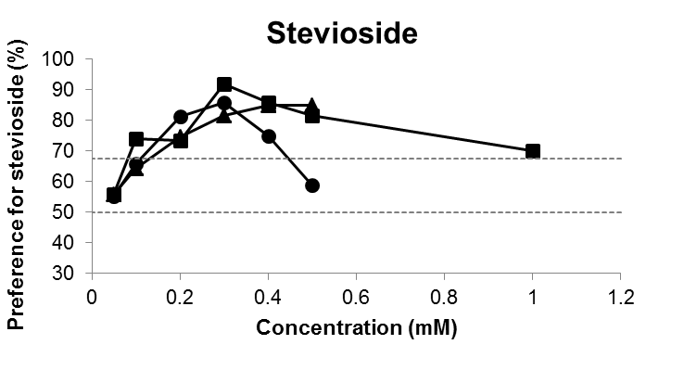
Figure 1. The taste preference of all three individuals for stevioside tested against tap water. Each data point (squares: S1; circles: S2; triangles: S3) represents the means value of 6 or 10 trials of 1 minute per animal. The dotted horizontal lines at 66.7 % and 50 % indicate the criterion of preference and the chance level, respectively

4.2 Rebaudioside A
The taste preference threshold for rebaudioside A was found to be at 0.05 mM for S1, and at 0.15 mM for both S2 and S3 (p<0.05, binomial test) (Figure 2). S3 was close to displaying a preference at 0.1 mM, with 69 % of the consumed liquid being rebaudioside A. However, a majority of the substance was consumed in only six out of the ten trials (p>0.05, binomial test).
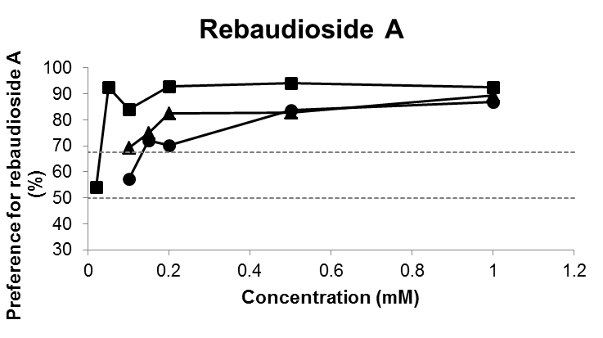
Figure 2. The taste preference of all three individuals for rebaudioside A tested against tap water. Each data point (squares: S1; circles: S2; triangles: S3) represents the mean value of 6 or 10 trials of 1 minute per animal. The dotted horizontal lines at 66.7 % and 50 % indicate the criterion of preference and the chance level, respectively.

4.3 Glycine
For glycine, the taste preference threshold was found to be at 15 mM for S1 and S2 (p<0.05, binomial test) (Figure 3). S3 died before the tenth trial of this concentration. He consumed a majority of the solution in 7 out of 9 trials, and with 66 % of the total consumption coming from the bottles containing glycine, he just missed the requirements for having a preference. He did, however, display a preference for glycine at 20 mM (p<0.05, binomial test). None of the three lemurs preferred glycine at 10 mM (p>0.05, binomial test).

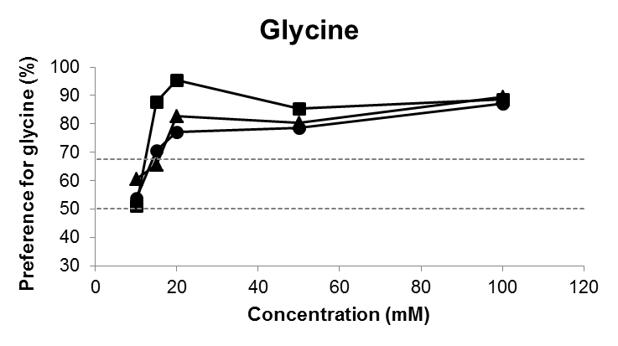
Figure 3. The taste preference of all three lemurs for glycine tested against tap water. Each data point (squares: S1; circles: S2; triangles: S3) represents the means value of 6 or 10 trials of 1 minute per animal. The dotted horizontal lines at 66.7 % and 50 % indicate the criterion of preference and the chance level, respectively.

4.4 L-alanine
The taste preference threshold for L-alanine was at 2 mM for S1 (p<0.05, binomial test) (Figure 4). However, S2 did not prefer L-alanine at any of the tested concentration, ranging from 200-2 mM (p>0.05, binomial test).

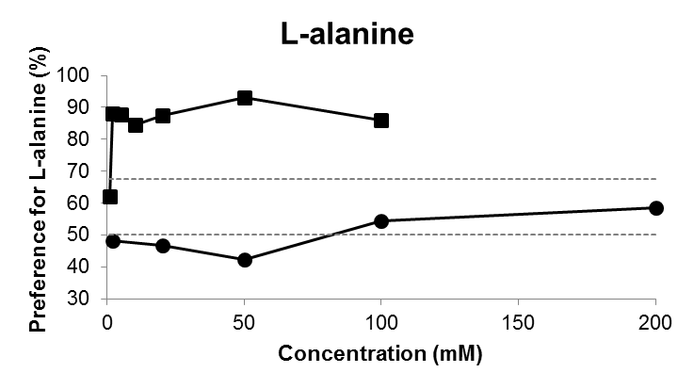
Figure 4. The taste preference of two lemurs for L-alanine tested against tap water. Each data point (squares: S1; circles: S2) represents the means value of 6 or 10 trials of 1 minute per animal. The dotted horizontal lines at 66.7 % and 50 % indicate the criterion of preference and the chance level, respectively.

4.5 L-proline
For L-proline, the taste preference threshold of S1 and S2 was 10 and 20 mM, respectively (p<0.05, binomial test) (Figure 5).

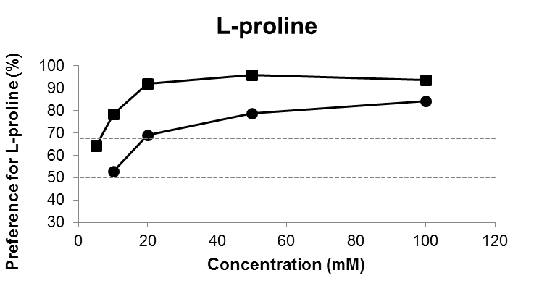
Figure 5. The taste preference of two lemurs for L-proline tested against tap water. Each data point (squares: S1; circles: S2) represents the means value of 6 or 10 trials of 1 minute per animal. The dotted horizontal lines at 66.7 % and 50 % indicate the criterion of preference and the chance level, respectively.

4.6 Polycose
The taste preference threshold for polycose was 40 mM for S1 and 30 mM for S2 (p<0.05, binomial test) (Figure 6).

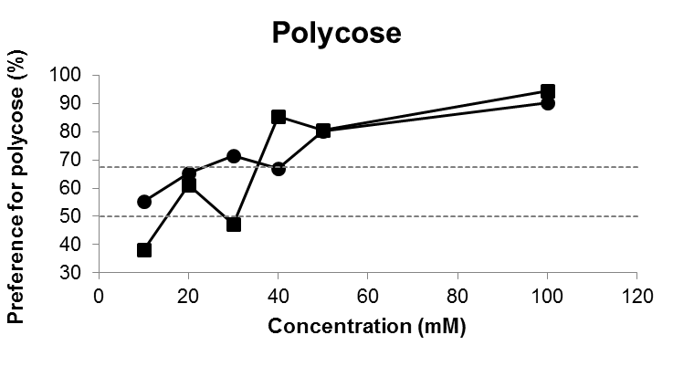
Figure 6. The taste preference of 2 lemurs for polycose tested against tap water. Each data point (squares: S1; circles: S2) represents the means value of 6 or 10 trials of 1 minute per animal. The dotted horizontal lines at 66.7 % and 50 % indicate the criterion of preference and the chance level, respectively.

4.7 D-sorbitol
The taste preference threshold for D-sorbitol was 30 mM for S1, whilst the lowest concentration the S2 preferred was 110 mM (p<0.05, binomial test) (Figure 7).

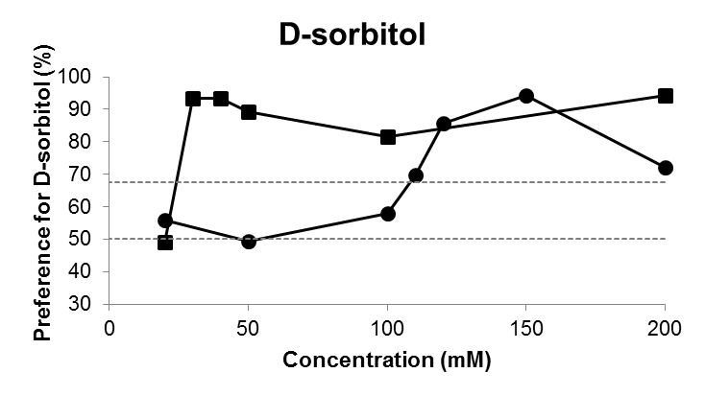
Figure 7. The taste preference of two lemurs for D-sorbitol tested against tap water. Each data point (squares: S1; circles: S2) represents the means value of 6 or 10 trials of 1 minute per animal. The dotted horizontal lines at 66.7 % and 50 % indicate the criterion of preference and the chance level, respectively.

4.8 Saccharin
No taste preference threshold was found for saccharin for any of the lemurs (Figure 8). Instead of a taste preference, a rejection for saccharin was found at a concentration of 1 mM for S1 (p<0.05, binomial test). Despite consuming less than 28% of saccharin at three additional concentrations (5, 0.5 and 0.2 mM), S1 consumed a majority of water in between 4 and 6 trials per concentration and therefore failed to meet one of the criteria for a rejection (p>0.05, binomial test). S2 showed neither a preference nor a rejection at any of the tested concentrations for saccharin (p>0.05, binomial test).

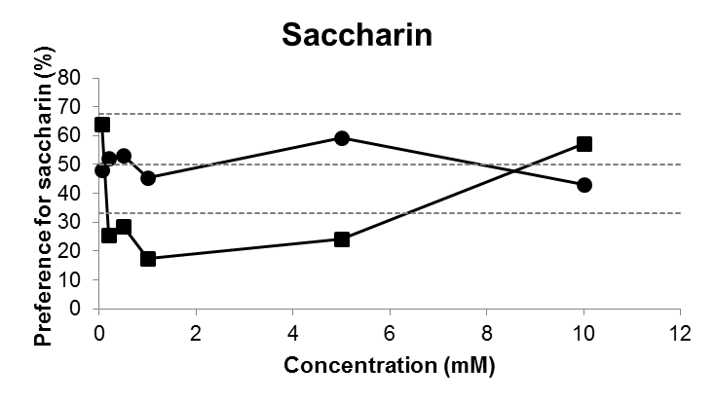
Figure 8. The taste rejection for saccharin tested against water. Each data point (squares: S1; circles: S2) represents the means value of 6 or 10 trials of 1 minute per animal. The dotted horizontal lines at 50 % and 33 % indicate the chance level and criterion for rejection, respectively.

4.9 Galactose
The taste preference threshold for galactose was found to be 70 and 90 mM for S1 and S2, respectively (p<0.05, binomial test) (Figure 9). Of the total consumption of liquid at 60 mM galactose, 80 % was from the solution for S1. However, only 7 out of 10 trials consisted of a majority of consumption of galactose (p>0.05, binomial test).

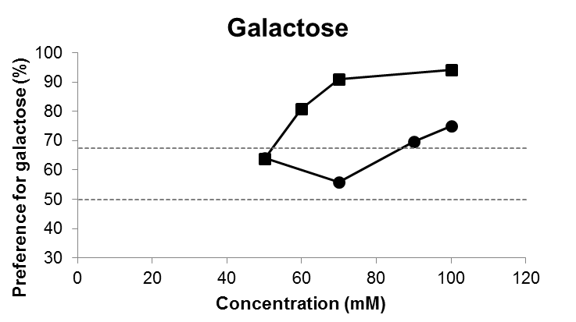
Figure 9. The taste preference of two black-and-white ruffed lemurs for galactose tested against tap water. Each data point (squares: S1; circles: S2) represents the means value of 6 or 10 trials of 1 minute per animal. The dotted horizontal lines at 66.7 % and 50 % indicate the criterion of preference and the chance level, respectively.

5. Discussion

In general, the results of the present study show that the black-and-white ruffed lemurs prefer the taste of the majority of the tested substances that humans perceive as sweet tasting, over water. Nevertheless, some exceptions were found. Neither of the two lemurs that participated in the experiment with the artificial sweetener saccharin displayed any preference at all for this substance. Additionally, S2 did not prefer L-alanine at any of the tested concentrations of this amino acid.

5.1 The taste preference threshold for galactose, polycose and three amino acids
Table 1 summarizes the taste preference thresholds of different primate species for the five substances galactose, polycose, glycine, L-proline and L-alanine.

Table 1. Taste preference thresholds (in mM) of primate species for galactose, polycose, glycine, L-proline and L-alanine. Concentrations followed by an asterisk indicate that the species preferred the substance at that given concentration, however, there is no data on the taste preference threshold for that species and substance. Two asterisks after a concentration indicate the detection threshold.
Species | Galactose | Polycose | Glycine | L-proline | L-alanine | Reference
Varecia variegata | 70-90 | 30-40 | 15-20 | 10-20 | 2 | This study
Ateles geoffroyi |  | 30 | 40 | 10 | 80 | Laska et al. (2001), Larsson et al. (2014)
Callithrix jacchus |  |  | 500, 890* | No pref. | No pref. | Haefeli et al. (1998), Nofre et al. (1996)
Papio hamadryas anubis |  | 30 | 890* |  |  | Laska et al. (2001), Nofre et al. (1996)
Macaca nemestrina |  | 10 |  |  |  | Laska et al. (2001)
Saimiri sciureus |  | 60 | 890* |  |  | Laska et al. (2001), Nofre et al. (1996)
Homo sapiens | 10-39** | 3.2-10* | 30.9** | 15.1** | 16.2** | Van Gemert (2011), Hettinger et al. (1996), Schiffman et al. (1981)

In the present study, the monosaccharide galactose was preferred at 70-90 mM by the two black-and-white ruffed lemurs. The taste preference threshold of these individuals for the other three monosaccharides (fructose, glucose and maltose) have been tested by Wielbass et al. (2015), with the thresholds being 25-50 mM for fructose, and 50 mM for maltose and for glucose. To the best of my knowledge, there are no previous studies that have tested whether or not members of the primate order, with the exception of humans, prefer the taste of galactose. However, in the Rhesus monkey (M. mulatta), galactose elicits similar nerve fibre activity as glucose does (Hellekant et al. 1997a), indicating that M. mulatta perceives both glucose and galactose in a similar manner. Humans are able to detect galactose at less than half of the preference threshold concentration that the black-and-white ruffed lemurs had in this study (van Gemert 2003). However, as the taste preference threshold of an animal for any given substance is only a conservative approximation of the detection threshold, it is possible that the detection threshold of the lemurs for galactose is lower than their preference threshold.

The taste preference threshold of the black-and-white ruffed lemurs for polycose was found to be at 30-40 mM, in the present study. Both the frugivorous spider monkeys (Ateles geoffroyi) and the omnivorous olive baboons (Papio hamadryas anubis) have a reported taste preference threshold of 30 mM polycose (Laska et al. 2001). The frugivorous, but opportunistic, pigtail macaques (Macaca nemestrina), on the other hand, have a lower threshold of 10 mM. The fruit and insect eating squirrel monkeys (Samiri sciureus) have the highest taste preference threshold (60 mM), compared to the other tested primate species. Out of these five species of non-human primates, the black-and-white ruffed lemur has neither the lowest nor the highest taste preference threshold for polycose. The black-and-white ruffed lemur is thought to rely mostly on simple sugars and fat for meeting its energy requirement (Schmidt et al. 2010), and it is therefore not surprising that species with less starch-rich diets, i.e. the squirrel monkey, has a higher threshold (Laska et al. 2001). It is also expected that species with more starch-rich diets, i.e. pigtail macaques and humans, have a lower threshold for polycose. Indeed, rodents that have a starch-rich diet consume significantly more polycose solutions compared to water and in some species even more than equimolar sucrose solutions, at concentrations as low as 1 mM (Feigin et al. 1987). Among the primate species that have been tested so far, humans prefer polycose at concentrations below that of other species’ preference threshold (Hettinger et al. 1996). To humans, however, polycose has been reported to taste similar to maltose (Hettinger et al. 1996). It has long been thought that the only carbohydrates that we can taste are mono- and disaccharides, in contrast to rodents that have an additional receptor for more complex carbohydrates (Giza et al. 1991). However, there is new support to the idea that humans might also have a polysaccharide receptor, separate from the sweet one (Lapis et al. 2014).

The taste preference thresholds of the black-and-white ruffed lemurs for the three amino acids that were included in the present study were at 10-20 mM for L-proline and 15-20 mM for glycine. L-alanine was only preferred by one of the lemurs, with a taste preference threshold of 2 mM, whilst the other lemur had no preference, nor rejection, for L-alanine at any of the tested concentration (2-200 mM). In comparison, spider monkeys (Ateles geoffroyi) have a similar taste preference threshold for L-proline as the black-and-white ruffed lemurs had (Larsson et al 2014). On the other hand, the spider monkeys prefer both glycine and L-alanine at higher concentrations than the black-and-white ruffed lemurs in this study does. The largest difference in taste preference threshold between these two species for the three above-mentioned amino acids is that of L-alanine. Not only is there a difference between the species (2 mM compared to 80 mM), there is also a large inter-individual difference for the black-and-white ruffed lemur. The common marmosets, on the other hand, did not show any preference for any L-amino acids, and only preferred glycine and D-amino acids to water (Haefeli et al. 1998, Nofre et al. 1996). The black-and-white ruffed lemurs participating in this study preferred glycine at concentrations below the human detection threshold (Schiffman et al., 1981). L-alanine was also preferred by one of the lemurs at concentrations one magnitude below that of the human detection threshold. On the other hand, the taste preference threshold for L-proline was approximately the same as the human detection threshold. However, as previously mentioned, the taste preference threshold is but an approximation of the detection threshold. Thus, the difference in sensitivity for these three amino acids may be even larger between the black-and-white ruffed lemurs and humans.

It has been hypothesised that a more specialized diet will lead to some losses in the range of a species’ taste abilities (Breslin 2013). The spider monkey is considered to be a highly frugivorous primate species (González-Zamora et al. 2009), although they are not as frugivorous as the black-and-white ruffed lemur (Britt, 2000). Larsson et al. (2014) argued that one explanation why the spider monkeys preferred some of the amino acids, whereas the insectivorous and gummivorous common marmosets displayed no preferences for any L-amino acids could be because the spider monkeys feed on a diet which is low in protein. The common marmosets, on the other hand, have a diet rich in protein. The findings from the present study lend support to this idea as the black-and-white ruffed lemur had similar, or even lower, thresholds than the spider monkeys for the tested amino acids.

5.2 The taste preference threshold for sorbitol, stevioside, rebaudioside A and taste rejection threshold for saccharin
The taste preference thresholds of different primate species for sorbitol, stevioside, rebaudioside A and saccharin are summarized in table 2. These four substances are all used commercially as sweeteners in a variety of human food.

Table 2. The taste preference threshold (in mM) of humans and black-and-white ruffed lemurs for four substances: sorbitol, stevioside, rebaudioside A and saccharin. A concentration with two asterisks indicates a detection threshold, and three asterisks indicate a taste rejection threshold (in mM)
Species | Sorbitol | Stevioside | Rebaudioside A | Saccharin | Reference
Varecia variegata | 30-110 | 0.1-0.2 | 0.05-0.15 | 1*** | This study
Homo sapiens | 10.6-36.7** | 0.008 | 0.011 | 0.006-0.03** | Van Gemert (2011), Hellfritsch et al. (2012)

As with several of the other substances included in this study, the taste preference threshold of non-human primates for the sugar alcohol sorbitol has not previously been assessed behaviourally, and only a few studies have tested whether or not non-human primates are able to detect sorbitol neurophysiologically (Plata Salamán et al. 1993). However, in the present study, the black-and-white ruffed lemurs were able to detect the sorbitol and preferred it to water with a taste preference threshold of 30 mM for one of them and 110 mM for the other one. The detection threshold for humans is between 10 and 37 mM, and sorbitol is approximately 0.6 times as sweet as sucrose (Van Gemert 2011, Bakal & O’Brien Nabors 2012). The taste preference threshold of the black-and white ruffed lemurs for sorbitol was approximately 0.5-0.8 times as high as their threshold for sucrose (Wielbass et al. 2015). However, without an experiment on the relative preference for these substances it is difficult to draw any conclusion with regards to how sweet sorbitol is compared to sucrose for the lemurs.

All three lemurs preferred stevioside at a concentration of 0.1-0.2 mM, and rebaudioside A was preferred between 0.05-0.15 mM. As with galactose, neither of these two substances has been tested on any other primate species, except humans, for a taste preference. Humans are more sensitive to stevioside than the black-and-white ruffed lemurs. In fact, the taste preference threshold of humans and of black-and-white ruffed lemurs for stevioside differs by one order of magnitude (Hellfritsch et al. 2012). Although the threshold for rebaudioside A is also lower for humans than that of the lemurs, this threshold value is within the same order of magnitude for one of the individuals. However, for the other two individuals there is a difference of one order of magnitude compared to the human threshold. Studies of nerve fibre responses in non-human primate species to a large variety of different substances showed that both strepsirrhini (e.g. Microcebus murinus: Hellekant et al. 1993) as well as haplorrhini species (e.g. chimpanzee (Pan troglodytes): Hellekant et al. 1997b) are able to detect stevioside at a millimolar level. However, the present study is the first to test the taste response to stevioside behaviourally, as well as at such low concentrations, in a non-human primate species. Stevia rebaudiana is endemic to South America (Katayama et al. 1976), and it is therefore likely that lemurs have not encountered any of the stevioglycosides during their evolutionary history. Both haplorrhini and strepsirrhini are able to detect stevioglycosides, and at least humans and black-and-white ruffed lemurs prefer them at a milli- and micromolar level. The most parsimonious explanation that arises is that the common ancestor of both suborders of primates was able to detect, and perhaps even prefer the taste of stevioglycosides, or substances of similar molecular structure.

An unexpected result of the present study is that S2 did not prefer stevioside at 0.5 mM, whereas the other individuals did. S1 was also tested at an even higher concentration, 1 mM, at which he still displayed a preference for stevioside over tap water. For humans, several sweeteners have been shown to have a bitter side taste that is positively correlated with the concentration of the substance (Schiffman et al. 1995). This is true for both stevioside, as well as rebaudioside A, with stevioside having a more prominent bitter side taste. S2 could be more sensitive to a bitter taste than the other two individuals, thus resulting in him not preferring stevioside at higher concentrations. There were no indications that rebaudioside A would not be preferred by any of the tested lemurs at a higher concentration. However, the highest tested concentration for both rebaudioside A, as well as for stevioside, was 1 mM. It is therefore possible that the stevioglycosides would not be preferred, or perhaps even rejected, if higher concentrations were tested in future studies. In general, the lemurs appeared to be much more keen to consume rebaudioside A than stevioside (personal observation).

Neither of the two lemurs that participated in the experiment with saccharin displayed any preference at all for this substance, despite being tested at a broad range of concentrations. In fact, S1 rejected saccharin at 1 mM, and nearly passed the criteria for a rejection at 5, 0.5 and 0.2. It is, however, possible that the lemurs would show a rejection at more concentrations of saccharin if a solution of sucrose was used as a solvent for saccharin as well as the alternative stimulus. This type of experiment has been performed with spider monkeys when assessing their responsiveness to bitter substances (e.g. Larsson et al. 2014). The spider monkeys will not cooperate in two-bottle preference tests if they do not find at least one of the substances palatable, and the lemurs in the present study were less interested in consuming any liquid during the trials in which saccharin was presented. The strepsirrhini species, gray mouse lemur (M. murinus), displayed no preference for saccharin (Schilling et al. 2004). However, only one concentration was tested in that study. This makes it difficult to determine whether it was the concentration that resulted in a lack of preference, or if they indeed did not prefer the substance itself. In an earlier study, the same research group did, however, find that the chorda tympani proper nerve in M. murinus responded to sodium saccharin at a concentration of 1.6 mM (Hellekant et al. 1993). However, as it was not pure saccharin, but sodium saccharin that was tested in that study, the nerve response might have been due to the sodium ion and not the saccharin.

The results from both the present study as well as other studies (Hellekant et al. 1997; Schiffman et al. 1995; Schilling et al. 2004), indicate that there could be a difference in sweet taste perception between lemurs and Old World monkeys (e.g. Macaca mulatta) and apes (e.g. humans). The latter two prefer the taste of saccharin at certain concentrations, whilst the lemurs appear to lack this preference, and perhaps even disliking it.

5.3 General individual differences
Personal observations that were made during the trials with saccharin and stevioside indicated that both individuals were able to determine whether or not it was a substance that they did not like, or a too high concentration. If they did not like the substance, or if the concentration was too high they would need only one trial to decide if they did not like the taste of it and to recognise the smell of it. Usually when they did not like it, they would smack their lips together a few times, and then be unwilling to taste it again. During the following trials with this particular substance, and concentration, they only needed a sniff and sometimes a quick sip to decide if they liked it or not.

A general difference between S1 and S2 was that S1, in most cases, consumed more liquid than S2. This was also true for the tap water and substances presented at lower concentrations for which no preferences, nor rejections, were found. The fact that only S1, and not S2, passed the criteria for rejection of saccharin could therefore simply be because S1 consumed water instead when the substance had an aversive taste, whilst S2 stopped drinking from both of the bottles presented to him as soon as he noticed that one of the bottles contained a substance with an aversive taste. This would also offer an explanation as to why S2 failed to show any preference or rejection for stevioside at the highest concentration, as well as his complete lack of preference and rejection for L-alanine.

The low sample size of the present study is, of course, a problem when trying to generalize to the species-level. However, there is not much known with regard to taste responsiveness in non-human primates to the tested substances. In fact, for several of these substances this is the first study to assess the taste preferences of non-human primate species. The results provided here indicate that the species is indeed able to detect these sweet-tasting substances and preferred the majority of them. With only one exception, L-alanine, the individuals preferred the same substances. Thus, it is likely that other members of this species would prefer these substances as well. However, there is, of course, a great need to test more individuals of this species in order to further make any conclusions with regards to a preference at a species level.

5.4 Rejected and non-preferred substances
The three substances that the black-and-white ruffed lemurs either rejected at some concentrations, or displayed neither a preference nor a rejection at any concentrations, L-alanine, saccharin and stevioside, all have in common that they have been described as having a bitter side taste for humans (Schiffman et al. 1981, Schiffman et al. 1995). This is also true for rebaudioside A (Schiffman et al. 1995), however, the results of the present study did not indicate that the lemurs would perceive it as equally bitter as stevioside. Indeed, for humans, stevioside is perceived as more bitter than rebaudioside A (Bakal & O’Brien Nabors 2012). In general, S2 appeared to be more sensitive to a bitter taste as he showed no preference at all for L-alanine and did not prefer stevioside at the highest concentration whereas S1 and S3 did prefer it.

The taste responsiveness, not to mention the taste preference threshold, of non-human primates have so far, with the exception of the present study, only been assessed for four of the nine tested substances. This is also the only strepsirrhini species that has been tested for any of the substances included in this study, with the exception of glycine. Thus, there is still much research needed in order to understand how the mechanisms of the sense of taste has evolved in primates.

5.5 Conclusion
The black-and-white ruffed lemurs preferred eight of the nine sweet-tasting substances that were tested during this study when tested against water. There were mixed results for the preference for saccharin and L-alanine, with one animal showing neither preference nor rejection whereas the other showed a rejection for the former and a preference for the latter substance. Interestingly, the black-and-white ruffed lemur displayed a preference for both of the tested stevioglycosides, despite the fact that the lemurs most likely have never been exposed to these substances, as they are endemic to different continents. More research is needed on the taste responsiveness of non-human primates for a wide variety of substances, including the nine sweet-tasting ones tested in the present study, if we are to understand how the sense of taste has evolved within the primate order.

5.6 Societal and ethical considerations
The experiments conducted in the present study comply with the Guide for the Care and Use of Laboratory Animals (National Institutes of Health Publication no. 86-23, revised 1996), and also with the current Swedish laws. They were performed according to a protocol approved by the ethical board of the Swedish Board of Agriculture (Jordbruksverket, protocol # 31-2647/10).

The animals that participated in this study were not forced to do so in any way. The experiments were completely dependent upon their willingness to cooperate. They could, and occasionally did, leave the smaller enclosure before a session was completed, and could also choose not to participate at all in the experiments. The substances that were tested during the present study are all approved for human consumption. As the aim of the study was to determine taste preference thresholds, the tested concentrations of the nine substances were not regarded as harmful to the lemurs. The veterinarians at Kolmården Wildlife Park were informed and updated about the concentrations, substances and behaviour of the lemurs in order to ensure the health of the lemurs.

6. Acknowledgements
I would like to thank my supervisor Matthias Laska for the help and assistance during the entire project, from planning to writing. I would also like to thank Mats Amundin for the support and help during the experiments. Finally, I would like to thank the veterinarians, the primate caretakers and the rest of the staff at Kolmården Wildlife Park for being of assistance with the more practical problems that arose during the project.

7. References

Bachmanov, A.A., Tordoff, M.G., Beauchamp, G.K., 2001. Sweetener preference of C57BL/6ByJ and 129P3/J mice. Chemical Senses 26, 905-913.

Bakal, A.I., O'Brien Nabors, L., 2012. Saccharin. Alternative Sweeteners, 151-158.

Breslin, P.A.S., 2013. An Evolutionary Perspective on Food and Human Taste. Current Biology 23, R409-R418.

Britt, A., 2000. Diet and feeding behaviour of the black-and-white ruffed lemur (Varecia variegata variegata) in the Betampona Reserve, eastern Madagascar. Folia Primatologica 71, 133-141.

CabreVert, N., Feistner, A.T.C., 1995. Comparative gut passage time in captive lemurs. Dodo-Journal of the Wildlife Preservation Trusts, 76-81.

Danilova, V., Hellekant, G., 2004. Sense of taste in a New World monkey, the common marmoset. II. Link between behavior and nerve activity. Journal of Neurophysiology 92, 1067-1076.

Danilova, V., Hellekant, G., Tinti, J.M., Nofre, C., 1998. Gustatory responses of the hamster Mesocricetus auratus to various compounds considered sweet by humans. Journal of Neurophysiology 80, 2102-2112.

Edwards, M.S., Ullrey, D.E., 1999. Effect of dietary fiber concentration on apparent digestibility and digesta passage in non-human primates. I. Ruffed Lemurs (Varecia variegata vauiegata and V-v. rubra). Zoo Biology 18, 529-536.

Feigin, M.B., Sclafani, A., Sunday, S.R., 1987. Species-differences in polysaccharide and sugar taste preferences. Neuroscience and Biobehavioral Reviews 11, 231-240.

Geuns, J.M.C., 2003. Stevioside. Phytochemistry 64, 913-921.

Giza, B.K., Scott, T.R., Sclafani, A., Antonucci, R.F., 1991. Polysaccharides as taste stimuli – Their effect in the nucelus-tractus-solitarus of the rat. Brain Research 555, 1-9.

Glaser, D., Hellekant, G., Brouwer, J.N., Vanderwel, H., 1978. Taste responses in primates to proteins thaumatin and monellin and their phylogenetic implications. Folia Primatologica 29, 56-63.

Glaser, D., Tinti, J.M., Nofre, C., 1995. Evolution of the sweetness receptor in primates. 1. Why does alitame taste sweet in all prosimians and simians, and aspartame only in Old-World simians. Chemical Senses 20, 573-584.

Gonzalez-Zamora, A., Arroyo-Rodriguez, V., Chaves, O.M., Sanchez-Lopez, S., Stoner, K.E., Riba-Hernandez, P., 2009. Diet of Spider Monkeys (Ateles geoffroyi) in Mesoamerica: Current Knowledge and Future Directions. American Journal of Primatology 71, 8-20.

Goodman, M., Porter, C.A., Czelusniak, J., Page, S.L., Schneider, H., Shoshani, J., Gunnell, G., Groves, C.P., 1998. Toward a phylogenetic classification of primates based on DNA evidence complemented by fossil evidence. Molecular Phylogenetics and Evolution 9, 585-598

Gordesky-Gold, B., Rivers, N., Ahmed, O.M., Breslin, P.A.S., 2008. Drosophila melanogaster prefers compounds perceived sweet by humans. Chemical Senses 33, 301-309.

Haefeli, R.J., Solms, J., Glaser, D., 1998. Taste responses to amino acids in common marmosets (Callithrix jacchus jacchus, Callitrichidae) a non-human primate in comparison to humans. Food Science and Technology-Lebensmittel-Wissenschaft & Technologie 31, 371-376.

Hellekant, G., Danilova, V., 1999. Taste in domestic pig, Sus scrofa. Journal of Animal Physiology and Animal Nutrition 82, 8-24.

Hellekant, G., Danilova, V., Ninomiya, Y., 1997a. Primate sense of taste: Behavioral and single chorda tympani and glossopharyngeal nerve fiber recordings in the rhesus monkey, Macaca mulatta. Journal of Neurophysiology 77, 978-993.

Hellekant, G., Hladik, C.M., Dennys, V., Simmen, B., Roberts, T.W., Glaser, D., Dubois, G., Walters, D.E., 1993. On the sense of taste in two Malagasy primates (Microcebus murinus and Eulemur mongoz). Chemical Senses 18, 307-320.

Hellekant, G., Ninomiya, Y., Danilova, V., 1997b. Taste in chimpanzees .2. Single chorda tympani fibers. Physiology & Behavior 61, 829-841.

Hellfritsch, C., Brockhoff, A., Stahler, F., Meyerhof, W., Hofmnann, T., 2012. Human Psychometric and Taste Receptor Responses to Steviol Glycosides. Journal of Agricultural and Food Chemistry 60, 6782-6793.

Hettinger, T.P., Frank, M.E., Myers, W.E., 1996. Are the tastes of polycose and monosodium glutamate unique? Chemical Senses 21, 341-347.

Jakinovich, W., Sugarman, D., 1988. Sugar taste reception in mammals. Chemical Senses 13, 13-31.

Lambert, J.E., 1998. Primate digestion: Interactions among anatomy, physiology, and feeding ecology. Evolutionary Anthropology 7, 8-20.

Lapis, T.J., Penner, M.H., Lim, J., 2014. Evidence that Humans Can Taste Glucose Polymers. Chemical Senses 39, 737-747.

Laska, M., 2002. Gustatory responsiveness to food-associated saccharides in European rabbits, Oryctolagus cuniculus. Physiology & Behavior 76, 335-341.

Laska, M., Kohlmann, S., Scheuber, H.P., Salazar, L.T.H., Luna, E.R., 2001. Gustatory responsiveness to polycose in four species of nonhuman primates. Journal of Chemical Ecology 27, 1997-2011.

Lee, J., 2015. Sorbitol, Rubus fruit, and misconception. Food Chemistry 166, 616-622.

Martin, R.D., 2000. Origins, diversity and relationships of lemurs. International Journal of Primatology 21, 1021-1049.

Megeji, N.W., Kumar, J.K., Singh, V., Kaul, V.K., Ahuja, P.S., 2005. Introducing Stevia rebaudiana, a natural zero-calorie sweetener. Current Science 88, 801-804.

Nofre, C., Tinti, J.M., Glaser, D., 1996. Evolution of the sweetness receptor in primates .2. Gustatory responses of non-human primates to nine compounds known to be sweet in man. Chemical Senses 21, 747-762.

Richter, C.P., Campbell, K.H., 1940. Taste thresholds and taste preferences of rats for five common sugars. Journal of Nutrition 20, 31-46.

Schiffman, S.S., Booth, B.J., Losee, M.L., Pecore, S.D., Warwick, Z.S., 1995. Bitterness of sweeteners as a function of concentration. Brain Research Bulletin 36, 505-513.

Schiffman, S.S., Sennewald, K., Gagnon, J., 1981. Comparison of taste qualities and thresholds of D-amino and L-amino acids. Physiology & Behavior 27, 51-59.

Schilling, A., Danilova, V., Hellekant, G., 2004. Behavioral study in the gray mouse lemur (Microcebus murinus) using compounds considered sweet by humans. American Journal of Primatology 62, 43-48.

Schmidt, D.A., Iambana, R.B., Britt, A., Junge, R.E., Welch, C.R., Porton, I.J., Kerley, M.M., 2010. Nutrient composition of plants consumed by black and white ruffed lemurs, Varecia variegata, in the Betampona Natural Reserve, Madagascar. Zoo Biology 29, 375-396.

Sclafani, A., Bahrani, M., Zukerman, S., Ackroff, K., 2010. Stevia and Saccharin Preferences in Rats and Mice. Chemical Senses 35, 433-443.

Sclafani, A., Clyne, A.E., 1987. Hedonic response of rats to polysaccharide and sugar solutions. Neuroscience and Biobehavioral Reviews 11, 173-180.

Sunderland, G., Sclafani, A., 1988. Tast preferences of squirrel-monkeys and bonnet macaques for polycose, maltose and sucrose. Physiology & Behavior 43, 685-690.

van Gemert, L.J., 2011. Flavour Thresholds: Compilation of Flavor Threshold Values in Water and Other Media, Oliemans Punter & Partners BV Utrecht, The Netherlands, p. 476.

Wielbass, A., Amundin, M., Laska, M., 2015 (in press). Gustatory responsiveness of black-and-white ruffed lemurs (Varecia variegata variegata) to food-associated sugars. International Journal of Primatology.

Wolwer-Rieck, U., 2012. The Leaves of Stevia rebaudiana (Bertoni), Their Constituents and the Analyses Thereof: A Review. Journal of Agricultural and Food Chemistry 60, 886-895.

