Department of Physics, Chemistry and Biology

Master Thesis
Behavioral differences in dog-human communication in the Labrador retriever
Lise-Lotte Halldén
LiTH-IFM- Ex--__/____--SE

Supervisor: Per Jensen, Mia Persson, Linköping University
Examiner: Hanne Løvlie, Linköping University
Department of Physics, Chemistry and Biology
Linköpings universitet
SE-581 83 Linköping, Sweden

Institutionen för fysik, kemi och biologi
Department of Physics, Chemistry and Biology

Avdelningen för biologi
Instutitionen för fysik och mätteknik
Rapporttyp
Report category

Examensarbete
D-uppsats
Språk/Language
Engelska/English
Titel/Title:
Behavioral differences in dog-human communication in the Labrador retriever

Författare/Author:
Lise-Lotte Halldén
Sammanfattning/Abstract:
Dogs have been domesticated for more than 14000 years, and have through evolution developed good communicative skills. Both concerning understanding communicative cues from humans and displaying human-directed contact seeking behaviors. However, selection is constantly changing according to human needs, and no relationship between behavior and original usage of the breed was found when looking at 31 different breeds in the Swedish dog population. This makes the Labrador retriever an interesting breed since it have been divided into two lineages with focus on different traits. Therefore, this study evaluates whether there are any behavioral differences between the two types concerning human-directed contact seeking behaviors, accuracy during pointing task, diligence and intensity. 101 Labradors were included in the present study and underwent a problem-solving task and a pointing test. The results revealed that hunting Labradors appeared more secure, were more active and engaged in more human-directed contact seeking behaviors compared to show Labradors. Hunting Labradors had a shorter latency to approach the bucket in the pointing test, while show Labradors showed a tendency to spend more time interacting with the test setup in the problem solving. In conclusion, since the types only have been separated for 40 years this study suggests that behavioral differences emerge early in the process of breeding with specific behavioral traits in mind.
ISBN
LITH-IFM-A-EX—99/1111—SE
__________________________________________________
ISRN
__________________________________________________

Serietitel och serienummer ISSN
Title of series, numbering

Handledare/Supervisor Per Jensen, Mia Persson

Ort/Location: Linköping
Nyckelord/Keyword:
Canis familiaris, dog-human communication, Labrador retriever, pointing test, problem-solving task
Datum/Date

2015-06-xx
URL för elektronisk version

Content
1 Abstract 2
2 Introduction 2
3 Material & methods 4
3.1 Animals 4
3.2 Testing procedure 5
3.2.1 Problem solving task 6
3.2.2 Pointing test 8
3.3 Data collection 10
3.4 Statistical analysis 13
4 Results 14
4.1 General differences between types during problem solving 14
4.2 Interaction with test setup 15
4.3 Contact seeking behaviors 17
4.4 Pointing test 18
4.5 Correlations 20
5 Discussion 22
5.1 Societal & ethical considerations 25
5.2 Conclusions 26
6 Acknowledgement 26
7 References 28

Abstract
Dogs have been domesticated for more than 14000 years, and have through evolution developed good communicative skills. Both concerning understanding communicative cues from humans and displaying human-directed contact seeking behaviors. However, selection is constantly changing according to human needs, and no relationship between behavior and original usage of the breed was found when looking at 31 different breeds in the Swedish dog population. This makes the Labrador retriever an interesting breed since it have been divided into two lineages with focus on different traits. Therefore, this study evaluates whether there are any behavioral differences between the two types concerning human-directed contact seeking behaviors, accuracy during pointing task, diligence and intensity. 101 Labradors were included in the present study and underwent a problem-solving task and a pointing test. The results revealed that hunting Labradors appeared more secure, were more active and engaged in more human-directed contact seeking behaviors compared to show Labradors. Hunting Labradors had a shorter latency to approach the bucket in the pointing test, while show Labradors showed a tendency to spend more time interacting with the test setup in the problem solving task. In conclusion, since the types only have been separated for 40 years this study suggests that behavioral differences emerge early in the process of breeding with specific behavioral traits in mind.

Introduction
One of our closest companions in today’s society, the dog, is believed to be the first animal being domesticated (Savolainen, 2007, Freedman et al. 2014). The earliest fossils indicate that domesticated dogs were already present in our society 12 000 - 14000 years ago in Eurasia (Leonard et al. 2002). During this time, human selection differentiated dogs into several breeds, where archaeological evidence show morphologically different dogs even in ancient Egypt 4000 years ago. Additionally, researchers have discovered evidence suggesting that Romans selected for dog breeds in the first century a.d (Clutton-Brock, 1999). Different breeds are selected for different traits, and different personalities arise along with this (Svartberg et al. 2005). In Sweden, one way to assess dog’s personality is to have the dog undergo a BPD – “Behavior and Personality description Dog” (Svenska Kennelklubben, 2015). It is a subjective personality description based on 8 different subtests designed to evaluate the dogs’ reaction and behavior across different contexts.
Regardless to different breeds and different personalities the long history together with humans probably led humans and dogs to develop similar cognitive abilities (Miklósi et al. 2000). It is shown that dogs are very good at understanding pointing cues from humans (Soproni et al. 2001). Miklósi et al. (2003) show that this feature is prominent in dogs, as wolfs do not have this ability to the same extent, and Hare et al. (2002) show that dogs outperform chimpanzees when searching for food using human communicative cues. McKinley and Sambrook (2000) concluded that dogs understand pointing cues even when the experimenter is placed closer to the incorrect object, not pointed at. There are also studies showing that dogs display human-directed contact seeking behaviors by gazing at humans when faced with an unsolvable problem (Gaunet 2008, Savalli et al. 2014). An unsolvable problem could for example be an object that is unreachable for the dog, which then gaze at humans as a communicative cue – asking for help (Miklosi et al. 2003, Passalacqua et al. 2011). Horn et al. (2011) show that the intensity of help seeking behaviors made by the dog depends on the owners’ behavior. These examples are cases of communication and interaction between humans and dogs, and show that dogs not only understand cues given by humans, but also try to communicate back.
How these social skills have arisen are still unclear, and there are two hypotheses about its origin. One theory argues that the selection was focused on tameness, and that other traits followed along with this. For example, it has been shown that foxes specifically selected on tameness, are as skilled as dogs in reading human social cues (Hare et al. 2005). The other theory implies that humans directly selected for specific skills of social cognition and communication with humans (Topál et al. 1998).
However, Svartberg (2006) shows that selection is constantly changing according to human needs, and that no relationship between behavior and original usage of the breed was found when looking at 31 different breeds in the Swedish dog population. This means that selection in the recent past highly affects behavior and appearance of the breeds. Svartberg’s conclusion makes it interesting to investigate what happens within a breed that has recently been divided into two types. This is namely the case with the Labrador retriever.
The Labrador retriever has its origin in Canada, where the ancestor of the Labrador was used by Canadian fishermen to retrieve mooring lines and escort boats to land (Labrador retrieverklubben, 2015). When Englishmen visited Canada they brought these dogs to England and mixed them with other retriever breeds in order to improve the breed into a proper retrieving gundog. The Labrador retriever was accepted as a breed by the English kennel club in 1903(Svenska Kennelklubben, 2015).
During the 1970s, the popularity for the Labrador retriever increased substantially, and a desire to divide the breed into two lineages emerged shortly thereafter (Labrador retrieverklubben, 2015). The reason for this division was the increased interest in different qualities ascribed to the breed. Some breeders decided to focus on the breeds retrieving traits while others concentrated on more complexional traits (Svenska Kennelklubben, 2015).
Against this background, the overall aim of the present study is to investigate potential behavioral differences concerning dog-to-human communication between the two lineages of Labrador retriever; hunting Labradors and show Labradors. This is done by performing a problem solving task and a pointing task on Labradors that just underwent a BPD. With these tests I can investigate whether there are any differences in human-directed contact seeking behaviors, accuracy during pointing task, diligence and intensity between the two lineages. This can potentially show the behavioral effects of the recent breeding into two different directions in the Swedish Labrador Retriever.

Material & methods

Animals
In order to investigate whether there are any behavioral differences between the two types of Labradors, pet dogs were recruited trough advertising in social media. Not all entrants were included in the study, just dogs with a pedigree fulfilling our criterion for being a hunting Labrador or a show Labrador. This criterion was met if, in the pedigree, there was a consistency in achievements for relatives three generations back in the pedigree. For hunting Labradors there had to be hunting trial achievements, and for show Labradors achievements from dog shows, giving the dog a title of the achievement in the pedigree name. No mixture of hunting trial and dog show achievements in the pedigree was accepted. In that case, the dog counted as a dual purpose, and did not qualify for this study.
In total, 101 dogs were recruited to participate in this study. Out of these dogs, 52 were show Labradors (28 females and 24 males) and 49 were hunting Labradors (25 females and 24 males). The age of the dogs ranged from 1-4 years old (Median age, show: 1,59 years, Median age, hunt: 1,54 years). Prior to the testing the owner of all dogs filled out a formulary with information about the dog; e.g. name, registration number and age.
A hunting Labrador female was excluded from both experiments because we were unable to make her walk in to the marquee where the experiments were performed. Also, one show Labrador male was excluded from the pointing task after the first session because he had not chosen a bucket in any of the repetitions.

Testing procedure
Prior to testing, all dogs underwent the BPD designed by the Swedish kennel club (see introduction). The BPD was arranged at 6 different locations throughout Sweden, and our testing was divided into 10 occasions.
The behavior tests were performed in a marquee with the size 3x3 meters, bought at Biltema (item number 14-318). Three of the marquees’ sides had walls, bought at Biltema (item number 14-319), while one side was open, and there was no floor in the marquee. In order to keep the dog inside the marquee during the testing, grids bought at Biltema (item number 45-313) was placed as a barrier. The reason for using a marquee during testing was partly to control the allowed area in which the dog could act, and partly to uniform the environment since the testing was performed in 6 different locations.
Both experiments were continuously recorded with a full HD camcorder (Canon Legria HF G25) put on a tripod placed two meters in front of the front left corner of the marquee. Every dog got an ID with number and name, which was showed on a paper every time video recording started.
In both experiments quarter pieces of FROLIC® were used as treats. One of the participating dogs suffered from a food allergy, whereupon this dog was allowed to use its regular food in order to be able to participate.
Prior to testing, the owner got instructions from the experimenter about how both experiments were going to be performed. Other than that they only knew they were participating in a scientific study taking place directly after the BPD. The owner got instructions on how to handle the dog and how to act during the test. The experimenter physically showed the positioning in the marquee and explained all details that the owner needed to know in order to feel comfortable with the experiments.
In both experiments the experimenter and owner were the only ones in the marquee with the dog. If there was any audience they were allowed to watch, in silence, at least 3 meters from the opening of the marquee.
If a dog would urinate in/on the marquee during any of the experiments it would be practice to clean the parts urinated on and move the marquee to a spot with no urine on the ground (since there was no floor inside).

Problem solving task
In the problem solving task a test apparatus with three compartments on top of a solid plate was used (see Figure 1). Each of the compartments was covered with slidable Plexiglas lids with odor ports. In each of these compartments there was a cavity to place a treat. In two of these compartments the lid could be opened by the dog, by sliding it to the side. The third lid, located in the middle of the plate, was sealed and impossible for the dog to open.
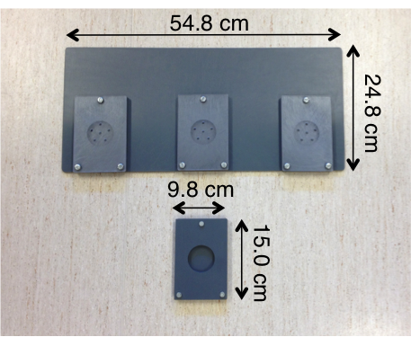
Figure 1: The test apparatus used for the problem solving task. The plate contains three identical problems where the middle one is unsolvable. The plate underneath was used in the initial food motivation test.

Before the problem solving task all dogs underwent an initial food motivation test. This was made in order to test the dogs’ willingness to eat the treat. The dog was presented with 3 quarter pieces of treat on a single plate similar to the actual problem solving plate (see Figure 1). This was done in the middle of the marquee, and was also recorded. The treats were presented one by one to the dog with a loose leash, while the owner was placed behind the dog in a passive manner. The experimenter was showing the dog that a treat was placed on the single plate, and then put the plate on the ground. When the dog had eaten the first treat the experimenter put a new treat on the plate (still placed on the ground). All but one dog (mentioned above) qualified and proceeded to the problem solving task.
After the motivation test, the owner waited with its dog just outside the marquee, in an opening in the grids on the front right side. The test apparatus was put on the ground in the back of the marquee, approximately 40 centimeters from the back wall, and in the middle from the side walls (see Figure 2). The experimenter then placed herself in the front left corner of the marquee and signaled to the owner to release the dog. Directly when the dog was released the experimenter started a timer, and the test was ended after 180 seconds. When the dog was released, the owner closed the grids behind him/her and stood passively in the front right corner, as shown in Figure 2. During the entire duration of the experiment both experimenter and owner were passive and facing the test apparatus, regardless of what the dog was doing. The only time the owner was allowed to contact the dog was if the dog escaped the marquee. In that case, the dog was quickly called back to the marquee in order to complete the test.
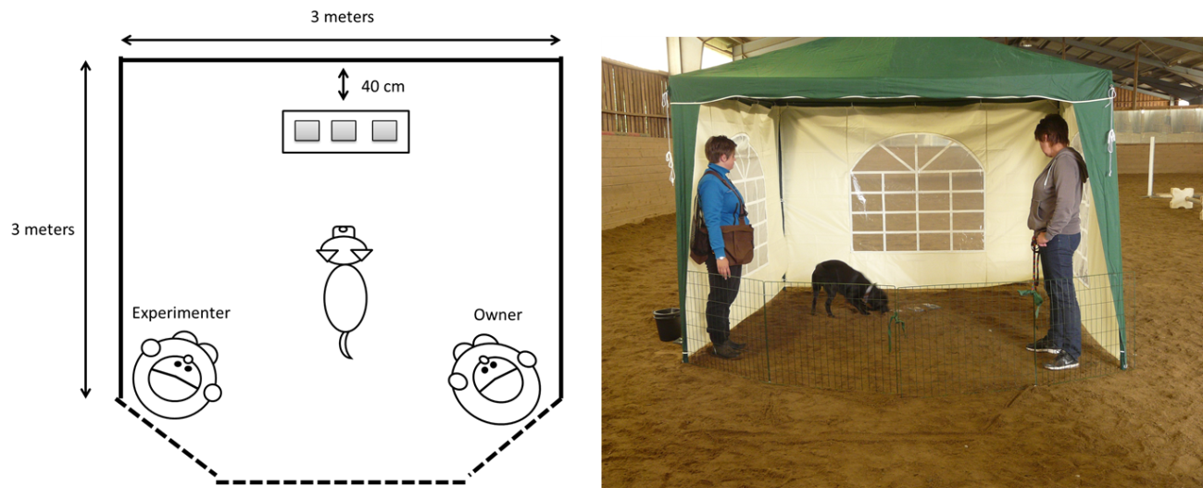
Figure 2: During the experiment the dog were loose in the marquee, with experimenter in the left front corner, the owner in the right front corner, with the grids closed. Both experimenter and owner faced the test apparatus during the whole experiment regardless of the dog’s position.

If the dog did not open any of the slidable lids within 60 seconds the experimenter quickly opened both lids halfway and then went back to being passive.
If the test apparatus was pushed outside the walls when the dog manipulated it, the experimenter quickly placed the apparatus inside the marquee and then went back to being passive.
After 180 seconds the test was considered finished regardless of whether the dog was able to solve any of the problems or not. If there was treats left in any of the slidable compartments the dog got help from the experimenter to get it. The owner was then asked to leash the dog and step out of the marquee while the experimenter prepared for the second experiment.

Pointing test
In this experiment two opaque black buckets, with the diameter of 21 centimeters and a depth of 19 centimeters, were used (see Figure 3a). The circumference at the top of the bucket was 65 centimeters and the circumference of the bottom of the bucket was 54 centimeters. Both buckets were rubbed with FROLIC® prior to testing in order to prevent the dogs from identifying the correct bucket by using olfactory cues. For the pointing test the grids were placed as in Figure 3b, with the dog and the owner placed in the middle of the opening.
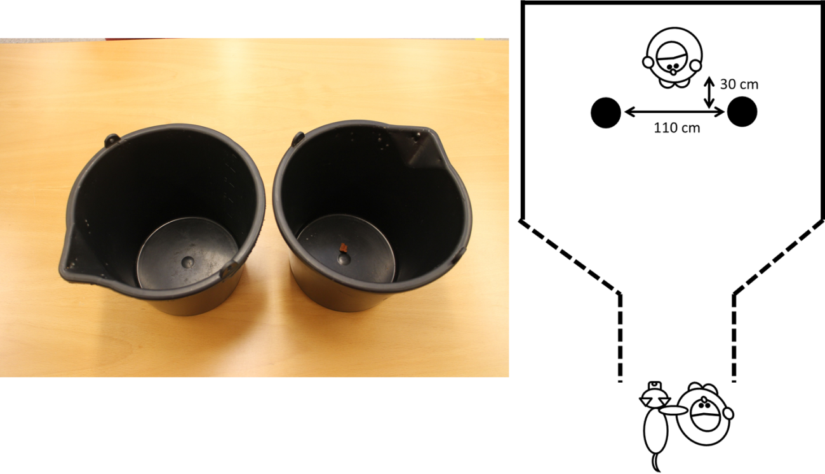
Figure 3: a) the buckets used for the pointing test b) the test setup during the pointing test

Before the pointing test all dogs underwent a pre-test to give the dog an opportunity to associate the buckets with treats. During the pre-test the owner was at the opening of the grids, while the experimenter was standing in the middle of the tent holding the buckets. The experimenter placed a treat in one of the buckets, and, after placing the bucket on the ground, telling the dog “varsågod”. This informed the dog that it was allowed to eat the treat. In order to give the buckets the same treatment and odor before the start of the experiment this procedure was repeated three times for each bucket. If the dog willingly ate all treats the experimenter offered, it qualified for the test.
During the pointing test the experimenter was standing in the back of the tent, approximately 40 centimeters from the back wall and in the middle from the sides, as shown in Figure 3b. The owner and the dog were placed in the opening of the grids, with the dog unleashed but held in the collar by the owner.
In order to prevent the dog from seeing the baiting of the bucket, the experimenter stood with her back turned against the dog and owner, baiting one of the buckets with a quarter piece of FROLIC®. After baiting, the experimenter turned around, and when established eye contact with the dog the experimenter put the buckets on the ground, approximately 110 centimeters from each other and approximately 30 cm in front of the experimenter (see Figure 4a). If the dog still kept eye contact with the experimenter the pointing cue was given immediately. If not, a short sound or calling of the dogs’ name was made to establish eye contact once again. The pointing cue was made by reaching out the arm with an open hand towards the bucket containing the treat for approximately two seconds (see Figure 4b). During the pointing the experimenter looked straight at the dog. Directly after the 2 second pointing the experimenter took the arm back to a neutral position and said “varsågod”. This was the cue to let the owner know that he/she had to release the dog. Up until this point the owner had not been allowed to look at neither the baiting nor the pointing and was instructed to stand with closed eyes or looking at his/her feet. This instruction was given to prevent the owner from giving the dog any cues when released.
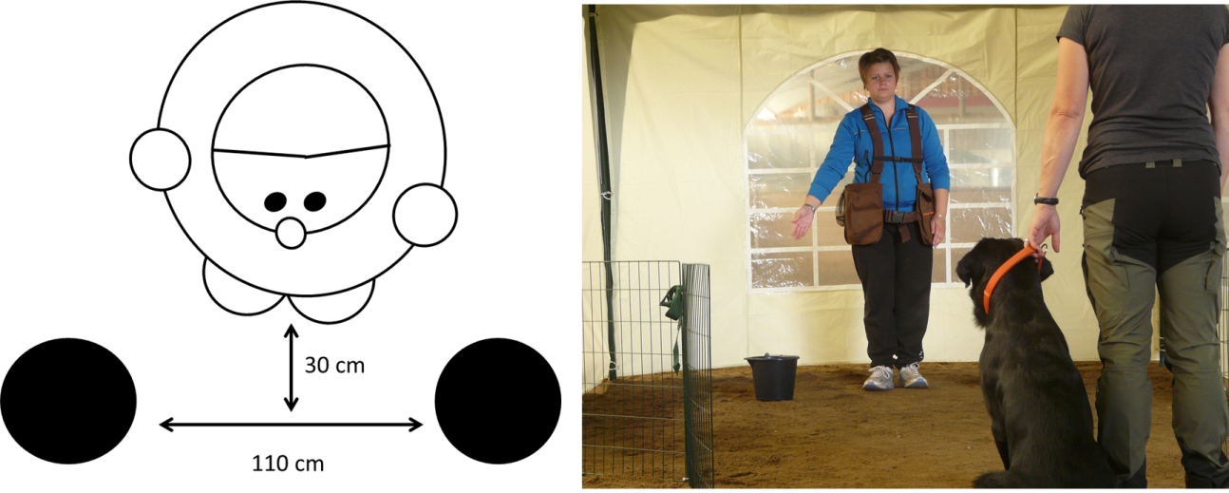
Figure 4: a) distance between buckets and between experimenter and buckets b) The experimenter points with arm fully stretched and an open hand, looking at the dog.

If the dog did not move directly after the experimenter’s “varsågod” the owner had been instructed beforehand to say “varsågod” as well. However, no other gestures were allowed.
A bucket was considered “chosen” when the dog’s nose was within a head length of it. As soon as the choosing criterion was met the other bucket, which was not chosen by the dog, was directly picked up by the experimenter. If the dog went up to the experimenter without choosing a bucket within a time frame of 3 seconds, or if the dog went out from the marquee, a repetition was labeled as “no choice”. However the outcome, the dog was called back to its owner after the selection process. The procedure was repeated for a total of 20 repetitions, with a small break of approximately one minute after 10 repetitions. The repetitions were presented in a pseudo-random order; not keeping the same bucket baited more than twice in a row. Half of the dogs were doing the test with the experimenter pointing with her left arm as number one, whereas the other half with the experimenter pointing with her right arm as number one.

Data collection
For the unsolvable problem experiment the movies were analyzed using The Observer XT 10 software. The ethogram used for this experiment is shown in Table 1. Frequency, duration and mean for each observed behavior and the latency pertaining to opening the lids were analyzed. In addition to these behaviors each direct transition made by the dog between test setup and owner, test setup and experimenter and experimenter and owner was recorded. A direct transition meant that the dog, without distraction or detour, walked directly between owner/experimenter and test setup. If distracted by sniffing on the ground, or if taking a detour on the way, the behavior was not considered a direct transition. Also, each dog was assigned a body posture score (Table 2) and an intensity score (Table 3). The intensity score was developed together with another master student, and 20 dogs (10 from this study and 10 from the other student’s study) was scored by both of us. The Spearman correlation rank was then calculated on these scoring, which showed that we interpreted the definitions similarly (rho = 0,70, p < 0,05).
Table 1: The ethogram used for the behaviors observed during the unsolvable problem experiment.
Behavior group | Behaviour | Definition
Position | Test setup | The dog’s head is within its own body length of the test setup
 | Experimenter | The dog’s head is within its own body length of the experimenter
 | Owner | The dog’s head is within its own body length of the owner
 | Elsewhere inside | The dog’s head is not within its own body length of either the test setup, the experimenter or the owner
 | Outside | The dog has at least its head and shoulders outside the tent
Activity | Standing | The dog is standing with its four paws touching the ground
 | Sitting | The dog is sitting down, its buttocks touching the ground
 | Lying down | The dog is lying down, its belly touching the ground
 | Walking | The dog is lifting its paws and is moving forward on the horizontal plan
 | Movement | The dog is lifting its paws without moving forward
Test | Test setup interactions | Physical interactions with the test setup
 | First problem solved | The dog accessed and ate the treats in one of the pits of the test setup
 | Second problem solved | The dog accessed and ate the treat in the other pit of the test setup
Human interactions | Eye contact experimenter | The dog is either positioned at the test setup, between the test setup and the experimenter or at the experimenter while gazing towards the face of the experimenter.
 | Eye contact owner | The dog is either positioned at the test setup, between the test setup and the owner or at the owner while gazing towards the face of the owner.
 | Physical contact experimenter | The dog is positioned close to the experimenter and in physical contact.
 | Physical contact owner | The dog is positioned close to the owner and in physical contact.
Other | Feeding Score | A score from 1 to 3 (late to early feeding) explaining the time it took for the dogs to eat the treats in the initial motivation test. See S1 for details.
 | Body Posture Score | A score from 1 to 5 (high to low) of the overall body posture. Se S2 for details.
 | Escape attempt | The dog’s nose is touching the bottom of the tent’s wall

Table 2: A subjective score of the body position of the dog. The score is based on overall posture and behavior during the unsolvable problem experiment.
Score | Description
1 | High wagging tail and high body position. Appears confident.
2 | Mostly high wagging tail and/or high body position. Appears fairly confident.
3 | Mostly neutral tail and/or body position. Could in some cases appear as somewhat insecure.
4 | Mostly low tail and/or body position. Can wag their tail. Appears unsecure and cautious.
5 | Low tail and/or body position. Appears unsecure and very cautious.

Table 3: A subjective score of the intensity of the dog. Low scores indicates high intensity and high scores indicate low intensity.
Score | Description
1 | Very intense. Moving all the time, energetic and with high pace, high frequency of paw using when interacting with test setup
2 | Intense. Mostly moving in a high pace, intermediate frequency of paw use when interacting with the test setup.
3 | Medium intensity. Moving around most of the time in medium/low pace. Medium frequency of paw using when interacting with test setup
4 | Low intensity. Low pace when moving around, might be passive (standing or sitting) for some time.
5 | Low intensity. Do not move around all the time, passive for considerable time during the test
For the pointing test the movies were analyzed using Windows Movie Maker software. The frequency of correct and incorrect choices was noted, and the latency from the dogs’ first movement forward after the “varsågod” command until the nose was just at the top of one of the buckets was calculated.

Statistical analysis
All statistical analyses were performed in IBM SPSS Statistics 22 software.
All data was checked for normal distribution by making histograms with normal distribution curves. These were then evaluated visually. From the result of the distribution check, a univariate GLM was performed on the normally distributed variables, while non-normally distributed variables was transformed with log10 or square root to check if they could become normally distributed. None of my variables became normally distributed after transformation, and were therefore analyzed using Mann-Whitney U test.
For the GLM, each investigated variable was put as dependent variable. Type (hunt, show) and sex were put as fixed factors, but no covariate variables were included. Both “interaction” of type and sex, and “main effects” of type and sex were put into the model. If there was no significant interaction between type and sex the test was remade once more, but without the interaction variable present.
The data from the pointing sessions was merged. For the correct/non correct choices three variables was made; one for each session and one with the total 20 pointings. Each variable corresponded to the number of correct choices in that particular session. The same procedure was done for the latency to the chosen bucket; one variable for each session and one with the total 20 pointings. However, in this case, the variables corresponded to the average latency (in seconds). These merged variables were then used in a univariate GLM since they all were normally distributed.
For the correlations, all dogs were included, and not divided by type. Spearman correlation was done with all variables of interest put in the same model, and the significant correlations of interest were then picked out from this big model.

Results

General differences between types during problem solving
There was a significant difference in body posture between the two types (F_{1, 97} = 1,831, p = 0,018). Hunting Labradors (1,92 ± 0,12) had a lower mean score than show Labradors (2,29 ± 0,09), which means that the hunting Labradors appeared more secure during the problem solving test.
The two types did not differ significantly in the intensity, but a trend was found between sexes (F_{1,97} = 2,907, p = 0,091). Females (3,40 ± 0,12) had a higher intensity score, and hence appeared less intense during the problem solving compared to males (3,04 ± 0,17).
.
Show Labradors (50,37 ± 3,47 seconds) spent significantly more time standing than hunting Labradors (38,35 ± 3,50 seconds) during the problem solving task (F_{1,97} = 5,729, p = 0,019) (see Figure 5).

Figure 5: Time spent standing (in seconds) during the test setup for the two types. The asterisk indicates a significant difference, where show Labradors spend significantly more time standing.
Hunting Labradors (8,31 ± 0,92) had a significantly higher frequency (F_{1,96} = 12,328, p = 0,001) of being in the neutral zone of the marquee, called “elsewhere inside” in the ethogram, compared to show Labradors (12,13 ± 0,66). Additionally, hunting Labradors (36,92 ± 3,54 seconds) showed a trend towards spending more time in the neutral zone (U = 1502,5, p = 0,079) than the show Labradors (28,56 ± 2,95 seconds).

Interaction with test setup
There was a significant difference between the two types concerning frequency of being in the test setup zone. Hunting Labradors (5,98 ± 0,32) had a significantly higher frequency (F_{1,97} = 10,103, p = 0,002) than show Labradors (4,6 ± 0,30) (see Figure 6a). On the other hand, a trend towards show Labradors (124,34 ± 5,95 seconds) spending more time in the test setup zone (F_{1,97} = 3,780, p = 0,055) compared to hunting Labradors (107,34 ± 6,29 seconds) was also found (see figure 6b). Likewise, when looking at the actual interaction with the test setup, hunting Labradors (6,42 ± 0,29) had a significantly higher frequency than show Labradors (5,46 ± 0,27) of starting an interaction (F_{1,97} = 6,019, p = 0,016) (see figure 6c). Show Labradors (112,34 ± 6,07 seconds), on the other hand, showed a trend towards spending more accumulative time interacting with the test setup (F_{1,97} = 3,667, p = 0,058) compared to hunting Labradors (95,47 ± 6,30 seconds) (see Figure 6d).
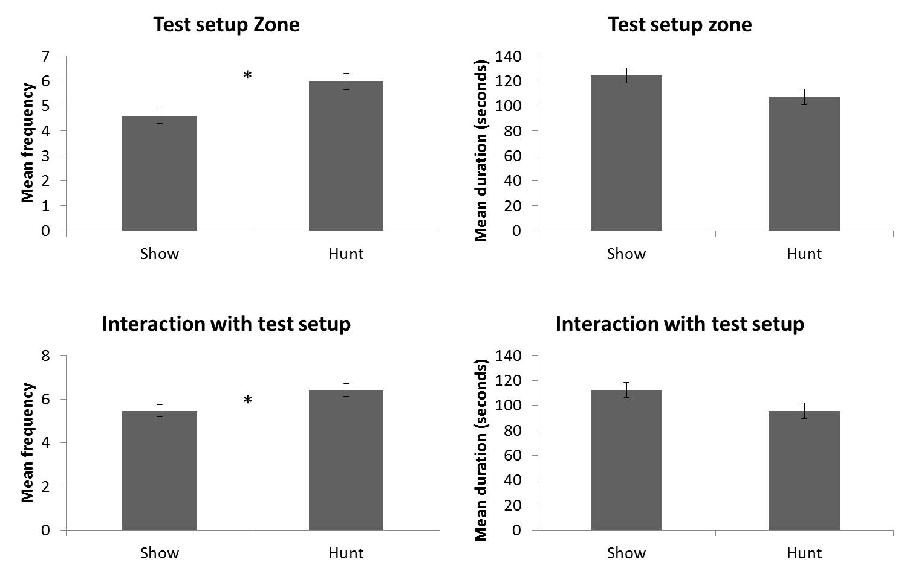
Figure 6: a) Hunting Labradors visited the test setup zone significantly more times than show Labradors b) Show Labradors had a tendency of spending more time in the test setup zone c) Hunting Labradors had a significantly higher frequency of starting interactions with the test setup d) Show Labradors showed a tendency towards spending more time interacting with the test setup compared to hunting Labradors.
The transitions made by the dog between the owner and the test setup were significantly higher (U = 1604, p = 0,007) for hunting Labradors (2,02 ± 0,19) than show Labradors (1,38 ± 0,14) (see Figure 7).

Figure 7: Transitions made by the dog between the owner and the test setup. The asterisk indicates a significant difference showing that hunting Labradors made more transitions than show Labradors.

Contact seeking behaviors
Hunting Labradors (21,28 ± 3,65 seconds) showed a trend towards spending more time in the owner zone (U = 1509,5, p = 0,071) compared to show Labradors (13,23 ± 2,51 seconds). Additionally, hunting Labradors (4,21 ± 0,43) also had a significantly higher frequency of entering the owner zone (U = 1684,5, p = 0,002) than show Labradors (2,58 ± 0,23). Likewise, hunting Labradors (3,27 ± 0,37) entered the experimenter zone with significantly higher frequency (F_{1,97} = 6,294, p = 0,014) than show Labradors (2,19 ± 0,22) but there was no significant difference in time spent in the experimenter zone between the two types.
Significant differences between types were found concerning eye contact with both the owner and the experimenter. Hunting Labradors (6,52 ± 0,82) sought eye contact with the owner with significantly higher frequency (F_{1,97} = 15,836, p = 0,000) compared to show Labradors (3,08 ± 0,32) (see Figure 8a). Hunting Labradors (11,99 ± 2,62 seconds) also held this eye contact significantly longer (U = 1775,5, p = 0,000) than show Labradors (5,03 ± 2,38 seconds) (see Figure 8b). The same was found for eye contact with the experimenter, where hunting Labradors (4,02 ± 0,49) sought eye contact with the experimenter with significantly higher frequency (F_{1,97} = 4,804, p = 0,031) compared to show Labradors (2,73 ± 0,34) (see Figure 8c). Hunting Labradors (5,74 ± 0,92 seconds) also showed a trend towards holding this eye contact with the experimenter longer (U = 1527, p = 0,054) than show Labradors (3,15 ± 0,48 seconds) (see Figure 8d).
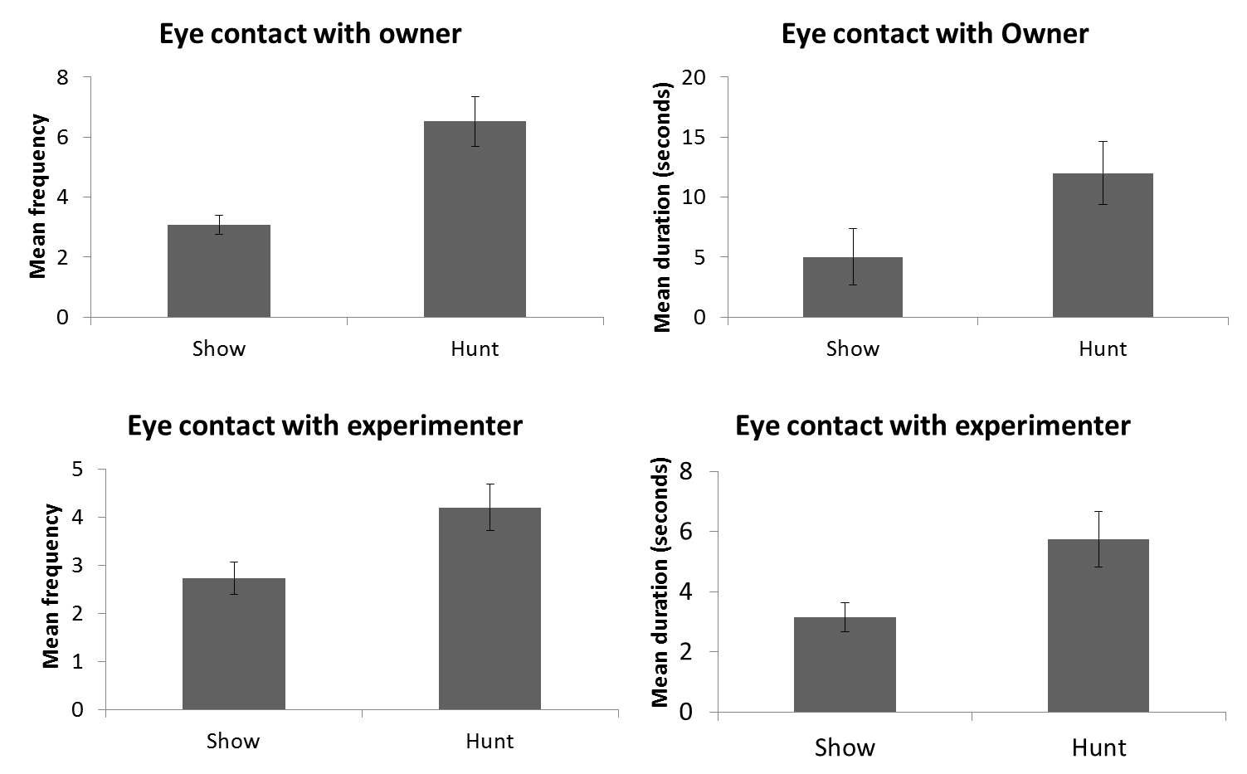
*
*
*
Figure 8: a) Hunting Labradors sought eye contact with significantly higher frequency compared to show Labradors b) Hunting Labradors held eye contact with the owner significantly longer than show Labradors c) A significant difference in seeking eye contact was shown, where hunting Labrador had a higher frequency of the behavior than show Labradors d) A trend towards hunting Labradors holding eye contact with the experimenter longer than show Labradors was found.
Hunting Labradors (0,77 ± 0,17) initiated physical contact with the owner significantly more often (U = 1508, p = 0,028) compared to show Labradors (0,35 ± 0,10). The duration of this behavior was also significantly higher (U = 1551, p = 0,011) in hunting Labradors (0,70 ± 0,19 seconds) compared to show Labradors (0,12 ± 0,04 seconds).

Pointing test
No significant difference between the two types of Labradors was found when comparing the number of correct choices during the pointing sessions one by one. However, when comparing the whole test, all 20 choices, a trend in the interaction between parameters type and sex was found (F_{1,97} = 3,481, p = 0,065) (see Figure 9). On the other hand, no significant effects were found when looking at the main effects of each parameter (p > 0,05).
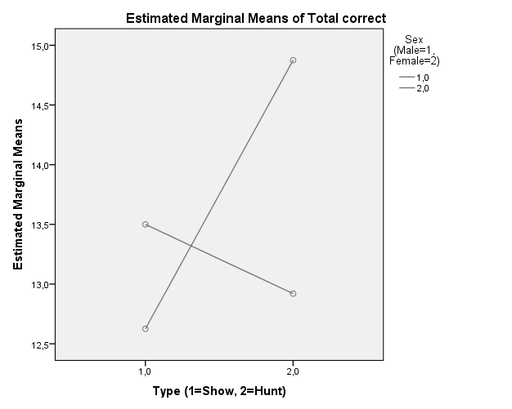
Figure 9: The interaction between type and sex considering correct choices made during the pointing test. Hunting Labrador males show a trend towards making more correct choices during the whole pointing session compared to show Labrador males.
When looking at the latency from the dogs’ first movement after “varsågod” until approaching the bucket, a significant difference was found for the average of first session (F_{1,98} = 11,072, p = 0,001). The hunting Labradors (1,42 ± 0,055 seconds) approached the bucket faster than show Labradors (1,732 ± 0,073 seconds). The same was found for the second session where hunting Labradors (1,404 ± 0,045 seconds) had a significantly shorter latency (F_{1,98} = 25,361, p = 0,000) compared to show Labradors (1,954 ± 0,096 seconds). Additionally, when comparing the average time to approach the bucket for all 20 choices hunting Labradors (1,413 ± 0,04 seconds) had significantly shorter latency to approach the bucket (F_{1,98} = 19,554, p =0,000) compared to show Labradors (1,839 ± 0,08 seconds) (see Figure 10).

Figure 10: Mean time to approaching bucket, for all 20 sessions. The asterisk indicates a significant difference where hunting Labradors are significantly faster at reaching the bucket compared to show Labradors.

Correlations
A positive correlation was found between the duration of being in the experimenter zone and the total number of being in the owner zone (rho = 0,560, p = 0,000) (see Figure 11).
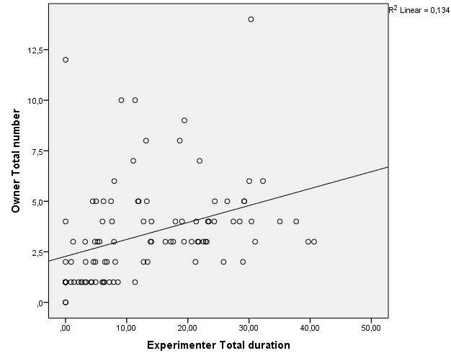
Figure11: Spearman bivariate correlation between the total duration of being in the experimenter zone and total number of visits to the owner zone.

A positive correlation between the total number of times the Labradors sought eye contact with the experimenter and the total duration of being in the owner zone was found (rho = 0,353, p = 0,000). Also, a positive correlation between total number of times the Labradors sought eye contact with the owner and the total number of visits to the experimenter zone (rho = 0,372, p = 0,000). However, the total number of times the Labradors sought eye contact with the owner was negatively correlated with the body posture score (rho = -0,222, p = 0,027), meaning that dogs scored with high body posture and a more secure appearance sought eye contact with the owner to a higher extent than dogs appearing insecure.
Table 4 shows that several correlations between the positioning in the marquee and the total number of escape attempts were found. Escape attempts was also found to correlate with seeking eye contact with both the owner and the experimenter, which also can be seen in table 4.
Table 4: The Spearman correlation between escape attempts and positioning in the marquee.
Behavior 1 | Behavior 2 | Rho | p-value
Escape attempt | Duration owner zone | 0,336 | 0,001
 | Duration test setup | -0,380 | 0,000
 | Duration experimenter | 0,258 | 0,010
 | Duration eye contact owner | 0,274 | 0,006
 | Duration eye contact experimenter | 0,234 | 0,019

Several variables were shown to correlate to the average latency to approach the chosen bucket – both when looking at the two sessions separately and when merging the two sessions. These correlations can be seen in table 5. Body posture score and the duration of interaction with the test setup were the ones positively correlated to the latencies, while transitions between owner and the test setup, seeking eye contact with the owner and seeking eye contact with the experimenter were the ones negatively correlated to the latencies.

Table 5: Several variables correlating to the average latency to approach the chosen bucket.
Variable 1 | Variable 2 | Rho | p-value
Body posture score | Average time 1-10 | 0,358 | 0,000
 | Average time 11-20 | 0,361 | 0,000
 | Average time total | 0,386 | 0,000
Transition owner/test | Average time 1-10 | -0,235 | 0,019
 | Average time 11-20 | -0,269 | 0,007
 | Average time total | -0,254 | 0,011
Duration interaction test | Average time 1-10 | 0,246 | 0,014
 | Average time 11-20 | 0,251 | 0,012
 | Average time total | 0,250 | 0,012
Seeking eye contact owner | Average time 1-10 | -0,319 | 0,001
 | Average time 11-20 | -0,271 | 0,006
 | Average time total | -0,297 | 0,003
Seeking eye contact exp. | Average time 1-10 | -0,267 | 0,007
 | Average time 11-20 | -0,280 | 0,005
 | Average time total | -0,286 | 0,004

Discussion
This study shows that there are behavioral differences between the two lineages of Labradors. Compared to show Labradors hunting Labradors appeared more secure, were more active and engaged in more human-directed contact seeking behaviors during a problem-solving task. Additionally, hunting Labradors approached the chosen bucket with a shorter latency in a pointing test. Show Labradors were standing more during the problem solving task, and interacted with the test setup for longer periods of time than hunting Labradors. Several correlations were found; where contact seeking behaviors were correlated to both number of escape attempts and the average latency to approach the chosen bucket in the pointing test. Finally, transitions and body posture were both correlated to average latency to approach the chosen bucket in the pointing test.
The trend towards hunting Labradors having a higher body posture and appearing more secure than show Labradors could indicate that the hunting Labradors were more comfortable with the assignment, or maybe that they were more confident in a novel environment. Although, show Labradors showed a trend towards engaging more in the test setup, and this could negate the previous indication. Compared to show Labradors, hunting Labradors had a significantly higher frequency of entering all different zones in the marquee. It shows that hunting Labradors were more physically active during the problem solving, but their activities did not include the actual test setup to the same extent as show Labradors. The intensity score was not significantly different between the types, and because of the frequency results from different zones, one can argue that perhaps the initial intention with the intensity score was missed. However, the frequency of entering different zones just shows dogs’ physical movement in the marquee. Although, this physical movement was captured in the intensity scoring, other aspects are also included in this score such as the way dogs were interacting with the test setup (one paw, two paws, just sniffing etc). Since show Labradors showed a trend towards interacting with the test setup more than hunting Labradors this could be the reason for the intensity not being captured, even if other results indicate that there was a difference.
Another interesting aspect was that hunting Labradors sought eye contact significantly more often and with a longer duration than show Labradors. Being in the concerned zones, which connected the physical activity with human-directed contact seeking behaviors, was a requirement for engaging in physical contact and performing transitions. Lofgren et al. (2014) found that hunting Labradors seek more eye contact than show Labradors, which is in line with the current findings. Lofgren et al. also found that hunting Labradors exhibit less excitability than show Labradors. This could be interpreted as a contradiction to the tendency I found of hunting Labradors having a higher body posture and higher frequency of entering the different zones. However, it might be inaccurate to interpret body posture and movement into different zones as an indication of the excitability of the dog. Marshall-Pescini et al. (2008) found that untrained dogs seek more eye contact than dogs being engaged in everyday training, but after having conversations with owners of show Labradors it turned out that many of them train and compete with their dogs. Consequently, the notion that hunting Labradors are the only ones working gets invalid, and this might explain why I did not witness the difference between the types that Marshall-Pescini et al. found in their study. Moreover, Mongillo et al. (2010) found that dogs focus their attention to, and gaze significantly more at, their owner than a stranger, with both present in the same room. This difference in human-directed contact seeking behaviors was not found in this study, but could be due to different experimental setup and the fact that the Labrador retriever is considered a highly social breed (Svenska kennelklubben, 2015).
The difference between the types concerning latency to approach the chosen bucket but not accuracy of correct and wrong choice could have several explanations. Because of all dogs undergoing a BPD prior to actual testing it was expected that hunting Labradors, since they are bred for work, would have significantly more correct choices than show Labradors. However, as mentioned above, show Labradors were also engaged in everyday training, which could explain why no difference in accuracy was found. Since the majority of hunting Labradors both trained and competed in retrieving trials, requiring them to perform during an entire day (Svenska spaniel- och retrieverklubben, 2015), their short latency could be an indication of a higher level of diligence. The workload with BPD, problem solving and pointing task might not have been particularly demanding for them, which means that they would be able to be both accurate and fast. So, the show Labradors were also used to perform during training, however not during such long periods of time. Therefore, they still managed to choose the correct bucket but not with the same speed. Furthermore, there was a trend concerning accuracy in the interaction between sex and type, where hunting Labrador males tended to have more correct choices than show Labrador males. Other than that, no significant differences linked to accuracy in the pointing task were found.
The fact that escape attempts were correlated to time spent by the test setup as well as in the experimenter and owner zones could be that it is linked to overall activity and movement. This could also be a sign of frustration as these zones were associated with an unsolvable problem and the fact that dogs did not receive any response when seeking contact from either the owner or the experimenter. When a dog experienced difficulty in solving the problem, and not receiving help, it might have wilted and tried to escape the marquee. Another interesting result was that transitions during the problem solving were negatively correlated to the average latency of approaching the bucket in the pointing test. This shows that dogs with fewer transitions had longer latency, and could in turn indicate a two-way communication. During the problem-solving task, dogs were seeking attention without receiving any response, but during the pointing test it is feasible to conclude that the given pointing cue attributed to the dogs confidently choosing a bucket. The fact that body posture also was linked to average latency could support this conclusion as well. A high body posture score was correlated to longer latency, which means that dogs that appeared insecure had longer latency during the pointing test. This could indicate that these dogs had lower confidence in their choices.
The findings from this study and the breeding goals for the two types of Labradors suggest that congruity exists between the two. For example, hunting Labradors are bred for retrieving abilities and therefore should be alert, active and quick during trials. At the same time they should work closely to their owner, and they are not allowed to take own initiatives during trials. Moreover, they are bred to be diligent during search exercises and when retrieving pray in rugged terrain (Svenska spaniel- och retrieverklubben, 2015). These ascribed traits cohere with the findings in this study. For example, both high body posture and the entering into the different zones with significantly higher frequency could be interpreted as sign of being alert and active. Additionally, the significantly shorter latency could be attributed to their quickness during work. Moreover, the human-directed contact seeking behaviors shown in this study corresponds well with the dog’s ability to work closely to the owner without taking extensive initiatives. Finally, shorter latency to approaching the chosen bucket in the pointing task could correspond to the breeding goal of hunting Labradors being diligent during a long period of time. When looking at the breeding goals for the show Labrador they are more linked to complexional traits, which makes it more difficult to link the breeding goals to the findings in this study.

Societal & ethical considerations
The ethical permit for this study was given by the committee for ethical approval of animal experimentation in Linköping, approval no 51-13. This study had no specific ethical concerns as only behavioral experiments involving minimal handling and no procedures were made on the dogs.
The dog is considered “man’s best friend” and plays an important role for many people in today’s society. Only in Sweden there were over 794 000 registered dogs in 2014 (Jordbruksverket, 2015). These dogs are used for a variety of things, such as competing, service, companion, hunting and herding. Different breeders have different interests and breeding goals, depending on the demands from owners/buyers and from specific breed organizations. This means that dog breeding is broad and complex.
Selection influences the dog in many different, sometimes negative ways. Today, several breeds have problems related to desired appearances. Sloping backs are desirable on German shepherds but may lead to back problems; excessive skin is desirable on Shar-peis but may lead to rash and eczema; and short snouts are desirable on Pugs but may lead to breathing difficulties. These are just a few of the problems dogs are suffering from when breeders are trying to achieve specific complexional traits. This elucidates the risks of breeding with focus on specific traits, and is not only true for morphological traits but could also be true for behavioral traits. Therefore, breeders have to select their direction carefully to avoid unforeseen and unwanted features.
Research about how dogs function and how selection influences the dogs can give breeders more knowledge how to avoid bad breeding directions. This will help keeping a healthy population within the breed without impoverishments.

Conclusions
In conclusion, this study shows that there are behavioral differences in human-directed contact seeking behaviors between the two types of Labradors. Additionally, there are behavioral differences suggesting that the two types differ concerning diligence and speed whereas no significant difference was found concerning accuracy in pointing task and intensity. Since the types only have been separated for 40 years this study suggests that behavioral differences emerge early in the process of breeding with specific behavioral traits in mind. Additionally, this study suggests that the two lineages have developed in different directions due to different selection. This study raises the question whether the Labrador retriever should be split into two different breeds in the future, because of both morphological and behavioral differences in the breed.

Acknowledgement
For the help provided to finishing this thesis I would like to acknowledge my supervisor Per Jensen along with his always enthusiastic PhD-student Mia Persson, Ann-Sofie Sundman and Post doc Lina Roth. An extra thanks goes to Mia for her untiring work with both setup and guidance during writing, and to Ann-Sofie for the help during the experiments. Of course a big thank you to all owners willing to participate with their dogs. Without them this study could not have been performed. Lastly, I want to thank the examiner Hanne Løvlie, together with the peer reviewers, for further helping me writing a better report.

References
Clutton-Brock J, (1999) A natural history of domesticated mammals. Ed. 2. Cambridge University Press, Cambridge UK
Freedman AH, Gronau I, Schweizer RM, Vecchyo DO, Han E, Silva PM, Galaverni M, Fan Z, Marx P, Lorente-Galdos B, Beale H, Ramirez O, Hormozdiari F, Alkan C, Vilà C, Squire K, Geffen E, Kisak J, Boyko AR, Parker HG, Lee C, Tadigotla V, Siepel A, Bustamante CD, Harkins TT, Nelson SF, Ostrander EA, Bonet MT, Wayne RK, Novembre J (2014) Genome sequencing highlights the dynamic early history of dogs. Plos Genetics 10, e1004631
Gaunet F (2008) How do guide dogs of blind owners and pet dogs of sighted owners (Canis familiaris) ask their owners for food? Animal cognition 11, 475-483
Hare B, Plyusnina I, Ignacio N, Schepina O, Stepika A, Wrangham R, Trut L (2005) Social cognitive evolution in captive foxes is a correlated by-product of experimental domestication. Current Biology 15, 226-230

Hare B, Williamson C, Tomasello M (2002) The domestication of social cognition in dogs. Science 298, 1634-1636
Horn L, Virányi Z, Miklósi A, Huber L, Range F (2012) Domestic dogs (Canis familiaris) flexibly adjust their human-directed behavior to the actions of their human partners in a problem situation. Animal cognition 15, 57-71
Jordbruksverket http://jordbruksverket.se (assessed March 2015)
Labrador retrieverklubben http://www.labradorklubben.se/ (assessed March 2015)

Leonard JA, Wayne RK. Wheeler J, Valadez R, Guillén D, Vilà C (2002) Ancient DNA evidence for old world origin of new world dogs. Science 298, 1613-1616
Lofgren SE, Wiener P, Blott SC, Sanchez-Molano B, Woolliams JA, Clements DN, Haskell MJ (2014) Management and personality in Labrador Retriever dogs. Applied Animal Behaviour Science 156, 44-53
Marshall-Pescini S, Valsecchi P, Petak I, Accorsi PA, Previde EP (2008) Does training make you smarter? The effects of training on dogs’ performance (Canis familiaris) in a problem solving task. Behavioural processes 78, 449-454

McKinley J, Sambrook TD (2000) Use of human-given cues by domestic dogs (Canis familiaris) and horses (Equus caballus). Animal cognition 3, 13-22.

Miklósi A, Kubinyi E, Topál J, Gácsi M, Virányi Z, Csányi V (2003) A simple reason for a big difference: wolves do not look back at humans, but dogs do. Current biology 13, 763-766
Miklósi A, Polgárdi R, Topál J, Csányi V (2000) International behaviour in dog-human communication: an experimental analysis of ‘showing’ behaviour in the dog. Animal Cognition 3, 159-166
Mongillo P, Bono G, Regolin L, Marinelli L (2010) Selective attention to humans in companion dogs, Canis familiaris. Animal behaviour 80, 1057-1063
Passalacqua C, Marshall-Pescini S, Barnard S, Lakatos G, Valsecchi P, Previde EP (2011) Human-directed gazing behaviour in puppies and adult dogs, Canis lupus familiaris. Animal Behaviour 82, 1043-1050
Savalli C, Ades C, Gaunet F (2014) Are dogs able to communicate with their owner about a desirable food in a referential and intentional way? Plos one 9, e108003

Savolainen P (2007) Domestication of dogs. In Jensen, P. The behavioural biology of dogs. UK CAB International.
Soproni K, Miklósi A, Topál J, Csányi V (2001) Comprehension of human communicative signs in pet dogs (canis familiaris). Journal of comparative psychology 115, 122-126
Svartberg K, Tapper I, Temrin H, Radesater T, Thorman S (2005) Consistency of personality traits in dogs. Animal Behaviour 69, 283–291
Svartberg K (2006) Breed-typical behavior in dogs – historical remnant or recent structures? Applied Animal Behaviour Science 96, 293-313
Svenska Kennelklubben http://skk.se (assessed March 2015)
Svenska spaniel- och retrieverklubben. http://ssrk.se/ (assessed March 2015)
Topál J, Miklósi A, Dóka A, Csányi V (1998) Attachment behaviour in dogs: a new application of the Ainsworth’s strange situation test. Journal of comparative psychology 112, 218–229

