Department of Physics, Chemistry and Biology

Master Thesis

Behavioural responses of Amur tigers (Panthera tigris altaica) and Bush dogs (Speothos venaticus) to mammalian blood odour components
Johanna Sjöberg
LiTH-IFM- Ex—13/2718--SE

Supervisor: Matthias Laska, Linköping University
Examiner: Mats Amundin, Linköping University

Department of Physics, Chemistry and Biology
Linköpings universitet
SE-581 83 Linköping, Sweden
Contents
1. Abstract 5
2. Introduction 5
3. Material and methods 7
3.1 Animals and management 7
3.2 Odour stimuli 8
3.3 Preparations 8
3.4 Experimental procedure 8
3.5 Statistics 10
4. Results 11
4.1 Amur tigers 11
4.1.1 All four stimuli 11
4.1.2 Horse blood 11
4.1.3 Trans-4,5-epoxy-(E)-2-decenal, Pig blood odour 12
4.1.4 Isopentyl acetate, Banana odour 12
4.1.5 Diethyl phthalate, Near-odourless Solvent control 12
4.1.6 Morning vs. Afternoon 14
4.1.7 Duration of interactions 15
4.1.8 Variability across sessions 15
4.1.9 Comparisons between odours 17
4.2 Bush dogs 18
4.2.1 All four stimuli 18
4.2.2 Horse blood 18
4.2.3 Trans-4,5-epoxy-(E)-2-decenal, Pig blood odour 18
4.2.4 Isopentyl acetate, Banana odour 18
4.2.5.Diethyl phthalate, Solvent 19
4.2.6 Morning vs. Afternoon 20
4.2.7 Duration of interactions 21
4.2.8 Variability across sessions 22
4.2.9 Comparisons between odours 23
4.3 Comparisons between the two species 24
5. Discussion 25
5.1 Main findings 25
5.2 Amur tigers 26
5.3 Bush dogs 26
5.4 Comparisons between the two species 26
5.5 The four odour stimuli 27
5.6 Odours as enrichment for carnivores 27
5.7 Limitations and further studies 28
6. Conclusion 28
7. Acknowledgements 29
8. References 30

Abstract
The sense of smell is important for carnivores and therefore olfactory enrichment might be an effective way to prevent stereotypic behaviours in captive felids and canids. In the present study, the behavioural responses of captive Amur tigers (Panthera tigris altaica) and bush dogs (Speothos venaticus) to wooden logs impregnated with four different odour stimuli were observed. No significant differences in interest, in terms of number of interactions, were found between the odour of horse blood and the odour of trans-4,5-epoxy-(E)-2-decenal (a component of pig blood) in either of the two species. However, both the horse blood and the trans-4,5-epoxy-(E)-2-decenal were significantly more interesting to both species compared to isopentyl acetate (a banana-like odour) and diethyl phthalate (a near-odourless solvent). Across all four odour stimuli, the tigers showed a larger variety of log-directed behaviours than the bush dogs. However, in both species sniffing was by far the most performed behavior. The results show that a single blood odour component was as interesting as the complex odour mixture of real blood. The results also support the idea that olfactory stimuli may be a suitable enrichment for captive both tigers and bush dogs.

Introduction
Olfaction plays an important role for finding and localizing prey for most carnivore species (Stoddart 1980). This is particularly true for species such as tigers (Panthera tigris), which track and hunt prey in areas with dense vegetation, (Schaller 1967; Brahmachary and Dutta 1987). Tigers, as most large felid species, use their sense of smell also in the context of social communication (Szokalski 2012; Clark and King 2008). They have been found to spray mark much more often than they urinate (Brahmachary et al. 1992; Poddar-Sarkar et al. 1994). Brahmachary et al. (1992) suggest that marking fluids in tigers are used for scent marking and serve the role as a source for communication with chemical signals between individuals. The scent marking behaviour of male tigers has also been seen to vary, depending on the reproductive status of females (Poddar-Sarkar et al. 1994). Not only felids, but also canids rely on their sense of smell for social communication. Porton (1983) found that urine-marking plays an important role in both the formation and maintenance of pair bond in bush dogs (Speothos venaticus). The urine-markings may contain information about both the identity of an individual and its reproductive status. The frequencies of urine-marking have also been found to be higher for male-female paired bush dogs than for male-male and female-female pairs (Porton 1983). Considering that both tigers and bush dogs strongly rely on their sense of smell, it seems reasonable to assume that olfactory stimuli can be an efficient way of environmental enrichment for both captive tigers and bush dogs.
Insufficient environments and lack of external stimuli can give rise to abnormal and stereotypic behaviours for animals in captivity. These are problems that carnivores are especially vulnerable to (Esteban Fuentes 2003). Providing animals in captivity with environmental enrichment can help to increase their activity levels, decrease or prevent stereotypic behaviours and give opportunities for performing species-specific behaviours (Powell 1995). Olfactory enrichment has been found to increase the activity levels in both primate species (Truelove 2006) and in lions (Baker 1997).
A previous study reported that the presentation of spices and different types of objects as enrichment resulted in a decline of stereotypic behaviours for all feline species studied (Skibiel et al. 2007). Tigers were one of the species that decreased the amount of time spent on stereotypic behaviours the most. The same study also found that the activity levels increased significantly when species data were pooled across species, for all enrichment treatments (Skibiel et al. 2007).
To gather information about food and resources, animals explore their surroundings. Carnivores in captivity have been found to increase their levels of exploration, social interactions and predatory behaviour, when they are provided with different odours, such as spices, scents of predators and prey odours (Yu et al. 2009; Powell 1995). Yu et al. (2009) suggested that the smell of another predatory species or the smell of a prey stimulates investigation and marking behaviour in Amur leopards (Panthera pardus orientalis). Enrichment has also been found to increase activity levels of bush dogs (Speothos venaticus) (Ings et al. 1997). Using feeding enrichment, Ings et al. (1997) found that the bush dogs increased their activity levels compared to the baseline.
Very little is known about the chemical composition of blood odour. However, it is known that the perceived quality of some odours can be caused by single components (Brahmachary and Dutta 1987). Recent studies have identified components that evoke a “blood-like” smell in humans (Buettner and Schieberle 2001; Konopka and Gorsch1991). Trans-4,5-epoxy-(E)-2-decenal has been found to have a distinct blood-like and metallic odour and is associated with meat by humans (Buettner and Schieberle 2001; Konopka and Gorsch 1991). As both tigers and bush dogs are carnivore species which strongly rely on their sense of smell, blood odour might be a likely candidate as olfactory enrichment for both these species.

It was therefore the aims of the present study to:

1. assess behavioural responses of two species of mammalian carnivores, Amur tigers (Panthera tigris altaica) and Bush dogs (Speothos venaticus) to the odour of real blood as well as to a mammalian blood odour component,
2. compare their behavioural responses to a blood odour component towards those to a plant-derived control odour and an odourless control,
3. compare the behavioural responses between the two carnivore species, and
4. assess the suitability of odour stimuli as environmental enrichment for captive tigers and bush dogs.

Material and methods

3.1 Animals and management
The study was conducted at Kolmården wildlife park, where a group of Amur tigers (Panthera tigris altaica) which consisted of three males and three females between 2-11 years of age was tested. The males comprised two eleven year old brothers, Kazan and Timur, and a five year old son of Kazan, Tzar. The females comprised three sisters, two four year old, Kyra and Olga, and one two years old, Kalinka, all daughters of Kazan. The tigers were housed in an outdoor enclosure (5000 m²) without access to the indoor quarters during opening hours. The outdoor enclosure contained trees, cliffs and huts, but mainly consisted of grassy areas. The outdoor enclosure also contained an artificial stream. Once in a week, during the cleaning routines of the outdoor enclosure, all of the tigers were looked in the indoor quarters.
A group of bush dogs (Speothos venaticus) composed of ten individuals, a 5 and 5 years old parent pair and their 8 offspring were also tested. During the study period, one female was sent to another zoo. The individuals included in the study were 1-6 years of age. The group of bush dogs also contained two juveniles. The juveniles were not included in the study because they were born after the study was started and too young to participate. The bush dogs were housed in an outdoor enclosure (1000 m²) with unlimited access to huts and indoor quarters. The outdoor enclosure contained cliffs and trees, but consisted mainly of grassy areas with some bushes. The bush dogs also had access to a small outdoor pool. During the cleaning routines of the enclosure, the animals still had access to the whole enclosure.

3.2 Odour stimuli
A total of four odour stimuli were used in the present study
Real horse blood was used as one odourant stimulus, to test whether the whole mix of odour components in blood was more interesting than just one component. Kolmården Wildlife Park sometimes have horses from private persons for euthanizing. The blood samples were taken during one such occasion, directly after the animal was euthanized and the samples were then deep frozen. For each observation one of the samples was then thawed immediately before it was used.
Trans-4,5-epoxy-(E)-2-decenal (CAS# 134454-31-2), “pig blood odour” has recently been identified as a volatile component in pig blood (Rachamadugu 2012) and has been described as having a “metallic, blood-like” odour quality (Buettner and Schieberle 2001). Trans-4,5-epoxy-(E)-2-decenal has also been shown to significantly contribute to the aroma of beef (Konopka and Grosch 1991). This odourant was obtained from Aromalab (Freising, Germany) as a stock solution of 5mg/ml and was further diluted 1:100 with near-odourless Diethyl phthalate.
Isopentyl acetate (CAS# 123-92-2), “banana odour” has been identified as a volatile component in a variety of fruits and has been described as having a fruity or “banana-like” odour quality (Burdock 2005; Jordan 2001; Salmon and Martin 1996). This odorant was diluted 1:1000 with near-odorless Diethyl phthalate.
Diethyl phthalate (CAS# 84-66-2), “solvent” was used both as solvent for the two monomolecular odorants and as a near-odorless control stimulus.

3.3 Preparations
Before the start of the actual experiments, both monomolecular odorants were diluted to concentrations that were detectable for the human nose. The purpose of this was to make the odours detectable for the animals, but at the same time not overwhelmingly strong. The horse blood was not diluted.

3.4 Experimental procedure
The different odours were presented to the animals using wooden logs of 48 x 7 x 4.5 cm. Each log was prepared with 500 microlitres of a given odour before each observation. The odour was applied on the two largest surfaces of a log using a pipette and then spread over the surface of the log, using a separate brush for each odour. Plastic gloves were used all the time when the logs were handled, to avoid that the logs were impregnated with human odours. The logs were marked on the short sides with a colour which represented a given odour. Logs impregnated with trans-4,5-epoxy-(E)-2-decenal (“pig blood odour”) were marked with red. Those with isopentyl acetate (“banana odour”) were marked with green. Those with Diethyl phthalate (“solvent”) were marked with blue and the logs with real blood were left unmarked.
The logs were then thrown into the outdoor enclosures of each species when the animals where kept outside. Five logs were used during each observation and only one of the four stimuli was used during each observation. After the logs were thrown into the enclosure, the animals were observed for six hours. All the behavioural responses of the animals, in terms of interactions with the logs were recorded for three hours in the morning and for three hours in the afternoon. The observations took place between 8.00 am and 4.00 pm. Every interaction the animals showed with the logs was recorded and, when possible, the duration of each interaction. If the logs were still in good condition after an observation, they were re-used with the same odour and the same species during further observations.
An ethogram was compiled, which included all the behaviours under consideration (see table 1). I used continuous sampling and recorded the occurrence of each behaviour on a protocol sheet. The procedure was repeated five times for each odour and species in pseudo-random order, which gave a total of twenty observation days per species. The observations were made on non-rainy days between April and September 2012. If it started to rain during an observation, the observation was disrupted and the results of that session included in the study. If there was no possibility to remove the logs after an observation, two days were introduced without observations, to allow the odour to fade away between the sessions. This only occurred with the tigers, because the carnivore keepers were not able to go into the enclosure when the tigers were present and the tigers were only locked inside the indoor quarters once a week.

Table 1. Ethogram of all behaviours considered in the present study.
Functional term | Descriptive term
Sniffing | Investigating site where odour is applied with nose
Licking | Licking site where odour is applied
Flehmen | Curling of upper lip to facilitate transfer of odours to VNO
Impregnating | Rubbing face or other body parts against site where odour is applied
Orientating | Turning head (ears and eyes) to orient themselves, after investigating site where odour is applied
Pawing | Scratching site where odour is applied with paw and claws
Vocalizing | Making sounds
Biting | Using teeth to investigate object
Toying | Playing, manipulating and moving object
Scent marking | Urinating on object

3.5 Statistics
To compare the number of interactions between the four different odour stimuli and between the two species, a Chi-square test was used. A Mann-Whitney U test was used to compare the average time the two species spent on each interaction, during the sessions with the four different odour stimuli.

Results

Table 2. Summary of the number of interactions in both the Amur tigers and the Bush dogs
Amur tigers | Sniffing | Licking | Flehmen | Impregnating | Orientating | Pawing | Vocalizing | Biting | Toying | Scent marking | Total
Horse Blood | 64 | 22 | 1 | 1 | 3 | 22 | 0 | 31 | 21 | 1 | 166
Epoxy, Pig blood odour | 93 | 12 | 2 | 0 | 9 | 15 | 0 | 17 | 15 | 0 | 163
Banana odour | 16 | 1 | 0 | 0 | 0 | 4 | 0 | 7 | 6 | 0 | 34
Odourless Solvent, control | 22 | 1 | 0 | 0 | 0 | 2 | 0 | 2 | 2 | 0 | 29
Total | 195 | 36 | 3 | 1 | 12 | 43 | 0 | 57 | 44 | 1 | 392
Bush dogs
Horse Blood | 467 | 6 | 9 | 0 | 27 | 2 | 0 | 17 | 5 | 7 | 540
Epoxy, Pig blood odour | 371 | 2 | 0 | 0 | 29 | 8 | 0 | 70 | 40 | 1 | 521
Banana odour | 261 | 2 | 1 | 0 | 10 | 0 | 0 | 9 | 6 | 8 | 297
Odourless Solvent, control | 206 | 0 | 0 | 0 | 6 | 0 | 0 | 9 | 1 | 2 | 224
Total | 1305 | 10 | 10 | 0 | 71 | 43 | 0 | 105 | 52 | 19 | 1582

4.1 Amur tigers

4.1.1 All four stimuli
During the twenty sessions, with all four odour stimuli considered, a total number of 392 interactions with the scented logs were observed (see table 2 and 3). These were distributed over nine of the ten behaviours described in the ethogram (see table 1). Sniffing was by far the most frequent behaviour and occurred 195 times, which makes up almost 50% of all interactions in total. Biting occurred 57 times, Toying occurred 44 times, Pawing occurred 43 times and Licking occurred 36 times. Orientating was observed 12 times, Flehmen was observed 3 times and Impregnating and Scent marking were only observed 1 time, respectively. The only behaviour which was not seen at all during the twenty observation days was Vocalization.

4.1.2 Horse blood
During the five sessions with horse blood used as odour stimulus, a total number of 166 interactions were observed (see table 2 and 3). Sniffing was the most frequent behaviour and was observed 64 times. Biting was observed 31 times, Licking and Pawing were observed 22 times each, respectively and Toying was observed 21 times. Orientating was observed 3 times and Flehmen, Impregnating and Scent marking were all only observed 1 time each, respectively. Vocalization was not observed at all during the five sessions with this odour.

4.1.3 Trans-4,5-epoxy-(E)-2-decenal, Pig blood odour
A total number of 163 interactions were observed during the five sessions in which trans-4,5-epoxy-(E)-2-decenal was used as odour stimulus (see table 2 and 3). Sniffing was observed 93 times, Biting was observed 17 times and Pawing and Toying were observed 15 times, respectively. Licking was observed 12 times, Orientating was observed 9 times in total and Flehmen was observed only 2 times. Out of the ten behaviours covered in the ethogram (see table 1), only seven were displayed during the five sessions with trans-4,5-epoxy-(E)-2-decenal. Impregnating, Vocalizing and Scent marking were not observed during the sessions with this odour.

4.1.4 Isopentyl acetate, Banana odour
During the five sessions with isopentyl acetate used as odour stimulus, a total of 34 interactions were observed (see table 2 and 3). They were distributed over five of the ten behaviours included in the ethogram (see table 1). Sniffing occurred 16 times, Biting occurred 7 times, Toying occurred 6 times and Pawing occurred 4 times. Licking was observed only 1 time during the five sessions. The five behaviours which were not displayed at all during the five sessions with this odour were Flehmen, Impregnating, Orientating, Vocalizing and Scent marking.

4.1.5 Diethyl phthalate, Near-odourless Solvent control
A total number of 29 interactions were observed during the five sessions with diethyl phthalate used as odour stimulus. Sniffing was observed 22 times. Pawing, Biting and Toying were observed 2 times each, respectively. Licking was observed only 1 time. Flehmen, Impregnating, Orientating, Vocalizing and Scent marking were not displayed at all during the five sessions with diethyl phthalate.

Table 3. Summary of the total number of interactions observed for all the 10 behaviours considered in the study, performed by the tigers, during all 20 sessions.
 | Sniffing | Licking | Flehmen | Impregnating | Orientating | Pawing | Vocalizing | Biting | Toying | Scent marking | Total
Horse Blood | 64 | 22 | 1 | 1 | 3 | 22 | 0 | 31 | 21 | 1 | 166
Epoxy, Pig blood odour | 93 | 12 | 2 | 0 | 9 | 15 | 0 | 17 | 15 | 0 | 163
Banana odour | 16 | 1 | 0 | 0 | 0 | 4 | 0 | 7 | 6 | 0 | 34
Odourless Solvent, control | 22 | 1 | 0 | 0 | 0 | 2 | 0 | 2 | 2 | 0 | 29
Total | 195 | 36 | 3 | 1 | 12 | 43 | 0 | 57 | 44 | 1 | 392

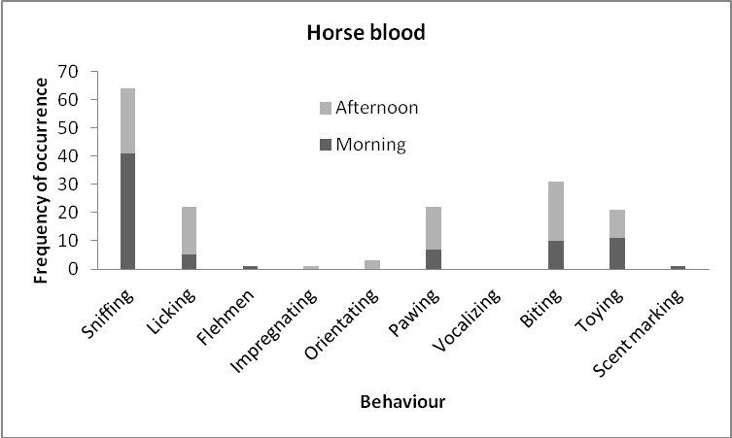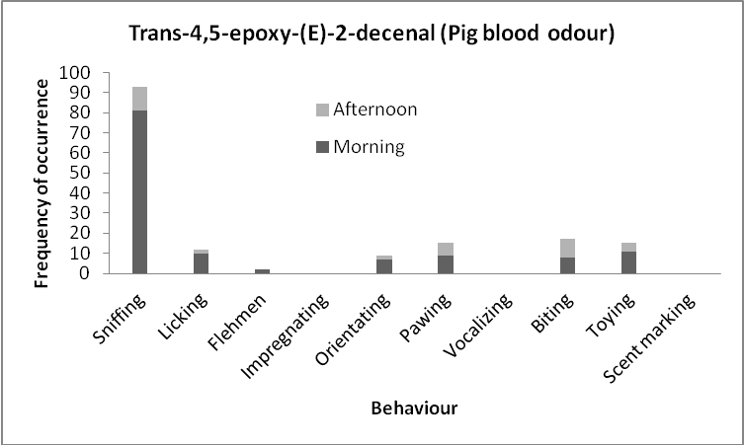
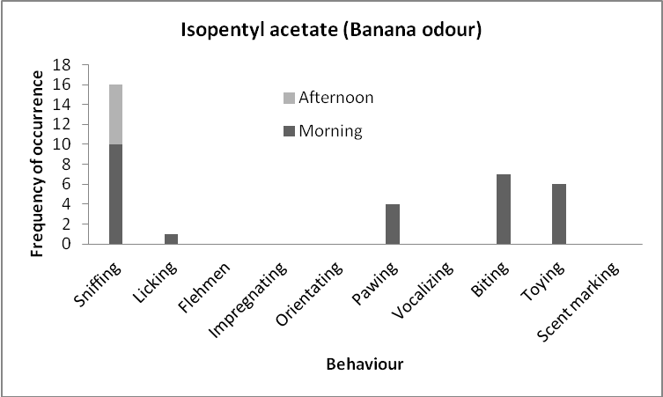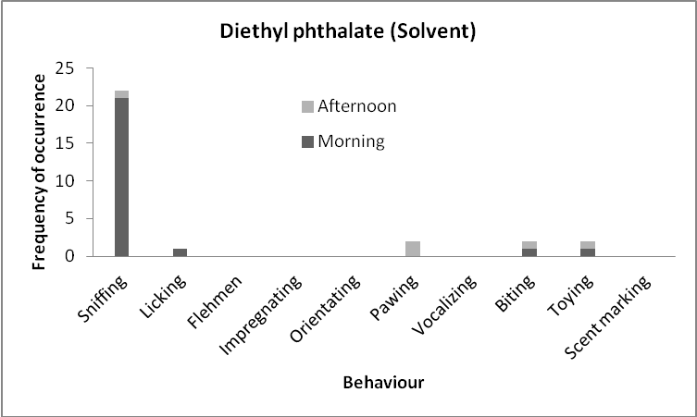
Figure 1. Frequency of occurrence of the different behaviours displayed by the tigers, during the five sessions performed with each of the four odour stimuli, and subdivided by morning and afternoon. The y-axis represents the number of interactions and the x-axis represents the 10 different behaviours covered in the study. Scales on the y-axis differ to make the bars comparable and the diagrams easier to read.

4.1.6 Morning vs. Afternoon
During the morning hours of all 20 sessions, with all four odour stimuli considered, a total of 256 interactions were observed (see table 4). This number was significantly higher than the 136 interactions that were observed during the afternoon hours (Chi-square value=18.81; P=0.0001) (see figure 1 and table 4). With the pig blood odour, a total of 128 interactions were observed during the morning hours, and this was significantly higher than the 35 interactions that were observed during the afternoon hours (Chi-square value=28.88; P=0.0001) (see figure 1 and table 4). The numbers of interactions with the banana odour during the morning hours (28) was significantly higher than the 6 interactions that were observed during the afternoon hours (Chi-square value=7.95; P=0.0048) (see figure 1 and table 4). The number of interactions during the morning hours with the solvent was 25. This was significantly higher than the 4 interactions that were observed during the afternoon hours (Chi-square value=6.97; P=0.0083) (see figure 1 and table 4). There was no significant difference in number of interactions between the morning hours and the afternoon hours, during the five sessions in which horse blood was used (see figure 1 and table 4).
Table 4. Frequency of occurrence of all interactions displayed by the tigers with each of the four odour stimuli, subdivided by morning and afternoon.
 | Total | Trans-4,5-epoxy-(E)-2-decenal (Pig blood odour) | Isopentyl acetate (Fruity odour) | Diethyl phthalate (Solvent) | Horse blood
Morning | 256 | 128 | 28 | 24 | 76
Afternoon | 136 | 35 | 6 | 5 | 90

Accordingly, during the five sessions with the pig blood odour, 6 out of the 7 observed behaviours were displayed more often in the morning than in the afternoon (see figure 1). Biting was the only behaviour which was displayed more often in the afternoon than in the morning (see figure 1). During the five sessions with the banana odour, all 5 observed behaviours were displayed more often in the morning than in the afternoon (see figure 1). During the five sessions with the solvent, 4 out of the 5 observed behaviours were displayed more often in the morning than during the afternoon (see figure 1). Pawing was the only behaviour which was displayed more often in the afternoon than in the morning. During the five sessions with the horse blood, 4 out of the 9 observed behaviours were displayed more often in the morning than in the afternoon. However, Licking, Impregnating, Orientating, Pawing and Biting were displayed more often in the afternoon than in the morning (see figure 1).

4.1.7 Duration of interactions
As it was not possible to record the length of each interaction, the duration of the interactions are therefore given as an average time, based on those interactions where recording of the time was possible. The length of each interaction was recorded from the moment the animal started interacting with a log, until the end of the interaction, with no regard to if the animal changed behaviour during the interaction. The tigers spent on average 12.46 seconds (mean value from n=45 observations) per interaction. During the five sessions with the horse blood, the tigers spent on average 17.42 seconds (mean value from n=27 observations) per interaction (see table 8). The average time per interaction during the sessions with the horse blood was significantly higher than both during the sessions with the solvent (P=0.0051) and during the sessions with the pig blood odour (P=0.0027). The average time per interaction, during the sessions with the horse blood was not significantly higher than during the sessions with the Banana odour (P=0.0548). During the five sessions with the pig blood odour, the tigers spent on average 6.24 seconds (mean value from n=9 observations) per interaction (see table 8). The average time per interaction the tigers spent during the sessions with the pig blood odour was not significantly higher than the average time per interaction they spent during the sessions with the solvent (P=0.757). There were no significant differences in average time between the pig blood odour and the Banana odour (P=0.6404). During the five sessions with the Banana odour, the tigers spent on average 7.6 seconds (mean value from n=5 observations) per interaction (see table 8). The average time per interaction the tigers spent during the sessions with the Banana odour was not significantly higher than the average time they spent per interaction, during the sessions with the solvent (P=0.4587). During the five sessions with the solvent, the tigers spent on average 1.78 seconds (mean value from n=4 observations) (see table 8).

4.1.8 Variability across sessions
The interest of the tigers in the four odour stimuli both in terms of number of interactions with the scented logs and average time spent on each interaction varied throughout the study. During the five sessions with the horse blood, the number of interactions varied across the sessions with the lowest number of interactions during the second session (1 interaction) and the highest number during the fourth session (79 interactions) (see figure 3). The average time per interaction decreased from 25.05 seconds during the first session, to 10.35 seconds during the last session (see figure 3). During the five sessions with the pig blood odour the number of interactions decreased from 114 during the first session, to 11 during the last session, with the lowest number of interactions (6 interactions) during the next to last session (see figure 3). The average time per interaction decreased from 7.07 seconds during the first session, to 1.26 seconds during the last session (see figure 3). During the five sessions with the banana odour the number of interactions decreased from 13 during the first session, to 0 during the last session (see figure 3). During the first session with the banana odour, the average time per interaction was 6.37 seconds, then it increased to 14.68 seconds, and during the last session it decreased to 1.16 seconds (see figure 3). During the five sessions with the solvent, the number of interactions decreased from 14 during the first session, to only 2 during the last session (see figure 3). The average time per interaction decreased from 1.83 seconds during the first session to 0.88 seconds during the last session (see figure 3).

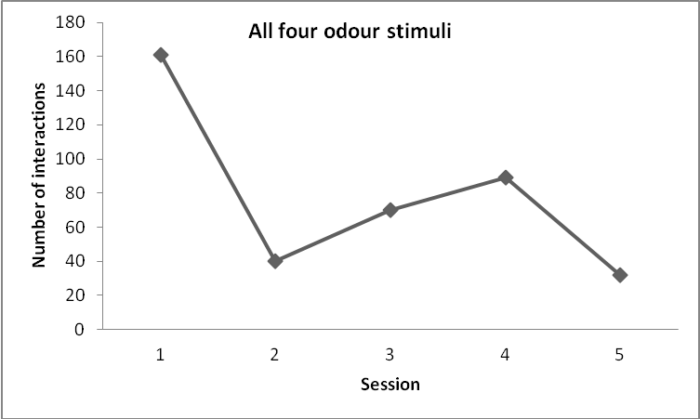
Figure 2. Total number of interactions displayed by the tigers with the scented logs across the five sessions with the data pooled from each of the four odour stimuli. The y-axis represents the number of interactions and the x-axis represents the order of the sessions.

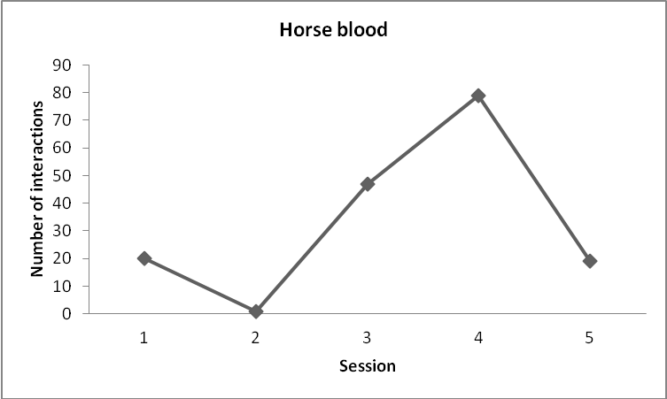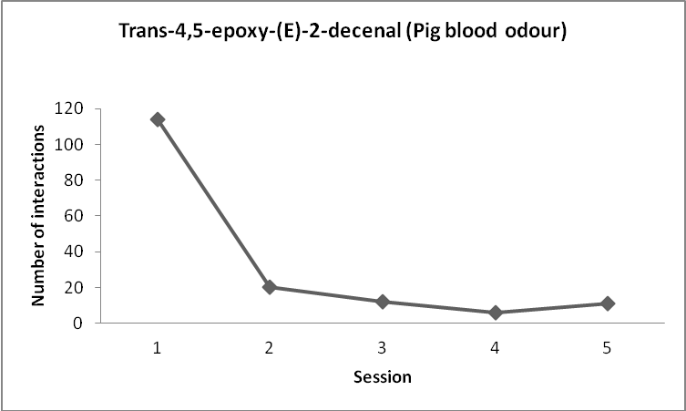
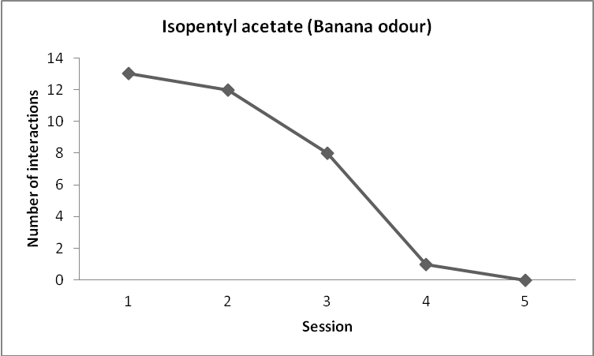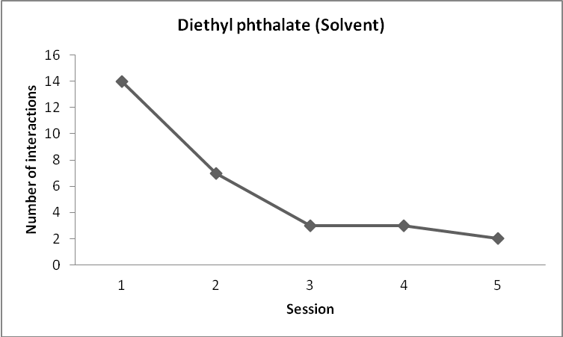

Figure 3. Number of interactions displayed by the tigers with the scented logs across the five sessions performed with each of the four odour stimuli. The y-axis represents the number of interactions and the x-axis represents the order of the sessions.

4.1.9 Comparisons between odours
When comparing the four different odour stimuli, the number of interactions were almost the same for horse blood (166 interactions) and the pig blood odour (163 interactions) (Chi-square value=0.01; P=0.91) (see table 3). There was no significant difference in the number of interactions between the banana odour (34 interactions) and the solvent (29 interactions) (Chi-square value=02; P=0.66) (see table 3). The number of interactions with the pig blood odour (163 interactions) was significantly higher than with the banana odour (34 interactions) (Chi-square value=47.31; P=0.0001) and with the solvent (29 interactions) (Chi-square value=53.24; P=0.0001) (see table 3). The number of interactions with the horse blood (163 interactions) was significantly higher than with the banana odour (34 interactions) (Chi-square value=48.88; P=0.0001) and with the solvent (29 interactions) (Chi-square value=54.9; P=0.0001) (see table 3).

4.2 Bush dogs

4.2.1 All four stimuli
During all the twenty sessions, with all four odour stimuli considered, the bush dogs showed a total of 1582 interactions with the scented logs (see table 2 and 5). Sniffing was by far the most common behaviour in the bush dogs with a total of 1305 interactions, which is more than 80% of all interactions. Biting was observed 105 times, Orientating, was observed 71 times and Toying was observed 52 times. Scent marking was observed 19 times, Licking was observed 10 times, Flehmen was observed 10 times and Pawing was observed 10 times. Impregnating and Vocalizing were not observed at all during any of the twenty observation days with the bush dogs (see table 2 and 5).

4.2.2 Horse blood
A total number of 540 interactions were observed during the five sessions in which horse blood was used as stimulus (see table 2 and 5). Sniffing was observed 467 times and was by far the most common behaviour. Orientating was observed 27 times and Biting was observed 17 times. Flehmen was displayed 9 times, Scent marking was displayed 7 times, Licking was displayed 6 times and Toying was displayed 5 times. Pawing was only observed 2 times, while Impregnating and Vocalizing were not observed at all during the five sessions with the horse blood (see table 2 and 5).

4.2.3 Trans-4,5-epoxy-(E)-2-decenal, Pig blood odour
The five sessions in which trans-4,5-epoxy-(E)-2-decenal (Pig blood odour) was tested, resulted in a total of 521 interactions (see table 2 and 5). Sniffing was the behavior which occurred most frequently, with a total of 371 interactions. Biting was observed 70 times, Toying was observed 40 times and Orientating was observed 29 times. Pawing occurred only 8 times and Licking and Scent marking also occurred very seldom and were observed 2 and 1 time, respectively. Flehmen, Impregnating and Vocalizing were not displayed at all during the five sessions with the pig blood odour (see table 2 and 5).

4.2.4 Isopentyl acetate, Banana odour
During the five sessions in which Isopentyl acetate (banana odour) was tested, a total of 297 interactions were observed (see table 2 and 5). Sniffing was by far the most common behaviour and comprised a total number of 261 interactions. Orientating was observed 10 times, Biting was observed 9 times, Scent marking was observed 8 times and Toying was observed 6 times. Licking and Flehmen were observed most seldom and were only seen 2 respectively 1 time. Impregnating, Pawing and Vocalizing were not displayed at all during the five sessions with the banana odour (see table 2 and 5).

4.2.5.Diethyl phthalate, Solvent
A total number of 224 interactions were observed during the five sessions in which the solvent was used as stimulus (see table 2 and 5). Sniffing was observed 206 times, Biting was observed 9 times and Orientating was observed 6 times. Scent marking and Toying were only observed 2 and 1 time, respectively, and Licking, Flehmen, Impregnating, Pawing and Vocalizing were not observed at all during the five sessions with the solvent (see table 2 and 5).

Table 5. Summary of the number of interactions for all behaviours considered in the study, preformed by the bush dogs.
 | Sniffing | Licking | Flehmen | Impregnating | Orientating | Pawing | Vocalazing | Biting | Toying | Scent marking | Total
Horse Blood | 467 | 6 | 9 | 0 | 27 | 2 | 0 | 17 | 5 | 7 | 540
Epoxy, Pig blood odour | 371 | 2 | 0 | 0 | 29 | 8 | 0 | 70 | 40 | 1 | 521
Banana odour | 261 | 2 | 1 | 0 | 10 | 0 | 0 | 9 | 6 | 8 | 297
Odourless Solvent, control | 206 | 0 | 0 | 0 | 6 | 0 | 0 | 9 | 1 | 2 | 224
Total | 1305 | 10 | 10 | 0 | 71 | 43 | 0 | 105 | 52 | 19 | 1582

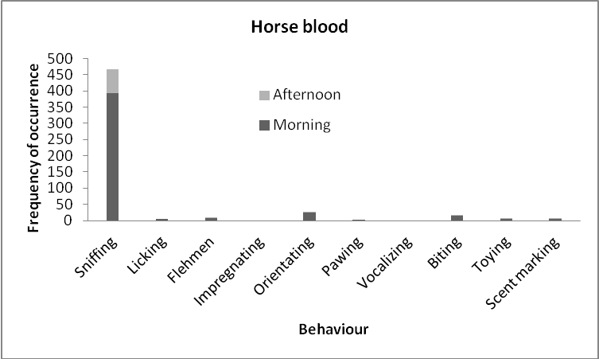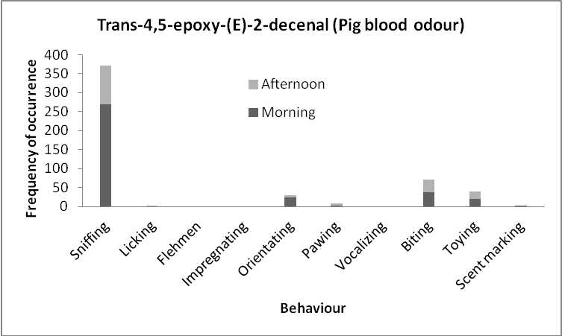
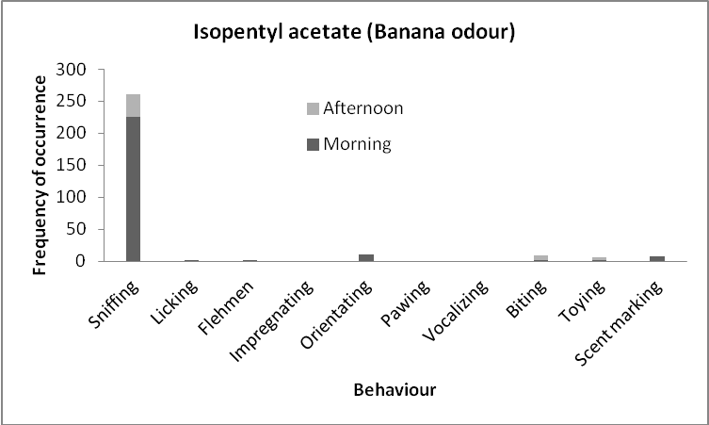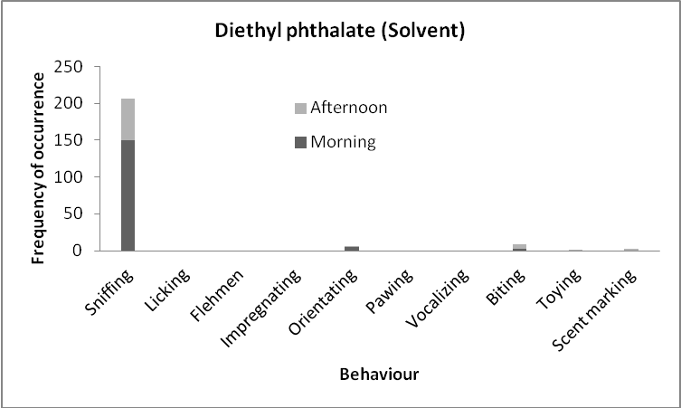
Figure 4. Frequency of occurrence of the different behaviours displayed by the bush dogs, during the five sessions performed with each of the four odour stimuli, and subdivided by morning and afternoon. The y-axis represents the number of interactions and the x-axis represents the 10 different behaviours covered in the study Scales on the y-axis differ to make the bars comparable and the diagrams easier to read.

4.2.6 Morning vs. Afternoon
During the morning hours of all 20 sessions performed with the bush dogs, a total of 1219 interactions were observed (see table 6). This was significantly higher than the 363 interactions that were observed during the afternoon hours (Chi-square value=249.87; P=0.0001) (see figure 6 and table 6). With the horse blood, a total of 459 interactions were observed during the morning hours and this was significantly higher than the total of 81 interactions that were observed during the afternoon hours (Chi-square value=150.77; P=0.0001) (see figure 4 table 6). With the pig blood odour, a total of 354 interactions were observed during the morning hours and this was significantly higher than the 167 interactions that were observed during the afternoon hours (Chi-square value=34.68; P=0.0001) (see figure 4 and table 6). With the banana odour, a total of 249 interactions were observed during the morning hours and this was significantly higher than the 48 interactions that were observed during the afternoon hours (Chi-square value=76.81; P=0.0001) (see figure 4 and table 6). With the solvent, a total of 157 interactions were observed during the morning hours, and this was significantly higher than the 67 interactions that were observed during the afternoon hours (Chi-square value=18.81; P=0.0001) (see figure 4 and table 6).
Table 6. Frequency of occurrence of all interactions displayed by the bush dogs with each of the four odour stimuli, subdivided by morning and afternoon.
 | Total | Trans-4,5-epoxy-(E)-2-decenal (pig blood odour) | Isopentyl acetate (fruity odour) | Diethyl phthalate (solvent) | Horse blood
Morning | 1219 | 354 | 249 | 157 | 459
Afternoon | 363 | 167 | 48 | 67 | 81

During the five sessions with the horse blood, a ll 8 observed behaviours were displayed more often in the morning than in the afternoon (see figure 4). During the five sessions with the pig blood odour, 4 out of the 7 observed behaviours were displayed more often in the morning than in the afternoon (see figure 4). Licking and Pawing were the two behaviours which were displayed more often in the afternoon, and Toying was observed the same number of times in the afternoon as in the morning (see figure 4). During the five sessions with the banana odour, 5 out of the 7 observed behaviours were displayed more often in the morning than in the afternoon. Biting and Toying were the behaviours which were displayed more often in the afternoon (see figure 4). During the five sessions with the solvent, only 2 out of the 5 observed behaviours were displayed more often in the morning than during the afternoon. Biting, Toying and Scent marking were displayed more often in the afternoon (see figure 4).

4.2.7 Duration of interactions
As it was not possible to record the length of each interaction, the duration of the interactions are therefore given as an average time, based on those interactions where recording of the time was possible. The length of each interaction was recorded from the moment the animal started interacting with a log, until the end of the interaction, with no regard to if the animal changed behaviour during the interaction. The bush dogs spent on average 5.63 seconds per interaction (mean value from n=105 interactions) (see table 8). During the five sessions with the horse blood, the bush dogs spent on average 7.8 seconds per interaction (mean value from n=53 interactions) (see table 8). The average time per interaction during the sessions with the horse blood where significantly higher than the average time per interaction, during the sessions with the solvent (P=0.0121). The average time per interaction during the sessions with the horse blood was significantly higher than during the sessions with both the banana odour (P=0.0005) and during the sessions with the pig blood odour (P=0.0000). During the five sessions with the pig blood odour, the bush dogs spent on average 3.2 seconds per interaction (mean value from n=24 interactions) (see table 8). There were no significant differences in average time per interaction between the sessions with the pig blood odour and the solvent (P=0.5078). Neither were there any significant differences in average time per interaction between the sessions with the pig blood odour and the sessions with the Banana odour (P=0.2364). During the five sessions with the Banana odour, the bush dogs spent on average 3.71 seconds per interaction (mean value from n=21 interactions) (see table 8). There were no significant differences in average time per interaction between the sessions with the solvent and the sessions with the banana odour (P=0.71). During the five sessions with the solvent, the bush dogs spent on average 3.01 seconds per interaction (mean value from n=7 interactions) (see table 8).

4.2.8 Variability across sessions
The interest of the bush dogs for the four odour stimuli both in terms of number of interactions with the scented logs and average time spent on each interaction varied throughout the study. During the five sessions with the horse blood, the number of interactions varied across the sessions with the lowest number of interaction during the fourth session (64 interactions) and the highest number during the third session (159 interactions) (see figure 6). The average time per interaction declined from 6.49 seconds during the first session, to 5.06 seconds during the last session, with a peak of 14.25 seconds (see figure 6). During the five sessions with the pig blood odour the number of interactions decreased from 161 during the first session, to 36 during the last session, with the lowest number of interactions (35 interactions) during the third session and the highest number of interactions (171 interactions) during the second session (see figure 8). The average time per interaction increased from 2 seconds during the first session, to 3.74 seconds during the last session (see figure 6). During the five sessions with the banana odour the number of interactions decreased from 84 interactions during the first session to 56 during the last session, with the lowest number of interactions during the fourth session (33 interactions) (see figure 6). During the first session with the banana odour, the average time per interaction was 3.21 seconds, then it increased to 5.04 seconds, and during the last session it decreased to 3.28 seconds (see figure 6). During the five sessions with the solvent, the number of interactions decreased from 51 times during the first session, to 14 times during the last session, with a peak during the second session with 75 interactions (see figure 6). The average time per interaction increased from 3.01 seconds during the first session to 6.3 seconds during the last session (see figure 6).

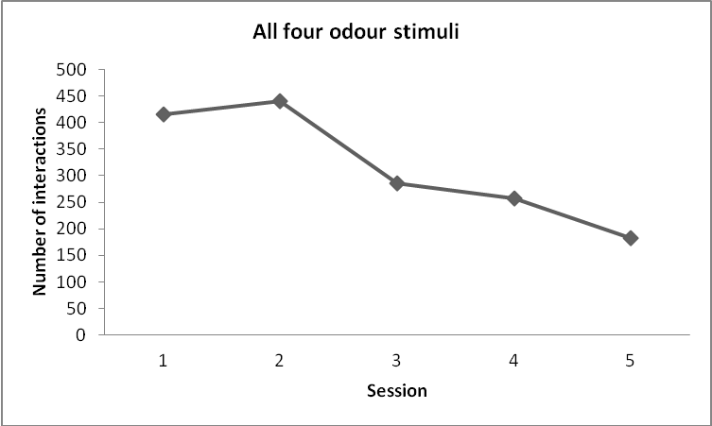
Figure 5. Total number of interactions displayed by the bush dogs with the scented logs across the five sessions with all four odour stimuli pooled. The y-axis represents the number of interactions and the x-axis represents the order of the sessions.

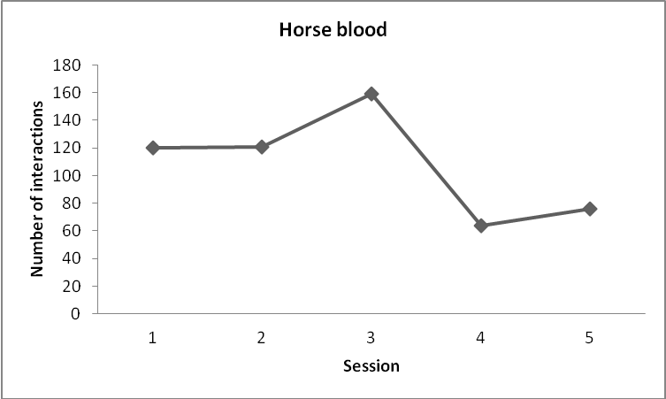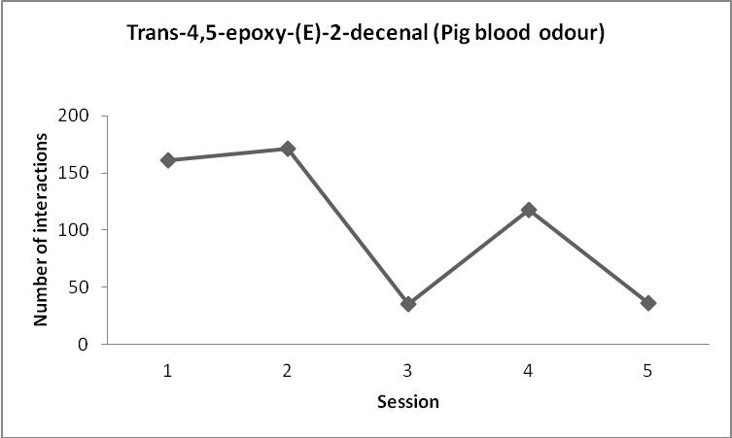
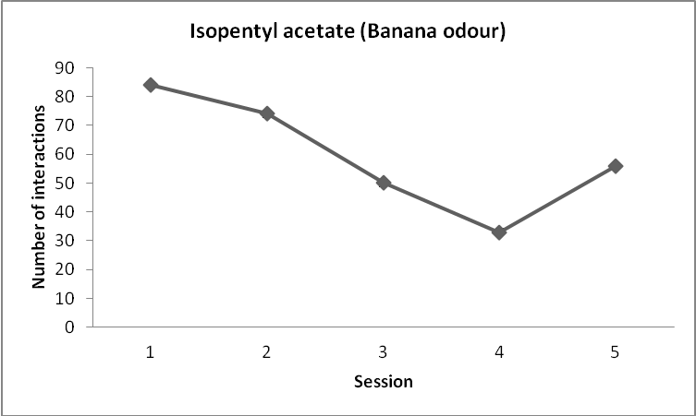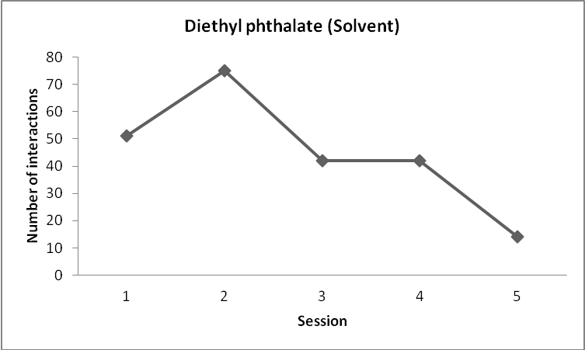
Figure 6. Number of interactions displayed by the bush dogs with the scented logs across the five sessions with all four odour stimuli pooled. The y-axis represents the number of interactions and the x-axis represents the order of the sessions.

4.2.9 Comparisons between odours
When comparing the number of interactions of the four different odour stimuli, there was no significant difference (Chi-square value=0.17; P=0.68) between the horse blood (540 interactions) and the pig blood odour (521 interactions) (Chi-square value=0.17; P=0.68) (see table 5). However, the number of interactions with the horse blood was significantly higher than both with the banana odour (297 interactions) (Chi-square value=36.03; P=0.0001) and the solvent (224 interactions) (Chi-square value=68.27; P=0.0001) (see table 5). There was a significant difference in number of interactions between the banana odour (297 interactions) and the solvent (224 interactions) (Chi-square value=5.14; P=0.023) (see table 5).The number of interactions with the pig blood odour was significantly higher than both the banana odour (Chi-square value=31.26; P=0.0001) and the solvent (Chi-square value=61.65; P=0.0001) (see table 5).

4.3 Comparisons between the two species

Table 7. The number of interactions per individual for both the tigers and the bush dogs with the four different odour stimuli.
 | Horse blood | Pig blood odour | Banana odour | Solvent | Total
Amur tigers | 27.66 | 27.16 | 5.66 | 4.83 | 65.3
Bush dogs | 54 | 52.1 | 29.7 | 22.4 | 158.2

As the number of individuals was not the same for the tigers and the bush dogs, the number of interactions per individual was calculated to allow for valid comparisons between the two species. The total number of interactions for all odours, and the four different odours separately were divided by the number of individuals of each species. The number of interactions per individual tiger was 65.3 (see table 7). The number of interactions per individual bush dog was 158.2 (see table 7). Thus, the number of interactions per animal was significantly higher for the bush dogs than for the tigers (Chi-square value=20.08; P=0.001). During the five sessions with the solvent, the number of interactions per individual was 22.4 for the bush dogs. This was significantly higher than the 4.83 interactions per individual tiger, tested with the solvent (Chi-square value=6.33; P=0.0119) (see table 7). During the five sessions with the banana odour, the number of interactions per individual bush dog was 29.7. This was significantly higher than the 5.66 interactions per individual tiger (Chi-square value=9.24; P=0.0024) (see table 7). With the pig blood odour, the number of interactions per individual was 52.1 for the bush dogs. This was significantly higher than the 27.16 interactions per individual tiger (Chi-square value=4.2; P=0.0404) (see table 7). During the five sessions with the horse blood, the number of interactions per individual bush dog was 54. This was significantly higher than the 27.66 interactions per individual tiger (Chi-square value=4.36; P=0.0368) (see table 7).
When comparing the time spent on each interaction across all four odour stimuli, the tigers displayed longer interactions (mean=12.46±7.05 seconds), compared to the bush dogs (mean=5.63±3.49 seconds) (see table 8). When looking at the separate odour stimuli and the average time the two species spent on each interaction, the tigers spent more time (mean=7.61±9.63 seconds) on each interaction with logs scented with the banana odour, than the bush dogs (mean=3.71±3.26 seconds) (see table 8). The tigers also spent more time (mean=6.24±7 seconds) on each interaction with the pig blood odour, than the bush dogs (mean=3.2±3.99 seconds) (see table 8). With the horse blood, the tigers also spent more time (mean=17.42±1.21 seconds) on each interaction, compared to the bush dogs (mean=7.79±7.72 seconds) (see table 8). When the logs were impregnated with the solvent, the bush dogs spent on average longer time (mean=3.01±2.13 seconds) on each interaction than the tigers (mean=1.78±0.45 seconds) (see table 8).

Table 8. The average time in seconds with standard deviation that the two species spent on each interaction with the logs, scented with the four different odour stimuli.
 | Total | Horse blood | Trans-4,5-epoxy-(E)-2-decenal (pig blood odour) | Isopentyl acetate (banana odour) | Diethyl phthalate (solvent)
Tigers | 12.46 ± 7.05 | 17.42 ± 12.21 | 6.24 ± 7 | 7.61 ± 9.63 | 1.78 ± 0.45
Bush dogs | 5.63 ± 3.49 | 7.79 ± 7.72 | 3.2 ± 3.99 | 3.71 ± 3.26 | 3.01 ± 2.13

Discussion

5.1 Main findings
The number of interactions per animal with the scented logs was significantly higher for the bush dogs than for the tigers with all four odour stimuli, and sniffing was by far the most common behaviour in both species. The highest number of interactions in both the tigers and the bush dogs, were observed during the sessions with the horse blood and the pig blood odour and there was no significant difference in the number of interactions between these two odours in any of the species. The number of interactions with both the horse blood and the pig blood odour was significantly higher than the number of interactions with the banana odour and the solvent in both species. The tigers spent longer time on average on each interaction than the bush dogs and both the tigers and the bush dogs spent longer time on average on each interaction with the horse blood than with the other three odour stimuli.

5.2 Amur tigers
Sniffing was, by far, the most frequently displayed behaviour by the tigers. This might indicate that the sense of smell is one of the most important senses for tigers when examining the surrounding and novel objects, compared to for example taste. The tigers displayed the highest number of interactions during the sessions with the horse blood (166) and the pig blood odour (163). This might indicate that the tigers associate the blood odour with prey or food. The high interest for the pig blood odour might also indicate that the tigers may perceive Trans-4,5-epoxy-(E)-2-decenal as blood-like, as is the case for humans (Konopka and Gorsch 1991). It also indicates that one single component of blood odour may evoke the same response in the tigers as the whole complex mixture of real blood. The tigers showed a slightly higher variability in the types of log-directed behaviours in proportion to the number of interactions in total, during all sessions, compared to the bush dogs. This might indicate that the tigers do not only rely on their sense of smell when investigating novel objects. As biting and Licking were also common behaviours, the tigers may use their sense of taste to investigate the source of interesting odours. Pawing and Toying were also displayed quite often and this might indicate that manipulation is an important way for the tigers to investigate objects.

5.3 Bush dogs
As for the tigers, Sniffing was also, by far, the most common behaviour displayed by the bush dogs. The sense of smell may, therefore be one of the most important senses for bush dogs, too. The bush dogs also displayed a higher number of interactions during the sessions with the horse blood (540) and the pig blood odour (521) than during the sessions with the banana odour (297) and the solvent (224). This may, indicate that the bush dogs, similar to the tigers, finds the Trans-4,5-epoxy-(E)-2-decenal as interesting as the whole complex mixture of real blood. Compared to the tigers, the bush dogs also showed a relatively high number of interactions during the sessions with the banana odour and the solvent. This indicates that the bush dogs might be more interested in novel objects and odours in general, than the tigers.

5.4 Comparisons between the two species
The bush dogs showed a higher number of interactions per animal with all four odour stimuli, compared to the tigers. This might have been due to the fact that the bush dogs are more active in general than the tigers that spend a large portion of their daytime hours inactive or resting. It might also indicate, as previously mentioned, that the bush dogs are more interested in investigating novel objects and foreign odours.

5.5 The four odour stimuli
The high interest for the horse blood displayed by both species might be due to the fact that the horse blood was coloured, which is one factor that distinguished the horse blood from the other stimuli, which were all colourless. This could have resulted in that both species perceived the contrast of the horse blood as darker than the rest of the odour stimuli. This could be tested by adding coloured, odourless markings to the logs applied with the other three odour stimuli. However, for both species, the interest for the pig blood odour was as high as for the horse blood, which points at that this single blood odour component was as interesting as the real blood. The banana odour, on the other hand, was not much more interesting than the solvent. This was expected for the tigers, because fruits are not a naturally included in their diet and they might therefore not associate the banana odour with food and it might therefore not have been perceived as interesting as the blood odours. The bush dogs, however, showed a quite high interest for both the banana odour and the solvent. This might only indicate that the bush dogs are more interested in odours in general, than tigers, since there were no significant differences in number of interactions between the banana odour and the solvent.

5.6 Odours as enrichment for carnivores
Insufficient environments and lack of external stimuli are factors that can lead to the development of stereotypic behaviours in captive animals (Hogan 2010). Odours as enrichment for large cats has repeatedly been reported to increase the activity level in captivity. Powell reported that an odour from the tarsal glands of a male deer increased the activity level of adult lions and also elicited social behaviours (Powell 1995). Baker found that captive lions increased their social behaviours between individuals after the enclosure was provided with fecal material from prey animals (Baker 1997). Quirke and O’Riordan 2011 showed that the levels of pacing in captive cheetahs decreased significantly after the animals were exposed to different kinds of olfactory enrichment, such as fresh oryx feaces. Olfactory enrichment for large cats may therefore be effective and easy to use, for lowering levels of stereotypic behaviours and promote species-specific behaviours, as large carnivores are especially vulnerable to stereotypies (Esteban Fuentes 2003).
The bush dogs showed a high number of sniffing and did not seem to lose their interest for the scented logs throughout the study (see figure 5 and 6). Therefore odours and novel objects as a form of enrichment for bush dogs in captivity might be a good way to increase the activity levels and promote species-specific behaviours.
However, the tigers in the present study seemed to lose their interest quicker than the bush dogs in the scented logs used as enrichment tools. Therefore it might be important to think of variation when providing enrichment for captive tigers. As the tigers showed a higher variability in their log-directed behaviours than the bush dogs, not only the odours, but also colour, taste, shape and texture are factors that could be varied when providing captive tigers with enrichment, to prevent that the animals lose their interest for the enrichment.

5.7 Limitations and further studies
As with all studies performed with live animals, there are many factors that might affect the results. In the present study, I observed that the general activity level of both species differed between the sessions. The study was conducted between April and October and the ambient temperature might therefore have had an effect on especially the bush dogs, as they are adapted for a much warmer climate than what we have in Sweden. During the morning hours of some of the sessions, the bush dogs stayed inside and did not become active until the ambient temperature increased. The bush dogs also seemed more inactive during days when the ambient temperature was low. The tigers, on the other hand, were more active early during the mornings and became more inactive as the temperature increased and when the sun stood high.
The tigers seemed to lose their interest for the logs very quickly and the number of interactions decreased after a number of sessions. This is why it is important to do the sessions with the different stimuli in random order and to keep an interval without olfactory enrichment between the sessions with the different odours (Clark and King 2008).
Both species showed the highest interest for the logs with the horse blood. As the horse blood was the only coloured odour, it might be one factor to study whether blood-coloured objects are more interesting to carnivores, than colourless objects, or objects with other colours than blood-like. However, the interest of both species in Trans-4,5-epoxy-(E)-2-decenal was not significantly different from that for horse blood, although it was colourless. This suggests that enrichment with colourless odours can be as efficient as enrichment with coloured odours.
For further studies, it might be of interest to assess the impact of the objects on the interest for the odours, by using the same odours as in this study on varying types of objects. It might also be of interest to perform a study, similar to the present one, but instead using different prey-related odours such as faeces. It would also be of interest to perform a study with carnivore species other than those used in the present study.

Conclusion
To conclude, there were no significant differences in interest between the horse blood and the pig blood odour for both the tigers and the bush dogs. The interest for both the horse blood and the pig blood odour was significantly higher than for the banana odour and the solvent. This might indicate that both the tigers and the bush dogs found the single blood odour component as interesting as the whole complex mixture of real blood. The results suggest that Trans-4,5-epoxy-(E)-2-decenal, might be perceived as a blood-like odour in both tigers and bush dogs and could maybe therefore be associated with prey-related odours. The study also shows that prey-related odours can be used as an effective means of enrichment for captive carnivores.

Acknowledgements
I want to thank my supervisor, Matthias Laska, for all the help, support and encouragement throughout the whole progress of this study. I would also like to thank the carnivore care takers at Kolmården zoo, whom have been helping me and simplified the data collection.

References

Baker Jr. WK (1997) Enriching the pride: Scents that make sense. The Shape of Enrichment 6, 2-3
Barja I, de Miguel FJ (2010) Chemical communication in large carnivores: Urine-marking frequencies in captive tigers and lions. Polish Journal of Ecology 58, 397-400
Brahmachary RL, Dutta J (1987) Chemical communication in the Tiger and Leopard. Tigers of the world (296-302). Tilson, RL. Noyes Publication. USA
Brahmachary RL, Sarkar M, Dutta J (1992) Chemical signals in the tiger. Chemical signals in vertebrates IV (471-475). Plenum Press. New York
Buettner A, Schieberle P (2001) Aroma Properties of a Homologous Series of 2,3-Epoxyalkanals and trans-4,5-Epoxyalk-2-enals. Journal of Agricultural and Food Chemistry 49, 3881−3884
Clark F, King AJ (2008) A critical review of zoo-based olfactory enrichment. Chemical Signals in Vertebrates 11, 392-397
Esteban Fuentes E (2003) Heavy prey: Promoting dragging behaviour in large cats. The Shape of Enrichment 12, 1
Gorman ML, Trowbridge BJ (1989) The role of odour in the social lives of carnivores. Carnivore behaviour, ecology and evolution (57-83). Chapman and Hall. London
Hogan LA, Johnston SD, Lisle A, Horsup AB, Janssen T, Philips CJ (2010) Stereotypies and environmental enrichment in captive southern hairy-nosed wombats, Lasiorhinus latifrons. Applied Animal Behaviour Science 126, 85–95
Ings R, Waran NK, Young RJ (1997) Effect of wood-pile feeders on the behaviour of captive bush dogs (Speothos venaticus). Animal Welfare 6, 145-152
Jordan MJ, Tandon K, Shaw PE, Goodner KL (2001) Aromatic profile of aqueous banana essence and banana fruit by gas chromatography-mass spectrometry (GC-MS) and gas chromatography-olfactometry (GC-O). Journal of Agricultural and Food Chemistry, 49, 4813-4817
Kleiman D (1966) Scent marking in the Canidae. Play, exploration and territority in mammals (167-177). Symposia of the Zoological Society of London 18. London
Konopka UC, Grosch W (1991) Potent odorants causing the warmed-over flavour in boiled beef. Lebensmittel-Untersuchung und Forschung 193, 123-125
Mellen JD (1993) A comparative analysis of scent-marking, social and reproductive behaviour in 20 species of small cats (Felis). American Zoologist 33, 151-166
Poddar-Sakar M, Brahmachary RL, Dutta J (1994) Scent marking in the tiger. Advances in the Biosciences 93, 339-344
Porton I (1983) Bush dog urine-marking: Its role in pair formation and maintenance. Animal Behaviour 31, 1061-1069.
Powell DM (1995). Preliminary evaluation of environmental enrichment techniques for African lions (Panthera leo). Animal Welfare 4, 361-370
Quirke T, O’Riordian RM (2011) The effect of a randomised enrichment treatment schedule on the behaviour of cheetahs (Acinonyx jubatus). Applied Animal Behaviour Science 135, 103-109
Ralls K (1971) Mammalian scent marking. Science 171, 3970, 443-449

Salmon B, Martin GJ (1996) Compositional and isotopic studies of fruit flavours. Part I. The banana aroma. Flavour and Fragrance Journal 11, 353-359
Schaller GB (1967). The tiger. The deer and the tiger (252-255). University of Chicago Press. Chicago and London
Skibiel AL, Trevino HS, Naugher K (2007) Comparison of several typesof enrichment for captive felids. Zoo Biology 26, 371–381
Stoddart DM (1980) Detection of food. The ecology of vertebrate olfaction (63-83). Chapman and Hall. London and New York
Szokalski MS, Litchfield CA, Foster WK (2012) Enrichment for captive tigers (Panthera tigris): Current knowledge and future directions. Applied Animal Behaviour Science 139, 1– 9
Truelove MA (2006) Flavor spray: Enrichment for the senses. The shape of enrichment 15, 4
Wielebnowski N, Brown JL (1998) Behavioral correlates of physiological estrus in cheetahs. Zoo Biology 17, 193–209
Yu S, Jiang Z, Zhu H, Li C, Zhang E, Zhang J, Harrington C (2009) Effects of odours on behaviours of captive Amur leopards (Panthera pardus orientalis). Current Zoology 55, 20-27

