Final Thesis

Olfactory discrimination of aliphatic aldehydes, carboxylic acids and acetic esters in South African fur seals (Arctocephalus pusillus)

Sandra Selin

LiTH-IFM-Ex--08/1968--SE

Contents
1 Abstract 1
2 Introduction 1
3 Materials and methods 3
3.1 Animals 3
3.2 Odorants 4
3.3 Test procedure 4
3.3.1 Experimental set-up 5
3.4 Data analysis 6
4 Results 7
4.1 Carboxylic acids 7
4.2 Aldehydes 8
4.3 Esters 9
4.4 Comparison between odorant classes 10
5 Discussion 10
5.1 Carboxylic acids 10
5.2 Aldehydes 11
5.3 Esters 11
5.4 Olfactory cues in social communication and reproductive behavior of seals 12
5.5 Comparison between species 13
5.6 Conclusion 14
6 Acknowledgements 14
7 References 14

1 Abstract
Using a food-rewarded two-choice instrumental conditioning paradigm, the ability of five South African fur seals (Arctocephalus pusillus) to distinguish between members of three homologous series of aliphatic odorants was investigated. Aliphatic aldehydes, carboxylic acids and acetic esters with carbon chain lengths of C4 to C7 were employed. These classes of odorants are thought to differ in their frequency of occurrence in the marine environment. The results showed that the seals successfully reached the learning criterion with all stimulus combinations but one and thus were clearly able to discriminate between most of the odorant pairs presented. No significant correlation between discrimination performance and structural similarity in terms of differences in carbon chain length in either of the odorant classes was found. Furthermore, the results showed that none of the odorant classes was significantly better or poorer discriminated by the seals than the other two classes. However, the acetic esters yielded the lowest mean percentage of correct discriminations and failure to distinguish between a given odorant pair occurred only with this odorant class. The results support the notion that the sense of smell may play an important and hitherto underestimated role in foraging, social communication and reproductive behavior of this pinniped species. However, the results do not support the hypothesis that discrimination performance may correlate with the frequency of occurrence of stimuli in a species’ chemical environment.

Keywords: Acetic esters, Aliphatic aldehydes, Arctocephalus pusillus, Carboxylic acids, Discrimination ability, Olfaction

2 Introduction
The sense of smell plays an important role in the regulation of behavior in a wide variety of species. The perception of odors starts with olfactory receptors (ORs) interacting with odor molecules (Buck & Axel 1991, Malnic et al. 1999). The ORs are on olfactory sensory neurons, which transmit signals to the olfactory bulb of the brain in response to stimulation with odor molecules. From the olfactory bulb, signals are then conveyed to several areas of the brain, including the olfactory cortex (Zou & Buck 2006) where processing of the olfactory information takes place and allows the brain to detect and discriminate between odors (Buck & Axel 1991).
Marine mammals are traditionally considered as having a poor sense of smell (Lowell & Flanigan Jr 1980, Brown 1985). However, behavioral observations suggest that olfaction may play an important role in social communication, reproductive behavior and food selection for several pinniped species, many of them fur seals. Ross (1972) reported nuzzling behavior, naso-nasal contact, in captive South African fur seals (Arctocephalus pusillus) and naso-nasal contact between mother and pup as final recognition has been described for harp seals, Phoca groenlandica (Kovacs 1987, Kovacs 1995), Alaska fur seals, Callorhinus ursinus (Bartholomew 1959), South American fur seals, Arctocephalus australis (Phillips 2003) and Antarctic fur seals, Arctocephalus gazella (Dobson & Joventin 2003). Miller (1974) reported that male New Zealand fur seals (Arctocephalus forsteri) investigated females by sniffing their facial and perineal regions during breeding season, presumably with the purpose of assessing the females’ reproductive state.
To the best of my knowledge, only two studies have so far examined olfactory performance in pinnipeds. Kowalewsky et al. (2006) showed that harbor seals (Phoca vitulina) have a high sensitivity for dimethyl sulfide (DMS), an odorant often linked to areas of high marine productivity (Bopp et al. 2003), which can be indicative of prey (Thompson & Miller 1990). The second study, by Laska et al. (2008), reported that South African fur seals were able to discriminate between a fish- and non-fish odor and, more importantly, between two fish odors, suggesting a good discrimination performance of odorants related to food selection and foraging.
The purpose of the present study is to extend the findings provided by Laska et al. (2008) by systematically assessing the discrimination ability of South African fur seals for classes of odorants that are likely to differ in their behavioral relevance for food selection and social communication of seals. Aliphatic aldehydes have repeatedly been reported to be important components in fish odors (Josephson et al. 1984, Kinsella & Hsieh 1985, Lindsey 1990) and are listed as naturally occurring in fish (Burdock 2001). Carboxylic acids have also been reported as important components of fish (Gruger et al. 1964, Burdock 2001) and as constituents in seal blubber (Arnould et al. 2005, Koep et al. 2007), and thus may contribute to the skin-borne body odor of the seals. Both aldehydes and carboxylic acids are thus presumably of behavioral relevance in foraging and social communation. Acetic esters, on the other hand, are known to be the quantitatively and qualitatively dominant components in the odors of a variety of fruits (Sun Pan & Kuo 1994) and are only rarely found in the marine environment and thus should be of little behavioral relevance to the seals.
Previous studies assessing discrimination performance in humans, squirrel monkeys (Saimiri sciureus) and mice (Mus musculus) have found a significant negative correlation between discrimination performance and structural similarity in terms of differences in carbon chain length of aldehydes (Laska & Teubner 1999, Laska et al. 1999, Laska et al. 2007), carboxylic acids (Laska & Teubner 1998) and esters (Laska & Freyer 1997, Laska & Hübener 2001).
The aims of the present study are threefold: (i) to provide first systematic data on the olfactory discrimination ability of South African fur seals for homologous series of carboxylic acids, aldehydes and esters; (ii) to assess whether a correlation between discrimination ability and structural similarity of the odorants under investigation exits; and (iii) to compare the results from the present study to those of earlier studies that employed the same classes of odorants in assessing discrimination performance in other species.

3 Materials and methods

3.1 Animals
The study was conducted using four adult females (Flisa, Tinny, Sealia and Villma) and one adult male (Jocke) South African fur seals (Arctocephalus pusillus) (Figure 1) kept as part of a group of ten animals at Kolmården Wild Animal Park, Sweden. The group was housed under semi-natural conditions in an 800 m² outdoor pool neighbouring a house bearing single cages. The animals were trained to enter the cages voluntarily and were fully accustomed to the procedure which allowed temporary separation for individual testing. Feeding of fish and occasionally squid occurred twice a day.
The experiments reported here comply with the Guide for the Care and Use of Laboratory Animals (National Institutes of Health Publication no. 86-23, revised 1985) and also with current Swedish laws.

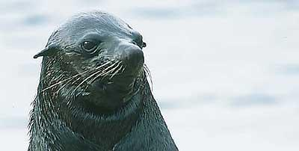
Figure 1. South African fur seal (Arctocephalus pusillus)

3.2 Odorants
A total of 13 odorants, including three sets of four structurally related odorants (Table 1) and the essential oil of black pepper (Piper nigrum) were used. The sets of odorants included members of three chemical classes: Carboxylic acids, aldehydes and esters, which only differed from each other in carbon chain length (C4-C7). All odorants, with the exception of the essential oil, were diluted using diethyl phthalate as the solvent. The level of dilution for each of the odorants was chosen to provide stimuli that were easily detectable and of approximately equal subjective intensity for humans.

Carboxylic acids | Dilution | Aldehydes | Dilution | Esters | Dilution
Butanoic acid (C4) | 1:10 | Butanal (C4) | 1:10 | Ethyl acetate (C4) | 1:10
Pentanoic acid (C5) | 1:10 | Pentanal (C5) | 1:10 | Propyl acetate (C5) | 1:10
Hexanoic acid (C6) | 1:10 | Hexanal (C6) | 1:10 | Butyl acetate (C6) | 1:3
Heptanoic acid (C7) | 1:2 | Heptanal (C7) | 1:5 | Pentyl acetate (C7) | 1:3
Table 1. Substances and dilutions

3.3 Test procedure
The test was based on a food-rewarded two-choice instrumental conditioning paradigm. In a previous study, the animals had been trained to sniff at two odor sampling ports and then to indicate their choice for one of the options by poking their nose into the corresponding sampling port.
For each of the three sets of stimuli, one odorant (either the C4 or the C7 stimulus) per animal was chosen as the rewarded stimulus (S+) and in an initial phase, each animal was allowed to become familiar with its S+. This was done by using black pepper oil as unrewarded stimulus (S-) in up to ten sessions; black pepper oil had been used as S- in previous experiments and was therefore known to the animals. Once familiarized with the S+, the black pepper oil was exchanged for one of the other odorants of the same set (Table 2) and each of the critical stimulus combinations was presented for four sessions. If needed, up to two sessions with black pepper oil as S- were implemented between the different combinations in order to boost the animal’s confidence and to refresh its memory for the reward value of the S+.

∆C1 | ∆C2 | ∆C3
4-5 | 4-6 | 4-7
6-7 | 5-7
Table 2. Assignment of odor pairs to groups according to differences in carbon chain length. ∆C1 corresponds to the discrimination of odorants which differ by only one carbon atom, and ∆C2 and ∆C3 to the discrimination of odorants which differ by two and three carbon atoms, respectively.

3.3.1 Experimental set-up
An opaque PVC board (50 x 100 x 1 cm) with two openings was placed at the front of the test cage. The two openings (7.5 cm diameter) were positioned 42 cm apart, at the same height and, with the board mounted onto the front side of the cage, 47 cm above the ground. Five HDPE containers (Rubbermaid® Cooling Bags, 35 x 35 x 20 cm) were used to present the odor stimuli – one for the S- (black pepper oil) and one each for the four stimuli of a given set of odorants (see Table 1). On the front side of the containers, a total of 130 holes (3 mm diameter) were drilled, distributed in intervals of even distance making it a filled circle (7.5 cm diameter) matching the openings on the PVC board. The removable lids were tight-fitted and two of them were equipped with a battery-powered ventilator (6 cm diameter) with the purpose of providing a constant airflow through the container and creating an outflow of 8 L/min at the holes on the front. In order to present the odor stimuli without giving the animals any visual cues, 1 ml of the odor was pipetted onto a Petri dish which in turn was placed into an opaque HDPE box (12 x 20 x 12 cm) which then was put in the container. A mirror placed on the top of the cage allowed the experimenter to observe the animal’s behavior behind the opaque board without being seen and without giving any unintentional visual cues.

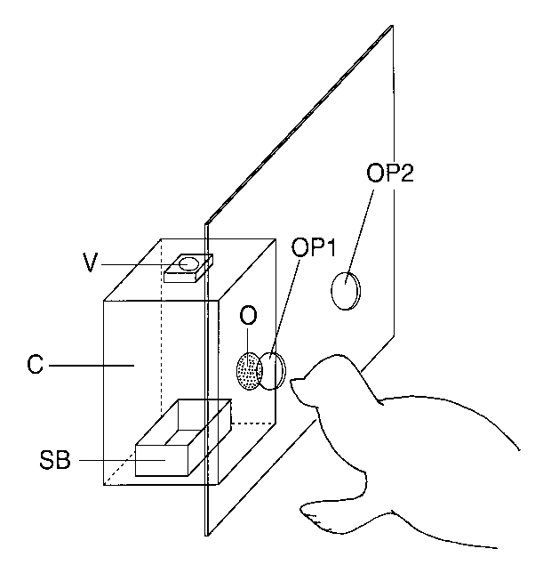
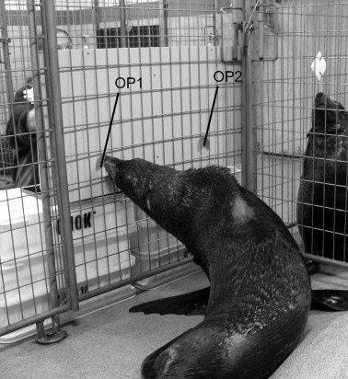
Figure 2. Left: Schematic drawing of the experimental set-up used to assess olfactory performance in South African fur seals. C: container; V: ventilator for ingoing airflow; SB: stimulus box; O: outlet for outgoing airflow; OP1: odor port 1; OP2: odor port 2. The second, identically built container placed behind odor port 2, is not shown. Right: Photo of the experimental set-up used to assess olfactory performance in South African fur seals. OP1: odor port 1; OP2: odor port 2. The containers cannot be seen in the picture.

At the beginning of each trial, the two containers were placed with their outlets towards the odor sampling ports. The animal was then allowed to sniff at both ports as long and as often as it needed to make a choice. Immediately after an animal had indicated its choice by poking its nose into the corresponding odor port, the containers were removed. In case of a correct choice, the animal received fish or squid as a reward, in case of an incorrect choice, a new trial began after a short time-out without any reward. Twenty such trials were performed per session and usually two sessions were carried out per day and animal. The order in which the rewarded stimulus was presented to the right or left odor sampling port followed a pseudorandomized sequence with the limitation that the same side was not used more than three times in a row. At the end of each session, the containers and the boxes that had been used were thoroughly cleaned.

3.4 Data analysis
In each trial, two outcomes were possible: (1) a correct response to the rewarded stimulus (hit), and (2) a false response to the negative stimulus (false alarm). The percentage of correct decisions was used as the measure of performance and the criterion was set to 67.5% correct in two consecutive sessions of 20 decisions each (corresponding to p < 0.05, binomial test).
Correlations between discrimination performance and structural similarity of odorants in terms of differences in carbon chain length were evaluated using the Spearman rank correlation coefficient.
Comparisons of group performance across tasks were made using the Friedman two-way analysis of variance.

4 Results

4.1 Carboxylic acids
Figure 3 illustrates the performance of the animals in discriminating between the different odor pairs. All four animals successfully reached the criterion with each of their stimulus combinations and thus were clearly able to discriminate between all carboxylic acids used.
No statistically significant correlation between discrimination performance and structural similarity in terms of differences in carbon chain length was found (Spearman, r_{s}=-0.03; p=0.92). Accordingly, only one of the animals (Sealia) showed an increase in performance that followed a decrease in structural similarity in terms of differences in carbon chain length.
Data was collected from four animals only, due to one animal being unavailable (Flisa).

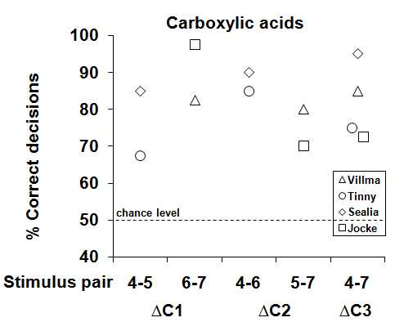
Figure 3. Performance of four animals in discriminating between members of a homologous series of carboxylic acids. Each data point represents the percentage of correct choices from 40 consecutive trials. The four different symbols represent data from each of the four individual animals tested.

4.2 Aldehydes
Figure 4 illustrates the performance of the animals in discriminating between the different odor pairs. All five animals successfully reached the criterion with each of their stimulus combinations and thus were clearly able to discriminate between all aldehydes used.
No statistically significant correlation between discrimination performance and structural similarity in terms of differences in carbon chain length was found (Spearman, r_{s}=-0.09; p=0.72). Accordingly, two of the animals (Tinny and Flisa) showed a decrease in performance that followed an increase in structural similarity in terms of differences in carbon chain length whereas in one animal (Villma) the opposite could be seen.
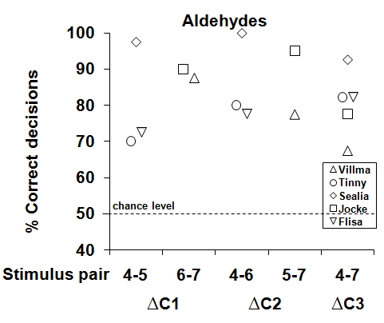
Fig 4. Performance of five animals in discriminating between members of a homologous series of aldehydes. Each data point represents the percentage of correct choices from 40 consecutive trials. The five different symbols represent data from each of the five individual animals tested.

4.3 Esters
Figure 5 illustrates the performance of the animals in discriminating between the different odor pairs. Only three of the animals successfully reached the criterion with each of their stimulus combinations and thus were clearly able to discriminate between all esters; Villma and Tinny failed to reach the criterion on one their stimulus combinations (odor pair 5-7).
No statistically significant correlation between discrimination performance and structural similarity in terms of differences in carbon chain length was found (Spearman, r_{s}=0.26; p=0.33). Accordingly, in one animal (Flisa) the performance decreased with increasing structural similarity in terms of differences in carbon chain length. Sealia, on the other hand, demonstrated a reverse result, i.e. there was an increase in performance that followed a decrease in structural similarity in terms of differences in carbon chain length.

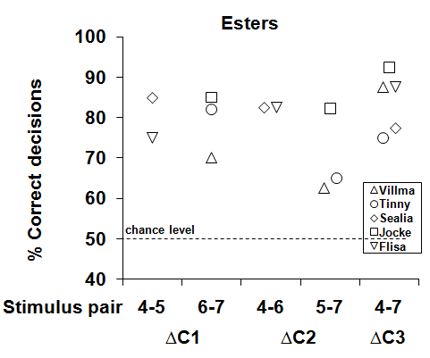
Fig 5. Performance of five animals in discriminating between members of a homologous series of esters. Each data point represents the percentage of correct choices from 40 consecutive trials. The five different symbols represent data from each of the five individual animals tested.

4.4 Comparison between odorant classes
A statistical comparison of performance between the three classes of odorants showed that none of them was significantly better or poorer discriminated than the two other classes (Friedman ANOVA, chi=1.83; p=0.40). This was further supported by comparing the average performance (mean ± SE) across all odor pairs within a given class, which was found to be quite similar for the three sets of odorants (carboyxlic acids: 82.1± 2.8%; aldehydes: 83.3±2.6%; esters: 79.5±2.2%). Nevertheless, the esters were the only odorant class in which two animals failed to reach the criterion for discrimination with one of the stimulus combinations.

5 Discussion
The results of this study demonstrate, for the first time, that South African fur seals have a well-developed olfactory discrimination ability for monomolecular odorants belonging to the classes of carboxylic acids, aldehydes and esters. No significant correlation between discrimination performance and structural similarity in terms of differences in carbon chain length in either of the odorant classes was found. Furthermore, the results show that none of the odorant classes was significantly better or poorer discriminated by the seals than the other two classes.

5.1 Carboxylic acids
Carboxylic acids can be found in a wide variety of fish and fish oil odors (Gruger et al. 1964). Burdock (2001) states that pentanoic acid, hexanoic and heptanoic acid all have been reported to be naturally occuring in fish odors and Guillén & Errecalde (2002) found small amounts of hexanoic acid in raw black bream (Brama raii) along with several other carboxylic acids. Members of this class of odorants have also been found in the blubber of South African fur seals (Arnould et al. 2005, Koep et al. 2007) and Cadweller & Shahidi (2001) reported the presence of butanoic acid as one of 27 potent odorants in crude seal blubber oil.
Accordingly, the occurrence of carboxylic acids is wide-spread in the chemical environment of the seals which might explain their good discrimination performance. The presence of carboxylic acids in fish and fish oil odors indicates that this class of odorants may play an important part in foraging. Moreover, as constituents in blubber, carboxylic acids presumably contribute to skin-borne body odors, which several studies have suggested to be important olfactory cues in the social communication and the reproductive behavior of seals.
5.2 Aldehydes
Volatile aldehydes are secondary products from the lipid oxidation of polyunsaturated fatty acids (PUFAs) which can be found in fish flesh, and these volatile aldehydes can contribute to the fresh aroma of various species of fish, even at low concentrations (Kinsella & Hsieh 1985). Accordingly, several studies using different extraction methods reported the presence of aldehydes in the odor of various species of fish: de Cunha Veloso et al. (2001) found small amounts of butanal, pentanal and hexanal along with a few other aldehydes in three species of snapper (Ocyurus sp., Lutjanus sp. and Rhomboplites sp.) and cobia (Rachycentron sp.). Varlet et al. (2006) detected the presence of several aldehydes, including hexanal and heptanal in fresh salmon (Salmo salar). Zhang & Lee (1997) accounted for several aldehydes in fresh mackerel (Scomber scombrus), for example pentanal, hexanal and heptanal, and by using two different extraction methods Alasalvar et al. (1997) were able to detect various aldehydes including butanal, hexanal and heptanal in fresh mackerel. Guillén & Errecalde (2002) successfully identified several aldehydes, including hexanal and heptanal, in raw black bream and rainbow trout (Oncorhynchus mykiss) and Refsgaard et al. (1999) detected varied levels of hexanal and heptanal along with a few other aldehydes in fresh salmon, cod (Gadus morhua), saithe (Pollachius virens), redfish (Sebastes spp.) and mackerel. In a recent study Ganeko et al. (2008) identified butanal, pentanal, hexanal and heptanal along with eight other aldehydes in fresh salmon.
PUFAs have also been found in seal blubber oil in appreciable amounts, and Cadweller and Shahidi (2001) were able to detect a total of 17 aldehydes in seal blubber oil, including hexanal.
Accordingly, the occurrence of aldehydes is wide-spread in the chemical environment of the seals which might explain their good discrimination performance. As with carboxylic acids, the presence of aldehydes in the odor of several species of fish indicates that this class of odorants may play an important part in foraging. Futhermore, as constituents in blubber, aldehydes presumably contribute to skin-borne body odors and are thus likely to be important in social communication and reproductive behavior, in which olfactory cues have been reported to play a central role.

5.3 Esters
Esters are known to be the quantitatively and qualitatively dominant components in the odors of a variety of fruits (Sun Pan & Kuo 1994). None of the esters used in this study are listed as naturally occuring in fish or fish oil odors, according to Burdock (2001), or in any other aspect of the marine chemical environment as far as this has been studied so far. Still, a few studies found esters other than the ones used here to be present in fish: Alasalvar et al. (1997) was able to detect two esters in fresh mackerel and the proportion of esters was almost equal to the proportion of aldehydes found (8.27% resp. 8.66%). Also, Guillén & Errecalde (2002) found a few esters in raw bream and rainbow trout.
Accordingly, the occurrence of esters in the chemical environment of the seals is limited, which does not seem to be in congruence with their good discrimination performance. An explanation for this can be linked to the olfactory receptors (ORs). Malnic et al. (1999) and Kajiya et al. (2001) showed that one OR is involved in recognizing several different odorants and that one odorant is recognized by a specific combination of numerous ORs. However, the specific combinations, the subsets, of ORs activated by a given ligand differ from odorant to odorant. It is possible that the subset of ORs interacting with esters shows an adequate overlap with the subsets of ORs responsible for recognizing other classes of compounds to allow the olfactory system to discriminate.

5.4 Olfactory cues in social communication and reproductive behavior of seals
As previously mentioned, carboxylic acids and, to some degree, aldehydes presumably contribute to the skin-borne body odors of seals. Olfactory cues, such as skin-borne body odors, have been suggested to play an important role in the reproductive behavior of pinnipeds. A behavioral study by Miller (1974) reported that male New Zealand fur seals investigated the perineal and facial regions of females during breeding season and Hardy et al. (1991) showed that male ringed seals (Phoca hispida) have enlarged sebaceous and apocrine glands with heightened activity when mature, and concluded that these glands could account for the strong odor emanating from the mature males during breeding season. Ryg et al. (1992) studied the secretion from the facial glands of male ringed seals in rut and suggested that the males use the scent to mark their breathing holes.
Furthermore, behavioral studies point to the importance of olfactory cues in social communication, especially between seal pups and their mothers. In harp seals, the mother identified her pup by visual, vocal and olfactory cues but final confirmation was made by olfaction only, with the mother making naso-nasal contact with her pup (Kovacs 1987). Nursing was almost always preceded by naso-nasal contact (Kovacs 1987, Kovacs 1995) and during the first two days following birth the mother smelled her pup significantly more than during the rest of the nursing period (Kovacs 1987). Bartholomew (1959) described a similar behavior in the Alaska fur seal where the mother smelled her pup intensely during and directly after birth, but on the other hand never groomed or licked it. He also reported naso-nasal contact as means of identifying the right pup. If the pup was not her own, the female either ignored or threatened it, otherwise she simply waited quietly for the pup to start nursing. Naso-nasal contact as final confirmation has also been described for South American fur seals (Phillips 2003) and for Antarctic fur seals (Dobson & Jouventin 2003), suggesting this behavior to be wide-spread among pinniped species.

5.5 Comparison between species
Thus far, only few studies have investigated the relationship between carbon chain length and discriminability of odorants. The more recent studies in this area have found a significant negative correlation between discrimination performance and structural similarity in terms of differences in carbon chain length of carboxylic acid (Laska & Teubner 1998), aldehydes (Laska & Teubener 1999, Laska et al. 1999, Laska et al. 2007) and esters (Laska & Freyer 1997, Laska & Hübener 2001) in humans, squirrel monkeys and mice. The present study found no such correlation which was somewhat surprising, pointing out the need for more research on olfaction in South African fur seals and their pinniped relatives.
An interesting difference in group performance between seal and human is worth noting. As a group, humans failed to significantly discriminate between specific aldehydes in four out of 21 tasks (Laska & Teubner 1999), one being butanal versus pentanal – an odorant pair successfully discriminated by the seals. Furthermore, Laska et al (1999) reported that three out of ten participants failed to significantly discriminate between heptanal and hexanal, another odorant pair successfully discriminated by the seals. Hexanal, described as a green and grassy odor (Burdock 2001) and known to contribute to the aroma of freshly-harvested fish (Josephson et al. 1984, Lindsey 1990) seemed to be the most difficult individual odorant to discriminate for humans. Odorant pairs that involved hexanal were not successfully discriminated three times more often compared to odorant pairs that involved heptanal.
Failure of human subjects to discriminate between certain odorant pairs was also found with the esters. As a group, humans failed to significantly discriminate six out of 21 odorant pairs (Laska & Hübener 2001), one being ethyl acetate versus propyl acetate – an odorant pair successfully discriminated by the seals.

5.6 Conclusion
The results of the present study provide, for the first time, evidence that South African fur seals have a well-developed discrimination ability for monomolecular odorants belonging to the classes of carboxylic acids, aldehydes and esters. In contrast to previous studies on humans, squirrel monkeys and mice, no significant correlation between discrimination performance and structural similarity in terms of differences in carbon chain length in either of the odorant classes was found. Moreover, the results show that none of the odorant classes was significantly better or poorer discriminated by the seals than the other two classes.
Given that the occurrence of esters in the natural environment of the seals is limited, their good discrimination performance was somewhat unexpected. This, however, could be explained by an overlap between the subset of olfactory receptors interacting with esters and the subsets of olfactory receptors recognizing other classes of compounds which may allow the olfactory system to discriminate between members of this class of odorants. The result for the carboxylic acids and aldehydes was, on the other hand, less surprising. As constituents in seal blubber, fish and fish oil odor, the occurrence of these classes of compounds are wide-spread in the chemical environment of the seals and are presumably important in foraging, social communication and reproductive behavior.
Further studies should systematically investigate other classes of compounds linked to prey and skin-borne body odors, and thus increase the knowledge about the discrimination abilities of the seals in order to further understand the role of olfaction in foraging, social communication and reproductive behavior.

6 Acknowledgements
I would like to thank my supervisor Prof. Matthias Laska for all of his help and support during this study. I would also like to thank Sunna Edberg and Therese Höglin for their invaluable help with collecting the data. Finally, I would like to thank Mats Amundin for all of his help during my time in Kolmården.

7 References

Alasalvar C, Quantick PC & Grigor JM (1997) Aroma compound of fresh and stored mackerel (Scomber scombrus). pp 39-54 in: Shahidi F & Cadwallader KR (eds) Flavor and lipid chemistry of seafoods. ACS Symposium Series 674, Washington DC.

Arnould JPY, Nelson MM, Nichols PD & Oosthuizen WH (2005) Variation in the fatty acid composition of blubber in Cape fur seals (Arctocephalus pusillus pusillus) and the implications for dietary interpretation. Journal of Comparative Physiology B 175, 285-295.

Bartholomew GA (1959) Mother-young relations and the maturation of pup behavior in the Alaska fur seal. Animal Behaviour 7, 163-171.

Bopp L, Aumont O, Belviso S & Monfray P (2003) Potential impact of climate change on marine dimethyl sulfide emissions. Tellus 55 B, 11-22.

Brown RE (1985) The marine mammals: orders Cetacea, Pinnipedia, and Sirenia. pp 723-731 in: Brown RE & Macdonald DW (eds) Social odours in mammals, vol. 2. Clarendon Press, Oxford.

Buck L & Axel R (1991) A novel multigene family may encode odorant receptors: A molecular basis for odor recognition. Cell 65, 175-187.

Burdock GA (2001) Fenaroli’s handbook of flavor ingredients, 4th ed. CRC Press, London.

Cadwallader KR & Shahidi F (2001) Identification of potent odorants in seal blubber oil by direct thermal desorption-gas chromatography-olfactometry. pp 221-233 in: Shahidi F & Finley JW (eds) Omega-3 fatty acids: chemistry, nutrition and health effects. ACS Symposium Series 788. American Chemical Society, Washington DC.

da Cunha Veloso MC, da Silva VM, Santos GV & de Andrade JB (2001) Determination of aldehydes in fish by high-performance liquid chromatography. Journal of Chromatographic Science 39, 173-176.

Dobson FS & Jouventin P (2003) How mothers find their pups in a colony of Antarctic fur seals. Behavioural processes 61, 77-85.

Ganeko N, Shoda M, Hirohara I, Bhadra A, Ishida T, Matsuda H, Takamura H & Matoba T (2008) Analysis of volatile flavour compounds of sardine (Sardinops melanostica) by solid phase microextraction. Journal of Food Science 73, 83-88.

Gruger Jr. EH, Nelson RW & Stansby ME (1964) Fatty acid composition of oils from 21 species of marine fish, freshwater fish and shellfish. The Journal of the American Oil Chemists’ Society 41, 662-667.

Guillén MD & Errecalde MC (2002) Volatile components or raw and smoked black bream (Brama raii) and rainbow trout (Oncorhynchus mykiss) studied by means of solid phase microextraction and gas chromatography/mass spectrometry. Journal of Agriculture and Food Chemistry 82, 945-952.

Hardy MH, Roff E, Smith TG & Ryg M (1991) Facial skin glands of ringed and grey seals, and their possible function as odoriferous organs. Canadian Journal of Zoology 69, 189-200.

Josephson DB, Lindsay RC & Stuiber DA (1984) Variations in the occurrences of enzymically derived volatile aroma compounds in salt- and freshwater fish. Journal of Agricultural and Food Chemistry 32, 1344-1347.

Kajiya K, Inaki K, Tanaka M, Haga T, Kataoka H & Touhara K (2001) Molecular bases of odor discrimination: Reconstruction of olfactory receptors that recognize overlapping sets of odorants. The Journal of Neuroscience 21, 6018-6025.

Kinsella JE & Hsieh RJ (1985) Lipoxygenase generation specific volatile flavor carbonyl compounds in fish tissues. Journal of Agricultural and Food Chemistry 37, 279-286.

Koep KSC, Hoffman LC, Dicks LMT & Slinde E (2007) Chemical composition of meat and blubber of the Cape fur seal (Arctocephalus pusillus pusillus). Food Chemistry 100, 1560-1565.

Kovacs KM (1987) Maternal behaviour and early behavioural ontogeny of harp seals, Phoca groenlandica. Animal Behaviour 35, 844-855.

Kovacs KM (1995) Mother-pup reunions in harp seals, Phoca groenlandica: cues for the relocation of pups. Canadian Journal of Zoology 73, 843-849.

Kowalewsky S, Dambach M, Mauck B & Dehnhardt G (2006) High olfactory sensitivity for dimethyl sulphide in harbour seals. Biology Letters 2, 106-109.

Laska M & Freyer D (1997) Olfactory discrimination ability for aliphatic esters in squirrel monkeys and humans. Chemical Senses 22, 457-465.

Laska M & Hübener F (2001) Olfactory discrimination ability for homologous series of aliphatic ketones and acetic esters. Behavioural Brain Research 119, 193-201.

Laska M, Joshi D & Shepherd GM (2007) Olfactory discrimination ability of CD-1mice for aliphatic aldehydes as a function of stimulus concentration. Journal of Comparative Physiology A 193, 955-961.

Laska M, Svelander M & Amundin M (2008) Successful acquisition of an olfactory discrimination paradigm by South African fur seals, Arctocephalus pusillus. Physiology and Behavior 93, 1033-1038.

Laska M & Teubner P (1998) Odor structure-activity relationships of carboxylic acids correspond between squirrel monkeys and humans. American Journal of Physiology 274, 1639-1645.

Laska M & Teubner P (1999) Olfactory discrimination ability for homologous series of aliphatic alcohols and aldehydes. Chemical Senses 24, 263-270.

Laska M, Trolp S & Teubner P (1999) Odor structure-activity relationships compared in human and nonhuman primates. Behavioral Neuroscience 113, 998-1007.

Lindsey RC (1990) Fish flavors. Food Reviews International 6, 437-455.

Lowell WR & Flanigan Jr. WF (1980) Marine mammal chemoreception. Mammal review 10, 53-59.

Malnic B, Hirono J, Sato T & Buck LB (1999) Combinatorial receptor codes for odors. Cell 96, 713-723.

Miller EH (1974) Social behaviour between adult male and female New Zealand fur seals, Arctocephalus forsteri (Lesson) during breeding season. Australian Journal of Zoology 22, 155-173.

Phillips AV (2003) Behavioral cues used in reunions between mother and pup South American fur seals (Arctocephalus australis). Journal of Mammology 84, 524-535.

Refsgaard HHF, Haahr A-M & Jensen B (1999) Isolation and quantification of volatiles in fish by dynamic headspace sampling and mass spectrometry. Journal of Agriculture and Food Chemistry 47, 1114-1118.

Ross GJB (1972) Nuzzling behaviour in captive cape fur seals. International Zoo Yearbook 12, 183-184.

Ryg M, Solberg Y, Lydersen C & Smith TG (1992) The scent of rutting male ringed seals (Phoca hispida). Journal of Zoology (London) 226, 681-689.

Sun Pan B & Kuo JM (1994) Flavour of shellfish and kamaboko flavorants. Pp 85-114 in: Shahidi F & Botta JR (eds) Seafoods: Chemistry, processing technology and quality. Blackie Academic and Professional, London.

Thompson PM & Miller D (1990) Summer foraging activity and movements of radio-tagged common seals (Phoca vitulina. L.) in the Moray Firth, Scotland. Journal of Applied Ecology 27, 492-501.

Varlet V, Knockaert C, Prost C & Serot T (2006) Comparison of odor-active volatile compounds of fresh and smoked salmon. Journal of Agriculture and Food Chemistry 54, 3391-3401.

Zhang H-Z & Lee T-C (1997) Gas chromatography-mass spectrometry analysis of volatile flavor compounds in mackerel for assessment of fish quality. pp 55-63 in: Shahidi F & Cadwallader KR (eds) Flavor and lipid chemistry of seafood’s. ACS Symposium Series 674, Washington DC.

Zou Z & Buck LB (2006) Combinatorial effects of odorant mixes in olfactory cortex. Science 311, 1477-1481.

