Tree size preferences of six epiphytic lichens

Tree size is an important factor affecting epiphytic lichens and for different species the probability of occurrence and abundance change in relation to tree size. The oak (Quercus robur) has to reach a considerable size before it becomes suitable for several lichen species, and to know how tree size affect different lichen species could be of importance when planning and managing oak stands.
Old growth deciduous forests have declined all over Europe to only a fraction of their original extents¹ and old trees have become scarce. Oaks can reach considerable age and as the trees ages the bark properties change^{2,3} and the bark texture are going from being smooth on young trees to rough with deep fissures on old. This is one of the possible reasons why oaks are such an important substrate for many epiphytic lichens, including several Red listed species. Several studies have shown the importance of tree size and/or number of old trees for occurrence of specific species^{4,5}. However, models predicting specific tree sizes for different lichen species’ establishment and abundance and how these models differ over sites of different quality seem to be lacking.
In this study the importance of tree size and other environmental factors on the occurrence and abundance of six epiphytic lichens known to represent different stages of the succession of lichens on oak was investigated at two sites, in southeastern Sweden. The sites differed in quality as judged by tree size distribution and number of old trees. Lichen occurrence and abundance was recorded on all oaks at each site and the effects of tree circumference, light condition, trunk inclination and site were analysed. The results showed that different lichen species responded differently to the environmental factors, but overall tree size seemed to be the far most important factor for different lichen species. For five of the six species the probability of occurrence and abundance (Fig. 1) showed significant relationships, one negative and four positive, to increasing tree size.
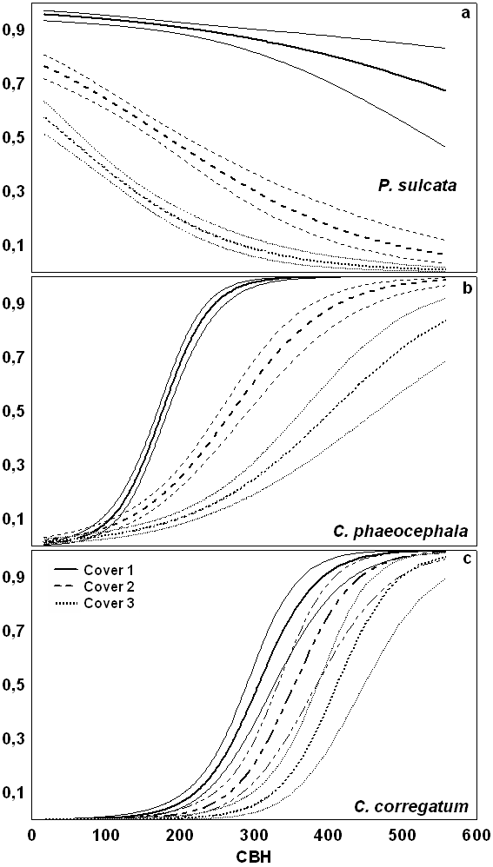
Figure 1. Tree size preferences for three of the six lichen species: Parmelia sulcata, Chaenotheca phaeocephala and Cliostomum corrugatum. The probability, with CI₉₅, of lichen occurrence (Cover 1) and abundance by circumference at breast height (CBH). Solid line represent lichen occurrence, broken line lichen cover of >10 cm² (Cover 2) and dotted line >100 cm² (Cover 3).

For two species, site quality was important and the probability of finding them increased on smaller trees at the high-quality site indicating that larger number of large trees, as potential dispersal sources could increase the colonisation probability. This is probably due to higher dispersal propagule loads and shorter dispersal distances which could be of importance for successful establishment. The results of this study highlight the importance of long-term management plans that consider the age structure within stands to contain trees of different sizes and to constantly maintain a certain amount of old trees that is needed for survival of sensitive lichen populations. Victor Johansson

- Hannah, L. Carr, J.L. & Lankerani, A. Biodivers. Conserv. 4, 128-155 (1995).
- Barkman J.J. Phytosociology and Ecology of Cryptogamic Epiphytes. (Van Gorcum, Assen, 1958)
- Pedersen, I. Bot. Tidsskr. 75, 105-120 (1980).
- Gustafsson, L. Fiskesjö, A. Ingelög, T. Pettersson, B. & Thor G. Lichenologist 24, 255-266 (1992).
- Johansson, P. & Ehrlén, J. J. Ecol. 91, 213–221 (2003).

