Final Thesis

Monitoring of butterflies in semi-natural grasslands – phenology, daily variation and weather effects

Linnea Wikström

LiTH-IFM--07/1778-SE
Contents

1. Abstract 1
2. Introduction 1
3. Material and methods 2
3.1 Study area 2
3.2 Butterfly recordings 3
3.3 Weather conditions 4
3.4 Data analyses 4
4. Results 6
4.1 Phenology 6
4.2 Impact of weather 9
4.3 Variation within a day 12
4.4 Inter-observer differences 15
4.5 Detecting changes in butterfly richness and abundance 16
5. Discussion 17
5.1 Phenology 17
5.2 Impact of weather 19
5.3 Variation within a day 21
5.4 Inter-observer differences 22
5.5 Detecting changes in butterfly richness and abundance 23
6. Acknowledgement 24
7. References 24
Appendix 29

1. Abstract
The butterfly fauna was monitored at six semi-natural grasslands in southeastern Sweden. The aim was to investigate phenology, inter-observer differences, variations within a day and variations due to weather conditions in recorded butterfly species richness and abundances using the line transect method. A total of 30111 butterflies belonging to 46 species were recorded. The results concerning the phenology highlighted the importance of using flexible dates when monitoring butterflies. The butterflies were affected by weather and the time of day for recording. When the overall cloudiness of the sky exceeded 50 %, the number of species showed a drastic fall unless the temperature was at least 22 °C. The butterfly numbers also showed a sharp decline at temperatures below 19 °C if the proportion of sunshine of the transect walk was below 80–85 %. No effect of wind speed, up to five on the Beaufort scale, was found. Many butterfly species showed well-defined daily rythms of flight activity, and the results indicated that transect walks should be performed between -4.5 and +4 h from the time when the sun reached its highest point. No significant difference in the number of observed butterflies between different recorders were found. Power analyses showed that minimal detectable difference for species richness when having five sites would be approximately 20 %. With this knowledge, the interpretation of results from butterfly monitoring will be facilitated and efforts can be made to minimize the impact of different factors on the data by adjusting the guidelines for monitoring.

Keywords: abundance, flight activity, inter-observer variance, Lepidoptera, line transect method, power analyses, species richness, weather impact.

2. Introduction
During the 20th century, butterfly species have declined rapidly throughout much of Europe and the decline has been especially pronounced over the last 50 years (Warren 1992, Pullin 1995, New 1997a, Maes & van Dyck 2000). The major cause of this decline is thought to be the loss and fragmentation of suitable habitats due to the intensification of agriculture and changes in land use. Butterflies are often associated with low-productive, unfertilized, semi-natural grasslands (van Swaay et al. 2006) which are characterized by high biodiversity and abundance of flowers (Ekstam & Forshed 1996). These habitats have faced one of the greatest declines in Europe during the last century and are expected to become increasingly marginalized as agriculture intensifies (Pullin 1995, van Swaay & Warren 1999). Extreme weather due to climate change and increased use of pesticides are also thought to contribute to changes in the butterfly fauna (New 1997a).
Many butterfly species are sensitive to changes in local habitat quality and they react faster to environmental changes than other organisms, for example plants (Erhardt & Thomas 1991). Butterflies are also relatively easy to monitor and can therefore be used as indicators or umbrella species when looking at local habitat status, environment conditions, biodiversity and climate change (New 1997b, Oostermeijer & van Swaay 1998, Blair 1999, van Swaay et al. 2006). In addition, butterflies are pollinators of plants, which make them interesting from this conservation perspective as well (Jennersten 1988, Bloch et al. 2006).
Many current conservation monitoring methods have shown to be tentative and in need of elaboration, refinement and statistical evaluation (Legg & Nagy 2006). Accurate, repeatable and cost-effective methods of monitoring the abundance and location of butterfly assemblages are important components of successful policies to conserve and enhance butterfly biodiversity (Pywell et al. 2003). The line transect method (Pollard 1977) has been shown to give a good estimate of the abundance of butterflies in an area. The recorded number of butterflies are however affected by weather, the time of day and time of the season for the survey. The line transect method states criteria which should be followed in order to provide a degree of uniformity. However, many of these criteria have not been thoroughly tested.
The aim of this study was to investigate inter-observer differences, variations within a day and variations due to weather conditions in recorded butterfly species richness and abundances using the line transect method. The phenology of butterflies during the season was also investigated and power analyses carried out to calculate minimal detectable differences for species richness and abundances.

3. Material and methods

3.1 Study area
The study was conducted during the summer of 2006 in six semi-natural pastures in the county of Östergötland in southeastern Sweden. Pastures were identified from regional inventory records of meadows and pastures in the Nature Conservation Programme by the Municipality of Linköping. The pastures used in this study were all classified as being of national interest, regularly grazed, and had an area of 5.9–8.8 hectares.

3.2 Butterfly recordings
Butterflies (Lepidoptera) and burnet moths (Zygaenidae), were recorded using the line transect method (Pollard 1977, Pollard & Yates 1993, Naturvårdsverket 2003), which is well established and has been shown in previous studies to give a good estimate of the abundance of butterflies in an area. The transect length was walked in a steady pace (approximately 100 meter/2 minutes), and every butterfly individual found within five meters from the transect line, in front or to the sides, was recorded and named to species. The transects were located in straight lines 25 meters apart, covering the whole of each site and oriented at right angles to the narrowest side of the pasture. No butterflies were recorded during the movement between transects. Butterfly species were identified by eye and in those cases where individuals had to be caught in order to be identified the inventory was temporarily paused and later resumed from the same spot. One pair of species was difficult to identify in the field, Leptidea sinapsis/ L. reali, and were therefore treated together.
The field work was carried out from the 22nd of May until the 16th of August, which is the period when the majority of Swedish butterflies are active (Söderström 2006). The butterflies were recorded between 09:00 and 16:30 Swedish summer time (Greenwich Mean Time + 2) under all different weather conditions except for rain. Every site was visited at least 15 times during the study period. In order to eliminate the possible effect of daily fluctuation in the number of observed butterflies, a rotating scheme allowed the six sites to be studied during different times of the day each visit.
The variation in butterfly abundance over the day was studied during an intense shorter period of 16 days at the end of June. This investigation was dedicated to one pasture, Ringetorp, which earlier in the season had proven to hold the highest abundance of butterflies. In this site, between three and seven (71 in total) counts were conducted each day between 08:00 and 19:00. During this period the other sites were visited with a longer time-span in between, but according to the same rotating scheme as before. After these 16 days, the rotation of the six sites returned to the original scheme.
In order to reveal how surveys on butterfly diversity and abundance vary with different observers, a group of four persons did the transect count two times each in Ringetorp on the 18th of July. The first set of recordings was carried out between 09:30 and 12:00, and the second set of recordings between 12:30 and 15:30, with a 15 minutes period between the start times of each observer. One person had experience of butterfly recording, while the other observers had only one afternoon of training.
Nomenclature follows Eliasson et al. (2005), and all species are referred to as “butterflies” in the following text.

3.3 Weather conditions
At the end of each transect walk, temperature, wind speed, percentage of sky covered by clouds and percentage sunshine (percentage of the transect walk carried out during sunshine) were recorded. The temperature was measured about 70 cm above ground. The wind speed was estimated by observing the swaying vegetation using the Beaufort scale. The percentage of sky covered by clouds was classified into four categories: 0–25 %, 26–50 %, 51–75 % and 76–100 %. The percentage of the transect walk carried out during sunshine was estimated to the nearest 10 %.

3.4 Data analyses
Only counts carried out in recommended weather and time of the day (Glimskär et al. 2006) were included in calculations concerning phenology, which gave a total of 146 counts. Butterfly species were placed in different groups depending on when the population peak occurred according to Söderström (2006) (Appendix 1). Species with peaks between the third week in June and the third week in July were placed in the summer group, species with peaks between the fourth week in July and the second week in August were placed in the late summer group, and species with two generations and hibernators were placed in a two generations/hibernators group. Since very few species with a population peak before the second week in June had been observed, these species were not presented in the figures. The number of species and individuals were standardized for each pasture.
In order to evaluate the percentage of total species richness found at different numbers of visits, 20 combinations of butterfly counts from different time periods (Table 1) were randomly selected and an average calculated for each pasture. The line equations of each pasture were then used to calculate an average curve of all six pastures.

Table 1. Time periods from which 20 combinations of butterfly counts were randomly selected for each pasture. In the case of six visits, two butterfly counts were randomly selected from each of the three time periods.
No. of visits | Time periods
1 | May 22nd – August 16th
2 | May 22nd – July 4th, July 5th – August 16th
3 | May 22nd – June 19th, June 20th – July 18th, July 19th – August 16th
4 | May 22nd – June 12th, June 13th – July 4th, July 5th – 26th, July 27th – August 16th
5 | May 22nd – June 8th, June 9th – 26th, June 27th – July 13th, July 14th – 30th,
 | July 31st – August 16th
6 | May 22nd – June 21st, June 22nd – July 20th, July 21st – August 16th

As an initial step to evaluate the importance of the different weather variables on the butterfly community, a Redundancy Analysis (RDA) was conducted on data from the intense study period, and a Canonical Correspondence Analysis (CCA) on the data from the entire season, using CANOCO 4.5 software (ter Braak and Smilauer 2002). RDA is a multivariate method based on linear assumptions and is preferable to use when data has low beta diversity, which was the case with data from the intense period. CCA is instead based on unimodal assumptions and preferable to use when data has high beta diversity, which was the case with data from the entire season. P-values were established for RDA and CCA in Monte Carlo tests with 9999 permutations. In order to diminish the influence of species with high abundance, species data were log-transformed in all analyses. For further analyses of how the number of species and individuals fluctuate with wind, data from the intense study period was used. This was because wind speed was the only weather variable to show sufficient variation during this period. Only those days with a minimum of five counts were used in the calculations and values were normalized within each day. For further analyses of variations due to temperature, overall cloudiness of the sky and the proportion of time during transect walked in sunshine, data from the entire season were used. A minimum of three butterfly counts made during a period of less than 14 days were standardized for each pasture, which gave a total of 79 counts. The butterfly fauna was assumed not to change in any major aspects during such a short time period. An inspection of the data on variation in number of butterfly species and individuals with temperature and sunshine revealed that it had linear properties, and therefore a multiple regression was carried out using STATISTICA software version 7.0 (StatSoft Inc. 2004).
Only those days in the intense study period with a minimum of five counts were used in the calculations concerning daily variations, which gave a total of 10 days and 56 counts. The number of observed individuals and species were normalized within each day, and the time for each count was calculated as the middle between start and stop time.
A Variance Component Analysis was carried out using STATISTICA software version 7.0 (StatSoft Inc. 2004) to test for inter-observer differences in the number of species and individuals.
Power analyses were performed in StudySize 1.09 using Student’s paired t-test in order to investigate how minimal detectable difference (δ) varies with sample sizes (i.e. number of sites) and SD. Mean and SD was calculated for species richness, total abundance, and abundance of the two most common species; Aphantopus hyperantus and Maniola jurtina from the data from the intense study period in Ringetorp. The total abundance and the abundance of Aphantopus hyperantus and Maniola jurtina were square root transformed before calculations. Only counts carried out in recommended weather and time of day (Glimskär et al. 2006) were used in the calculations, which gave a total of 50 counts. Null hypothesis stated that the average difference was zero, and power was assumed to be 0.8 (β=0.2), and α=0.05 as in Glimskär et al. (2005).

4. Results
A total of 30 111 butterfly individuals belonging to 46 species (Appendix 1) were observed in the six pastures. Of those 23 558 butterfly individuals of 35 species were observed during the 16-days intensive study period conducted in Ringetorp.

4.1 Phenology
The number of species (Figure 1) belonging to the summer group reached a peak in the beginning of July, with counts between the third week in June and the last week in July made over the standardized mean value. The number of individuals (Figure 1) had a broader peak, with counts made over the mean value between the beginning and the end of July. The number of species and individuals from the late summer group followed the same basic pattern with an increase in the beginning of July, and counts between the beginning of July and the second week in August made over the mean value. However, the number of individuals decreased somewhat earlier in this group. Both the numbers of species and individuals belonging to the two generations/hibernators group had a small increase in the beginning of the season, but decreased after the second week in June. The numbers increased from the end of June, with counts made over the mean value from the second week in July to the middle of August. The number of species peaked in the first week of August, somewhat earlier than the number of individuals.
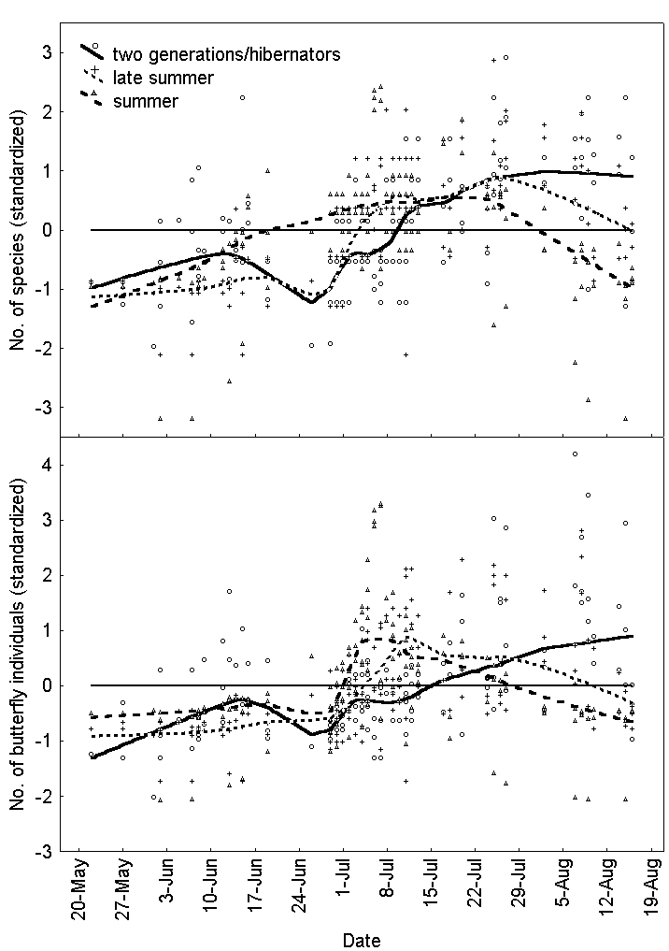
Figure 1. The number of butterfly species (upper graph) and individuals (lower graph) from 22nd of May until 16th of August in six pastures. Trend line set to lowess with a stiffness of 0.3.

The increase in the percentage of species richness found with number of visits approximated a characteristic logarithmic distribution for all six pastures (Figure 2). The increase was rather sharp between one, two and three visits, and started to reach a plateau at five visits. The average percentages of species richness found at different numbers of visits were; one: 31, two: 49, three: 73, four: 78, five: 85 and six visits: 89. The average curve based on the line equations from all sites was calculated as follows:

$y_{\text{average}}=\text{30}\text{.}\text{20}+\text{78}\text{.}\text{31}∗\text{log}\text{10}(x)$ (1)

SD for the two estimates of the constants were 5.100 and 10.060 respectively.
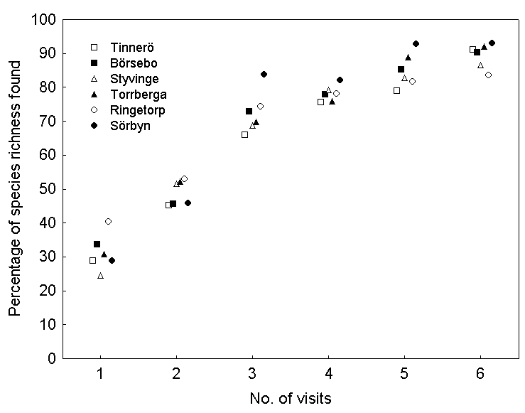

Figure 2. Percentage of species richness found at different numbers of visits in six pastures. The symbols represent the average value of 20 random selections of counts from different time periods (Table 1). In the case of six visits, two counts were randomly selected from each of the three time periods.

4.2 Impact of weather
Results from the RDA (data not shown) on data from the intense study period showed that the weather variables significantly explained some of the variation in butterfly assemblages (F=12.032, P=0.0001). The sum of all canonical eigenvalues was 0.422, which indicate that 42 % of the variance was explained by the weather variables. The eigenvalue for the second-axis, with which wind speed was closely associated (data not shown), was 0.157. However, wind speed did not seem to affect the number of observed butterfly species or individuals (Figure 3).

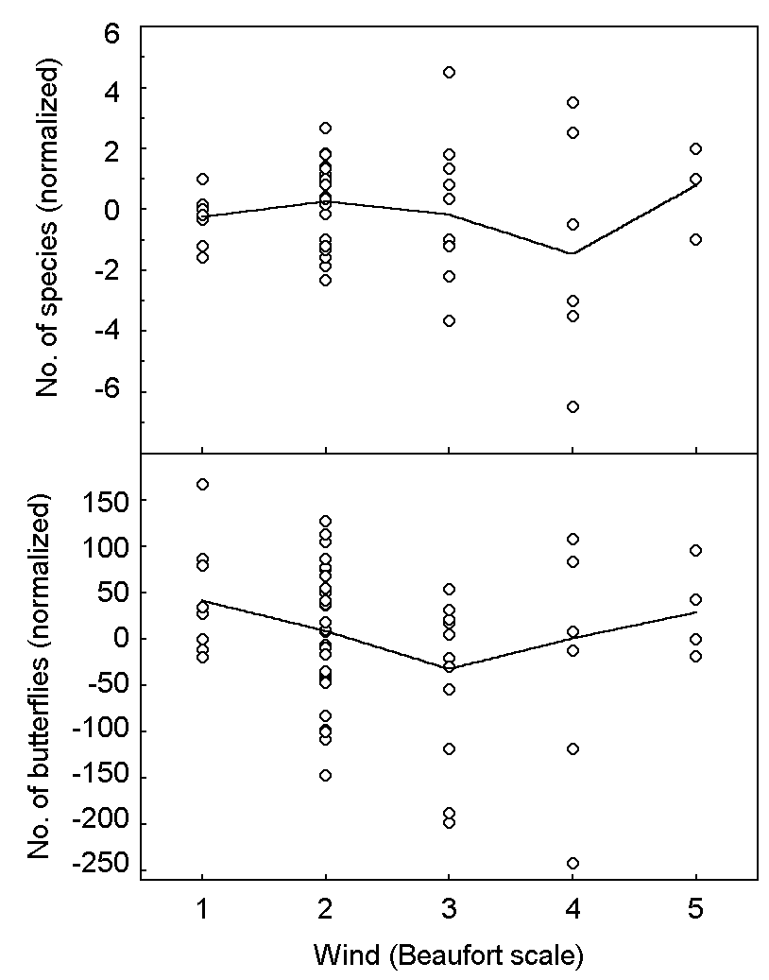

Figure 3. Numbers of observed butterfly species (upper graph) and individuals (lower graph) per count in different wind speeds in Ringetorp according to the Beaufort scale. One is 0.3–1.5 ms⁻¹, and five is 8.0–10.7 ms⁻¹ on the Beaufort scale.

Results from the CCA (data not shown) on data from the entire season showed that the weather variables significantly explained some of the variation in butterfly assemblages (F=2.504, P=0.0001). However an inspection of the ordination diagram revealed that this variance confounded with seasonal variations.
Both the number of observed butterfly species (Figure 4) and individuals (data not shown) followed the same basic pattern concerning temperature and proportion of time during transect walked in sunshine. In temperatures of 10–19 °C at least 80–85 % of the counts had to be made in sunshine to obtain values above the standardized mean value. A threshold could be seen at around 20 °C where the limit was approximately 70 % sunshine. At 22 °C, counts made in around 40 % sunshine were over the mean value, and in temperatures above 29 °C counts were made over the mean value without any sunshine at all. With result from the multiple regression, the standardized number of butterfly species (F_{(2,76)}=6.28, P=0.003, R²=0.14) and individuals (F_{(2,76)}=8.55, P=0.004, R²=0.18) at different temperatures and percentage of sunshine can be estimated as follows:

$\text{Species}=−0\text{.}\text{96}+0\text{.}\text{022}∗\text{temperature}(°C)+0\text{.}\text{0072}∗\text{sunshine}(\text{\%})$ (2)

$\text{Individuals}=−1\text{.}\text{21}+0\text{.}\text{032}∗\text{temperature}(°C)+0\text{.}\text{0072}∗\text{sunshine}(\text{\%})$ (3)

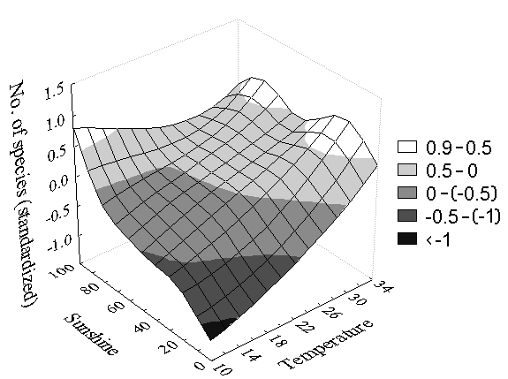

Figure 4. Numbers of observed butterfly species at different temperatures and percentage sunshine (proportion of time during transect walked in sunshine) in six pastures.

Both the number of observed butterfly species (Figure 5) and individuals (data not shown) followed the same basic pattern concerning temperature and the overall cloudiness of the sky. If 76–100 % of the sky was covered by clouds it had to be at least 28 °C for counts to be made above the standardized mean value. At 51–75 % coverage it had to be approximately 22 °C, at 26-50 % 13 °C, and at 0–25 % coverage around 12 °C.
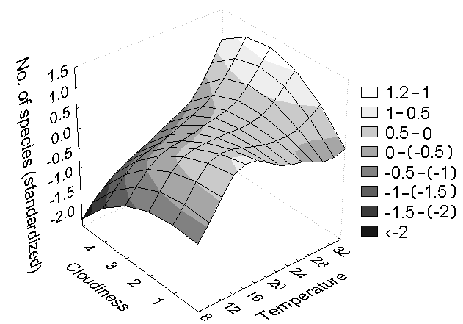

Figure 5. Number of observed butterfly species at different temperatures and cloud coverage in six pastures. The percentage of sky covered by clouds was classified into four categories: 1=0–25 %, 2=26–50 %, 3=51–75 % and 4=76–100 %.

4.3 Variation within a day
Between 08:00 and 17:00 Swedish summer time (06:00 and 15:00 Greenwich Mean Time) most counts of species were above or close to the normalized mean value. Later in the afternoon all counts were made below the mean value (Figure 6). The number of individuals had a sharp increase in the morning, with all counts above or close to the mean value from 08:00 to 17:00. After 17:00 all counts were made far below the mean value (Figure 6).
The number of individuals of Brenthis ino and Aphantopus hyperantus (33.2 % of total butterfly observations) reached a peak between 09:00 and 10:00, after which they decreased, and from 12:00 to 16:00 most counts were below the mean value (Figure 6). After 16:00 the number of individuals of Brenthis ino and Aphantopus hyperantus were once again increasing. Zygaena species (Zygaena filipendulae, Zygaena viciae, Zygaena lonicerae and Adscita statices) showed a different pattern of daily activity (Figure 6), with counts below the mean value up until 12:00, after which they increased slightly, and later in the afternoon around 16:00 they decreased. Note that the sun reached its highest point at 13:01 in Linköping during the intensive study period¹.

¹ pers. comm., Weine Josefsson, SMHI, Norrköping Sweden

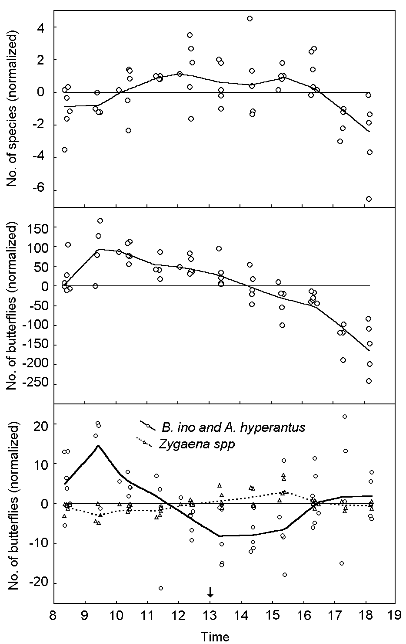Figure 6. Number of observed butterfly species (upper graph) and individuals (middle graph) in Ringetorp at different times of the day (Swedish summer time). Number of observed individuals of Brenthis ino and Aphantopus hyperantus, and Zygaena species (lower graph) at different times of the day. Trend line set to lowess with a stiffness of 0.3. Arrow indicates when the sun reached its highest point (13:01).

4.4 Inter-observer differences
No significant difference in the number of observed butterfly species (F_{(3,3)}=0.57, P=0.67) or individuals (F_{(3,3)}=1.43, P=0.39) between the four different recorders were found (Figure 7). However, there were significant differences between the different sampling sessions in the number of observed species (F_{(1,3)}=14.40, P=0.03) and individuals (F_{(1,3)}=15.53, P=0.03).

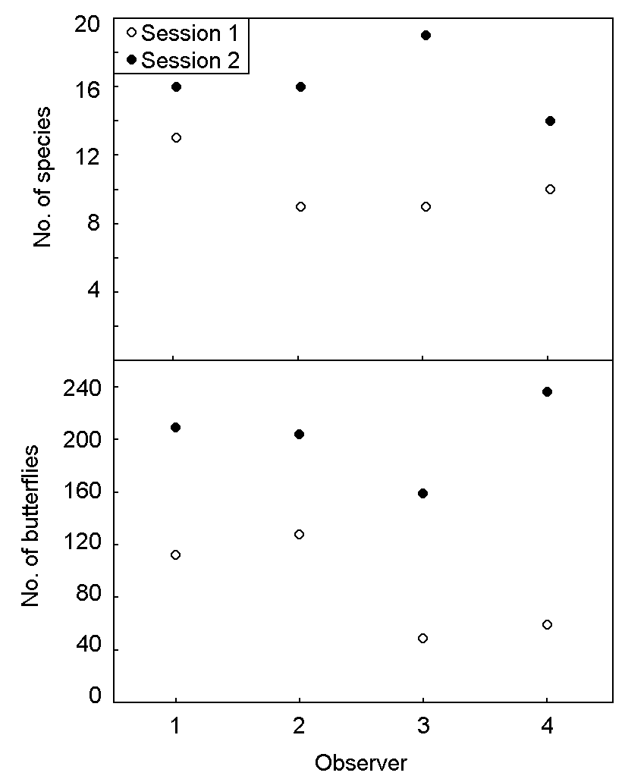

Figure 7. Number of observed butterfly species (upper graph) and individuals (lower graph) of four different observers at two sessions in Ringetorp. Session one (09:30–12:00) unfilled circles, and session two (12:30–15:30) filled circles. Observer one was an expert, while the others had no field experience except one afternoon of training.

4.5 Detecting changes in butterfly richness and abundance
If possible bias is ignored and the variation is assumed to be purely random, estimates of SD can be used to calculate minimal detectable difference at different sample sizes (Figure 8). Mean (SD) for species richness, total abundance, abundance of Aphantopus hyperantus and abundance of Maniola jurtina was calculated, using data from the intensive study period in Ringetorp, to 18.0 (2.22), 19.2 (2.80), 9.4 (3.47), and 8.6 (1.40) respectively. Note that data on total abundance, abundance of Aphantopus hyperantus and abundance of Maniola jurtina was square root transformed before the calculations of mean and SD were performed. Results from this study showed that minimal detectable difference for species richness, when having five sites (i.e. sample size) and using power 0.8, alfa 0.05 % and a paired t-test, would be approximately 20 %. If the number of sites was increased to ten, minimal detectable difference for species richness decreased to approximately 10 %. The results also illustrated that there can be large variations in minimal detectable differences between species. For example, minimal detectable difference for the abundance of Aphantopus hyperantus and Maniola jurtina when having five sites was approximately 40 and 10 % respectively.

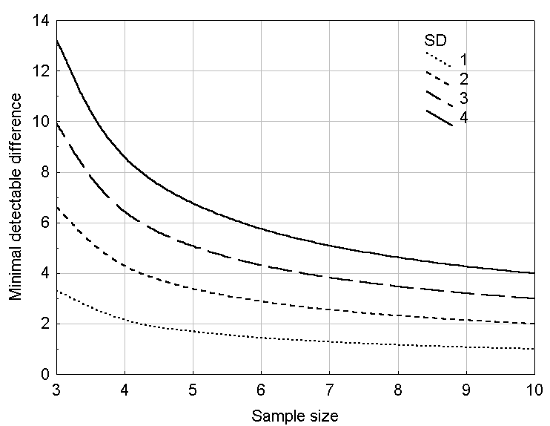

Figure 8. Minimal detectable difference in two-sided paired t-test as a function of sample size and SD, using α=0.05, Power (1-β=0.8), and H₀: mean=0.

5. Discussion
In this study, the phenology, inter-observer differences, variations within a day and variations due to weather conditions in recorded butterfly species richness and abundances have been investigated using the line transect method. The results concerning the impact of weather conditions indicated that there were thresholds for cloudiness, sunshine and temperature below which counts tended to be particularly low. The study has also shown that there may be large differences between species in daily rhythms of flight activity irrespective of weather conditions. The importance of using flexible dates when monitoring has been highlighted since the duration of flight periods as well as emergence dates may be affected by variation in the weather.

5.1 Phenology
Information about the phenology is important when monitoring the change in abundance and species richness of butterflies. Since the flight periods differ between species, repeated counts over the season is essential when the aim is to monitor the entire butterfly community at a site (Kéry & Plattner 2007). Results from this study highlight the importance of using flexible dates when monitoring. The summer species hatched late this year and the peak in butterfly abundance for both the summer and the late summer group coincided in the beginning of July (Figure 1). With fixed dates and a count in June, the abundance of some summer species may have been underestimated. The numbers of observed individuals were low up to the beginning of July for all groups, which most likely were due to low temperatures early in the summer of the study year (Warren 1987, Nilsson & Franzén 2006). Thermal conditions influence growth of butterflies in all life stages (Weiss 1988, New 1997), and the low temperatures might have delayed hatching dates (Warren 1987, Pivnick & McNiel 1987, Weiss et al. 1988). A small increase in the abundance of species belonging to the two generations/hibernators group could be seen in the middle of June. Since species with two generations often have a less abundant first generation in Sweden (Söderström 2006), this first peak was expected to be lower than the second one. However, the weather earlier in the season might have further suppressed this first peak.
Variation in the weather has been shown to affect emergence dates as well as the duration of flight periods (Warren 1987, Eliasson 2001, Thorne et al. 2006). A species may have different flight period even within a country, and in some cases different numbers of generations depending on factors such as altitude and climate (Pollard & Yates 1993, New 1997). This is most certainly the case in Sweden, and monitoring programs need to adjust for such differences in order to be successful. A solution might be to have flexible rather than fixed dates for monitoring, and to adjust these dates after the flight periods in different regions. The National Inventory of Landscapes in Sweden (NILS) (Glimskär et al. 2006) carries out counts of butterflies at only three occasions over the season. The selection of appropriate dates for such monitoring is crucial to be able to estimate changes in abundance and species richness over time.
The change of the butterfly fauna over the season can be assumed to also occur in a smaller scale within the defined groups (see 3.4 Data Analyses). It would therefore be incorrect to assume that a single count in the middle of July would be enough to detect almost the entire species richness in the summer and late summer group. Even though the number of species and individuals found at this one occasion might be high, some species are with certainty left undetected since they have either already disappeared or not yet emerged. In this study only three species with distinct flight periods in the spring (Antochardis cardamines, Pyrgus malva and Callophrys rubi) were observed. However, in years with more favorable weather condition in the early summer, an additional sampling date in the beginning of the season to capture early species composition would probably increase the number of observed species. Ideally, monitoring should be performed at points in the season that are phenologically as similar as possible between years. When selecting these dates for monitoring, the emergence dates of some particular butterfly species might be used as indicators. Each of these species should represent a group of species with as similar flight period as possible.
Since the phenology differ between species of butterflies, a challenge for monitoring programs is not only to decide when to carry out counts, but also to investigate how many counts are needed during the season to capture as much of the species richness as possible. In Sweden, recordings are recommended to be carried out at least every 7–14th day in each locality between May and August in order to cover most species (Nilsson 2002, Naturvårdsverket 2003). However, such an intensive monitoring scheme would be very expensive and time consuming.
In order to evaluate the required number of visits to find a certain percentage of the species richness at a site, the calculated average curve can be used as a model. In this study, the increase in the percentage of species richness found with different number of visits approximated a characteristic logarithmic distribution for all pastures (Figure 2), which is in agreement with Dennis et al. (1999). The increase in the proportion of total species found was especially pronounced when comparing one, two and three visits. It is obvious that few visits leave many species undetected. One or two visits to the same site during a season can clearly not be regarded as enough if the goal is to investigate the species richness. Vessby et al. (2002) found that the number of observed butterfly species reached an asymptote between 5 and 10 visits. In this study, the increase in the proportion of species richness found seems to start reaching a plateau after 5 visits at an average of 85 %. Consequently, increasing sampling intensity from three to five visits in NILS would increase the species richness found with approximately 12 percent units on average. However, the gains of increasing sampling effort need to be weighted against the cost, since funding often is scarce in conservation work.

5.2 Impact of weather
The development of reliable methods for monitoring is crucial in order to evaluate conservation efforts and setting conservation priorities. Pollard & Yates (1993) have stressed the importance of that butterfly counts reflect "real" changes in abundance rather than variations caused by varying conditions during sampling. If the influence of factors such as weather conditions is known, efforts can be made to minimize their impact on the data by adjusting the guidelines for monitoring.
In this study, no effect of wind speed, up to five on the Beaufort scale, on observed numbers of species or individual was found (Figure 3). This is in agreement with other studies (Pivnick & McNiel 1987, Swengel & Swengel 2000). However Dover et al. (1997) found that counts were particularly low above wind speeds of 8 knots (three on the Beaufort scale). Butterflies are known to redistribute as wind speeds increase, and activity in the components of the landscape offering shelter have been shown to increase as wind speed increased (Dover et al. 1997). Adults of Thymelicus lineola change their activity pattern under strong winds by moving close to the ground and never attempt flight (Pivnick & McNiel 1987), which makes counts during such conditions unreliable. It is possible that the influence of wind speed on butterfly counts is greater during periods with lower temperatures than the temperatures during this study. Counts in the early spring have been shown to be unreliable as the species present tend to fly mainly in areas sheltered from the wind (Pollard 1977). Effects of wind speed can also vary greatly between different biotopes (Pollard & Yates 1993), and recommendations concerning wind conditions are therefore needed to be interpreted somewhat different depending on the current weather conditions, time of season and the exposure of the study site. Wind speeds above five on the Beaufort’s scale were not encountered during the intensive study period, but experience from a few days with wind speeds of six and seven during the rest of the season suggests that this might indeed be the upper limit for conducting meaningful butterfly census.
The activity of butterflies are to a high extent limited by temperature since most butterflies require a high and restricted range of body temperature in order to fly. They often achieve these temperatures trough behavioural thermoregulation such as basking in the sun (Kingsolver 1985, Pivnick & McNiel 1987, Dennis et al. 2006). Cloudiness has been shown to affect counts of Danaus plexippus (Meitner et al. 2004, Davis et al. 2002), and to inhibit flight activity of Hesperiidae species even if temperature conditions remained favorable (Pivnick & McNiel 1987). However, for most species, flight will not require sunshine if the temperature in the shade is sufficiently high (Pollard & Yates 1993). Data in this study show the effect of cloudiness on two levels, the overall cloudiness of the sky and the proportion of time during transect walked in sunshine. The activity of the butterflies showed a threshold when cloudiness exceeded 50 %. At this cloudiness, the number of species showed a drastic fall unless the temperature was at least 22 °C (Figure 5). This can be used as a guideline when considering the overall weather situation, and act as help in decision-making concerning the suitability of a particular day for recordings. During the actual time for recording, there was a sharp decline in butterfly numbers at temperatures below 19 °C if the proportion of sunshine of the transect walk was below 80–85 % (Figure 4). At 20 °C the butterflies were active at a lower proportion of sunshine (70 %), and at 22 °C around 40 % sunshine. Above 29 °C, the amount of sunshine seemed to be of minor importance. These criteria are somewhat stricter than those proposed by Pollard (1977), where counts may be made if the temperature is over 17 °C irrespective of sunshine and below 17 °C if at least 60 % of the walk is made in sunshine. However, since Pollards method was developed in the British Isles, the limits proposed by my study might be more suitable for the Swedish butterfly fauna and climate. The minimum conditions for recording are according to Pollard & Yates (1993) indeed close to the flight threshold of some species, and counts made just above these limits are likely to produce low counts. Thomas et al. (1986) have for example noted that Hesperia comma tends to be inactive at the minimum weather conditions recommended by Pollard et al. (1977).

5.3 Variation within a day
Butterflies are often surveyed using the line transect method described by Pollard (1977). The recommendations are that transect walks should be undertaken between 10:45 and 15:45 British Summer Time to counter some of the influence of differing activity profiles of the butterflies. However, the data that these recommendations are based upon seem to be rather scarce (Moore 1975). Moore (1975) presents data from two days and concludes that the maximum density of butterflies for the day was found to occur at any time from about three hours before noon to about four hours after noon. Pollard and Yates (1993) have tried to assess variation in butterfly counts due to time of day, and found that it had a small, but significant effect on the counts of Aphantopus hyperantus compared with the variation due to week and year of recording. However, the data used in their analysis were spread out over the whole season during two years (57 counts) and not only directed to estimate daily variation. In this study 56 counts from two weeks, spread out from -5 to +6 h from the time when the sun reached its highest point, were used to asses the daily variation in number of observed butterfly species and individuals during the peak abundance of the season at a species-rich site. The results from this study indicate that transect walks should be performed between -4.5 and +4 h. The butterfly species richness and abundance was close to or near the normalized mean value in most counts carried out between -5 and +4 h (Figure 6). However, since counts carried out between -5 and -4 h in the morning might give quite low numbers, the recommendations are set to start transect walks after -4.5 h. Both the species richness and abundance of butterflies were low after +4 h, and it can therefore be regarded as inappropriate to carry out counts this late in the afternoon. Butterfly activity is known to be strongly influenced by microclimate conditions such as air temperatures and light intensity (Rawlins 1980, Shreeve 1984, Meyer & Sisk 2001), which often are less favorable close to sunrise and sunset. The number of observed butterfly individuals peaked in the morning, and started to decrease earlier in the afternoon than the number of species (Figure 6). After +2 h, most counts were below the normalized mean value. The reason for this decline was however largely due to the activity pattern of two of the most abundant species; Brenthis ino and Aphantopus hyperantus. These species had much fewer active individuals, but still many compared to other species, in the early afternoon.
It is clear that simple counts taken at one time of the day might be misleading since many butterflies show well-defined daily rythms of flight activity (New 1997). Yamamoto (1975) and Frazer (1973) have described variations in counts of butterflies at different times of day. Frazer (1973) showed that populations of Aglais urticae are maximal within an hour or two of noon, and emphasized that a serious source of sampling error might lie in which time of day the counts are carried out. Results from this study also show that the number of observed individuals of a species might fluctuate greatly over the course of the day, and that there can be large differences in daily rhythms of flight activity between species. The number of active individuals of Brenthis ino and Aphantopus hyperantus was for example very high in the morning compared to the early afternoon (Figure 6). On the 3rd of July, 145 individuals of Aphantopus hyperantus was recorded on a count carried out between -4 and -3 h, while only 60 individuals were recorded between 0 and +1 h, although the weather conditions stayed practically the same (data not shown). The opposite activity pattern was shown by Zygaena species (Zygaena filipendulae, Zygaena viciae, Zygaena lonicerae and Adscita statices) with lower abundance in the morning, and a peak in the afternoon. These differences in daily activity pattern of butterfly species are important to consider since it might bias the results from a monitoring scheme. If counts at a site are carried out in the morning one year and in the afternoon the following year, the abundance of some species might be either over- or underestimated. If the daily activity pattern of each butterfly species is known, this could be used to adjust for time of the day of the count. When the aim of a monitoring scheme is to study changes in abundance of some individual species, the counts should preferably be performed at the same time of day every year to minimize the effect of daily activity patterns.

5.4 Inter-observer differences
As monitoring of species to some extent depends on perception and personal skills, it is essential to know if and to what extent butterfly counts vary with different recorders. In this study, no significant difference in the number of observed butterfly species or individuals between the different recorders were found (Figure 7) even though one observer was an expert and three were novices. These results are encouraging, and provide evidence that the line transect method is robust in this respect, and that results from different recorders can be used without problems of observer bias. Previous validation of the line transect method (Pollard et al. 1975; Douwes 1976; Pollard 1977; Pollard & Yates 1993) has also revealed that it seem to be robust for inter-observer differences, however this might partly be because the particular observers had worked closely together and would be expected to make similar recordings. In this study it was somewhat surprising that no significant difference could be found between the individual with previously experience of butterfly census and the other individuals whose only experience was an afternoon of education. There were significant differences between the different sampling sessions in the number of observed species and individuals in this study which most likely was due to variations during the day and weather conditions.

5.5 Detecting changes in butterfly richness and abundance
Information concerning the minimal detectable difference of species richness and abundance is important for the reliability, as well as the design, of a monitoring scheme (Foster 2001). In this study, estimates of SD were used to calculate minimal detectable difference at different sample sizes. Results showed that minimal detectable difference for species richness when having five resampled sites would be approximately 20 % when using power 0.8, alfa 0.05 % and a sample size of five. Hence, a change in species richness with 20 % could be detected in eight times out of ten. The results from this study have also indicated that there can be large variations in minimal detectable differences between species. In the case of Aphantopus hyperantus, a 40 % change could be detected in eight times out of ten with a sample size of five, whereas a 10 % change could be detected for Maniola jurtina. Although this kind of information is important for the reliability of a monitoring scheme, a challenge is how to implement calculated power analyses into evaluations of data. Calculated minimal detectable differences can be used to set a detection level, and changes that fall under this level can then be ignored even if they turn out to be significant in statistical tests. It is important to note that the above numbers are probably underestimates, as power analyses were calculated using data taken from only one site during a short period of time. Power analyses based on data from other sites and longer time periods, including between season variation, are likely to produce larger minimal detectable differences.

6. Acknowledgement
First of all I would like to thank my supervisors Dr Karl-Olof Bergman and Professor Per Milberg for all their support and encouragement during this study. Thanks also to Anders Holmstrand, Jens Johannesson, Carina Greiff, Anders Glimskär, and Markus Franzén for help and interest in my project. I am also very grateful to Stiftelsen Oscar och Lilli Lamms Minne who have supported this work financially, and to all landowners who kindly have let me work on their property. Last but not least I would like to thank Dennis Jonason, Martin Planthaber, Joakim Sandell and Victor Johansson for their participation in the inter-observer study and rewarding discussions.

7. References

Blair R B (1999) Birds and butterflies along an urban gradient: surrogate taxa for assessing biodiversity? Ecological Applications 9, 164-170

Bloch D, Werdenberg N & Erhardt A (2006) Pollination crisis in the butterfly-pollinated wild carnation Dianthus carthusianorum? New Phytologist 169, 699-706.

Davis AK & Garland MS (2002) An evaluation of three methods of counting migrating monarch butterflies in varying wind conditions. Southeastern Naturalist 1, 55-68.

Dennis RLH & Sparks TH (2006) When is a habitat not a habitat? Dramatic resource use change under differing weather conditions for the butterfly Plebejus argus. Biological Conservation 129, 291-301.

Dennis LH, Sparks TH & Hardy PB (1999) Bias in butterfly distribution maps: the effect of sampling effort. Journal of Insect Conservation 3, 33-42.

Douwes P (1976) An area census method for estimating butterfly population numbers. Journal of Research on the Lepidoptera 15, 146-152.

Dover JW, Sparks TH, & Greatorex-Davies JN (1997) The importance of shelter for butterflies in open landscapes. Journal of Insect Conservation 1, 89-97.

Ekstam U & Forshed N (1996) Äldre fodermarker. Naturvårdsverket.

Eliasson CU (2001) A study of the scarce fritillary (Euphydryas maturna) (Lepidoptera: Nymphalidae) in Sweden, Västmanland 2 - phenology, protandry, sex-rate and mating behaviour. Entomologisk Tidskrift 4, 153-167.

Eliasson CU, Ryholm N, Holmer M, Jilg K & Gärdefors U (2005) Nationalnyckeln till Sveriges flora och fauna. Fjärilar: Dagfjärilar. Hesperiidae – Nymphalidae. ArtDatabanken, SLU, Uppsala.

Erhardt A & Thomas JA (1991) Lepidoptera as indicators of change in the seminatural grasslands of lowland and upland Europe. pp. 213-237 in: Collins NM & Thomas JA (eds) The conservation of insects and their habitats. 1st ed. Academic Press, London.

Frazer JFD (1973) Estimating butterfly numbers. Biological Conservation 5, 271-276.

Foster JF (2001) Statistical power in forest monitoring. Forest ecology and management 151, 211-222.

Glimskär A, Bergman KO, Claesson K & Sundquist S (2006) Fältinstruktioner för fjärilar, humlor, grova träd och lavar I ängs- och betesmarker NILS 2006. SLU Umeå, version 1.0.

Glimskär A, Löfgren P & Ringvall A (2005) Uppföljning av naturvärden I ängs- och betesmarker via NILS-statistisk utvärdering och förslag till design. SLU Umeå, Arbetsrapport 146.

Jennersten O (1988) Flower visitation and pollination efficiency of some north European butterflies. Oecologia 63, 80-89.

Kéry M & Plattner M (2007) Species richness estimation and determinants of species detectability in butterfly monitoring programmes. Ecological Entomology 32, 53-61.

Kingsolver JG (1985) Thermal ecology of Pieris butterflies (Lepidoptera: Pieridae): a new mechanism of behavioural thermoregulation. Oecologia 66, 540-545.

Legg CJ & Nagy L (2006) Why most conservation monitoring is, but need not be, a waste of time. Journal of Environmental Management 78, 194-199.

Maes D & van Dyck H (2000) Butterfly diversity loss in Flanders (north Belgium): Europe’s worst case scenario? Biological Conservation 99, 263-276.

Meitner CJ, LP Brower & Davis AK (2004) Migration patterns and environmental effects on stopover of Monarch butterflies (Lepidoptera, Nymphalidae) at Peninsula Point Michigan. Environmental Entomology 33, 249-256.

Meyer CL & Sisk TD (2001) Butterfly response to microclimatic conditions following ponderosa pine restoration. Restoration Ecology 9, 453-461.

Moore NW (1975) Butterfly transect in a linear habitat 1964-1973. Entomologist´s Gazette 26, 71-78

Naturvårdsverket (2003) Undersökningstyp: Dagaktiva fjärilar. Version 1:1, 2003-04-04. Handbok för miljöövervakning. Naturvårdsverket, Stockholm.

New T R (1997a) Butterfly conservation. 2nd ed. Oxford University Press, Melbourne, Australia.

New TR (1997b) Are Lepidoptera an effective “umbrella group” for biodiversity conservation? Journal of Insect Conservation 1, 5-12.

Nilsson SG (2002) A method for population studies of butterflies at the landscape scale. Entomologisk Tidskrift 123, 193-201.

Nilsson SG & Franzén M (2006) Biologisk mångfald i Linnés hembygd i småland 5. Dagfjärilar och bastardsvärmare (Lepidoptera: Rhopalocera and Zygaenidae). Entomologisk Tidskrift 127, 39-55.

Oostermeijer JGB & van Swaay (1998) The relationship between butterflies and environmental indicator values: a tool for conservation in changing landscapes. Biological conservation 86, 271-280.

Pivnick KA & McNiel JN (1987) Diel patterns of activity of Thymelicus lineola adults (Lepidoptera: Hesperiidae) in relation to weather. Ecological Entomology 12, 197-207.

Pollard E (1977) A method for assessing changes in the abundance of butterflies. Biological Conservation 12, 115-134.

Pollard, E & Yates TJ (1993) Monitoring butterflies for ecology and conservation. 1st ed. Chapman & Hall, London.

Pollard E, Elias DO, Skelton MJ & Thomas JA (1975) A method of assessing the abundance of butterflies in Monks Wood National Reserve in 1973. Entomologist´s Gazette 26, 79-88.

Pullin AS (1995) Ecology and conservation of butterflies. Chapman & Hall, London.

Pywell RF, Warman EA, Sparks TH, Greatorex-Davies JN, Walker KJ, Meek WR, Carvell C & Firbank LG (2003) Assessing habitat quality for butterflies on intensively managed arable farmland. Biological Conservation 118, 313-325.

Rawlins JE (1980) Thermoregulation by the black swallowtail butterfly, Papilio polyxenes (Lepidoptera: Papilionidae). Ecology 61, 345-357.

Shreeve TG (1984) Habitat selection, mate location, and microclimatic constraints on the activity of the speckled wood butterfly Pararge aegeria. Oikos 42, 371-377.

Statsoft Inc. (2004) STATISTICA (data analysis software system) version 7. www.statsoft.com

StudySize CreoStat HB version 1.09. Gothenburg, Sweden.

Swengel AB & Swengel SR (2000) Observations on Lycaeides in the northern midwest, USA (Lepidotera: Lycaenidae). Holarctic Lepidoptera 7, 21-31.

Söderström B (2006) Svenska fjärilar, en fälthandbok. Stockholm: Albert Bonniers Förlag AB.

ter Braak CJF & Smilauer P (2002) Canoco reference manual and user’s guide to Canoco for windows: software for Canonical Community Ordination (version 4). Microcomputer Power, Ithaca, NY.

Thomas JA, Thomas CD, Simcox DJ & Clarke RT (1986) Ecology and declining status of the silver-spotted skipper butterfly (Hesperia comma) in Britain. The Journal of Applied Ecology 23, 365-380.

Thorne JH, O’Brien J, Forister ML & Shapiro M (2006) Building phonological models from presence/absence data for a butterfly fauna. Ecological Applications 16, 1842-1853.

van Swaay CAM & Warren MS (1999) Red Data Book of European butterflies (Rhopalocera). Nature and Environment No. 99, Council of Europe Publishing, Strasbourg.

van Swaay CAM, Warren MS & Grégoire L (2006) Biotope use and trends of European butterflies. Journal of Insect Conservation 10, 189-209.

Vessby K, Söderström B, Glimskär A & Svensson B (2002) Species-richness correlations of six different taxa in swedish seminatural grasslands. Conservation Biology 16, 430-439.

Warren MS (1987) The ecology and conservation of the Heath Fritillary Butterfly, Mellicta athalia. I. Host selection and phenology. Journal of Applied Ecology 24, 467-482.

Warren MS (1992) The conservation of British butterflies. pp. 246-274 in: Dennis RLH (ed) The ecology of butterflies in Britain. 1st ed. Oxford University Press, New York.

Weiss SB, Murphy DD & White RR (1988) Sun, slope, and butterflies, topographic determinants of habitat quality for Euphydryas editha. Ecology 69, 1486-1496.

Yamamoto M (1975) Notes on the methods of belt transect census of butterflies. Journal of Faculty of Science Hokkaido University, Series 6. Zoology 20, 93-116.

Appendix

Appendix 1. Butterfly species and their abundance, number of sites where they were found and group belonging at six pastures in Östergötland, SE Sweden. SP: spring, S: summer, LS: late summer, TH: two generations/hibernators.
Species | Abundance | No. of sites | Group
Aphantopus hyperantus | 7554 | 6 | S
Maniola jurtina | 5102 | 6 | S
Coenonympha arcania | 4450 | 6 | S
Argynnis aglaja | 2346 | 6 | S
Brenthis ino | 2174 | 6 | S
Boloria selene | 1543 | 6 | S
Coenonympha pamphilus | 816 | 6 | TG
Polyommatus amandus | 674 | 5 | S
Polyommatus icarus | 622 | 6 | TG
Pieris napi | 609 | 6 | TG
Melitaea athalia | 568 | 6 | S
Ochlodes sylvanus | 444 | 6 | LS
Lopinga achine | 390 | 1 | S
Thymelicus lineola | 381 | 6 | LS
Lasiommata maera | 329 | 4 | S
Polyommatus semiargus | 287 | 6 | S
Pieris rapae | 217 | 6 | TG
Argynnis paphia | 216 | 6 | LS
Lycaena virgaureae | 191 | 6 | LS
Leptidea sinapsis/ L. reali | 174 | 6 | TG
Boloria euphrosyne | 119 | 6 | S
Gonepteryx rhamni | 115 | 6 | TG
Aglais urticae | 114 | 6 | TG
Hesperia comma | 98 | 5 | LS
Zygaena filipendulae | 96 | 3 | S
Inachis io | 74 | 6 | TG
Pieris brassicae | 72 | 6 | TG
Lycaena phlaeas | 69 | 6 | TG
Lyceena hippothoe | 66 | 6 | S
Antochardis cardamines | 40 | 6 | SP
Aricia artaxerxes | 39 | 4 | S
Argynnis adippe | 38 | 6 | LS
Zygaena lonicerae | 29 | 3 | S
Zygaena viciae | 15 | 2 | S
Nymphalis antiopa | 13 | 4 | TG
Issoria lathonia | 6 | 3 | TG
Favonius quercus | 4 | 2 | LS
Erebia ligea | 4 | 2 | LS
Pararge aegeria | 3 | 1 | TG
Cynthia cardui | 3 | 2 | TG
Pyrgus malva | 2 | 1 | SP
Callophrys rubi | 1 | 1 | SP
Adscita statices | 1 | 1 | S
Hipparchia semele | 1 | 1 | LS
Polygonia c-album | 1 | 1 | TG
Lasiommata megera | 1 | 1 | TG

